Omnicomm Online

User manual 02.11.2018

Contents

Introduction 7
General information 7
Authorization 7
Operations with reports 8
Desktop 9
Selection of a period for report generation
Setting of objects tree 10
Setting of VH pop-up information 12

Setting of VH icons 13
Report pin-up (fixing report) 13

User Reports
Reports 14
Executive's Desktop 15
Fuel 16
Refuelings and drains 16
Fuel volume 19
Fuel volume (engine hours) 20
Fuel dispensing 21

Dispenses, filling and fuel volume drained from tank 22

Tanker list 26
Fuel balance 26
Movement 27
Standstills 27
Speed 28

Movement 29

Standstills

Speed

Movement

Movement for the period 32
 | Cartographic 33
 | Track 33
 | Location 35
Statistics 37
Statistics 37
 | Consolidated report 42
 | Shifts report 44
 | Work 46
 | Engine revolutions 46
 | Onboard voltage 48
Auxiliary equipment operation 50
Refrigerator state 51
Refrigerator operation 51
Tire pressure 51
 | Events and violations 52
45 | Violations 52
48 | Events 55  Driving analysis 58
52 | Other 59
52 | Current state 59  Geofences 59

Log 61
Drivers registration 64
Task status 66
Communication with the driver 66
Multimedia 67
Group work 67
Trip performance 69
Current trip 69
Notifications 71
Control over VH maintenance 73
Task creation73
Performance recording 76
Scheduled tasks 76
Performed tasks 77
Routes 79
Route creation 79
Setting route waypoints 79
Creation of trip schedule 79
Creating of one-time trip 79
Duplicate route creation79
Drivers 80
Drivers assignment to VH 80
Deassignment from the VH 81
Geofences 82
Appendix. Calculation of the VH operation parameters 84 84

Omnicomm Online

Introduction

Manual overview
The user manual contains detailed description of operation with Omnicomm Online reports generated for the objects: vehicles (cars and fuel tankers), drivers, geofences and routes.

General information
Omnicomm Online allows a user to control operation of vehicles and drivers using reports being its feature. To access Omnicomm Online you need only a PC connected to the Internet.
Browsers recommended for work in Omnicomm Online: Google Chrome, Mozilla Firefox, Yandex Browser.
Processing and storage of the obtained data is performed on the basis of Omnicomm company resources.
There are three types of users in the system:
User
- who generates reports on objects to which this user has a right of access;
- performs addition, removal, editing of profiles, assignment and unassignment of drivers to/from VH;
- performs setup and review of notifications;
- performs import and export of objects.
Dealer
- creates users and it sets up rights of access;
- performs import and export of objects, notifications and user settings;
- manages objects list.
Administrator
- performs dealers management;
- is an employee of Omnicomm.

Authorization
Open your browser and enter the address http://online.omnicomm-world.com. A user authorization window will open.

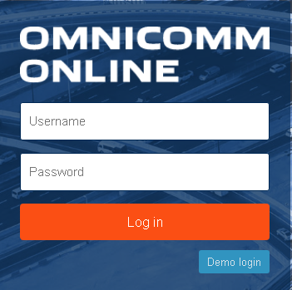

Dealer's “Login” and “Password” are to be obtained at Omnicomm Sales department.

Operations with reports
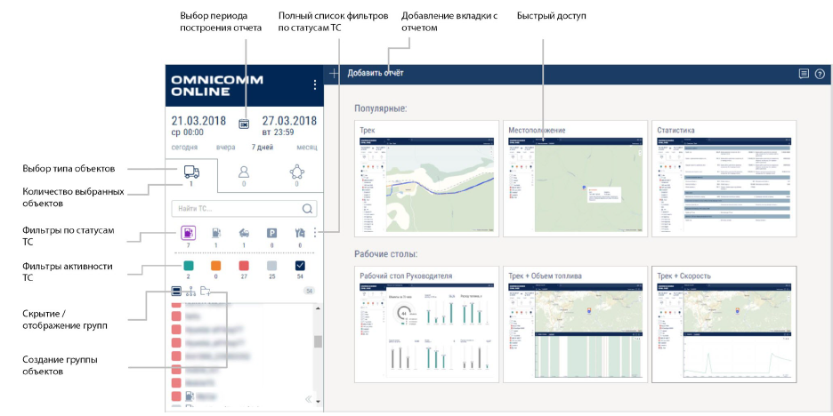
Selecting the report generation period
Full list of filters by vehicle status
Adding a tab with a report
Quick access
Choosing the type of objects
Quantity of selected objects
Filters by vehicle status
Vehicle activity filters
Hide/show groups
Create a group of objects

Desktop
There are two types of desktops on Omnicomm Online:

Executive's desktop is a report containing general information on all VH of the user. Description of the Executive's desktop is given in the “Reports” section.
Desktop is a combined set of related reports on the VH. Please see the example:
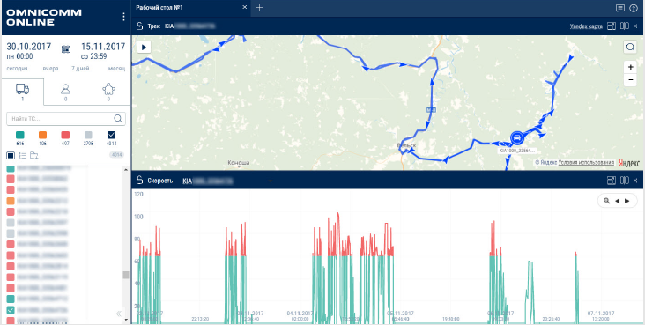

Нужно вставить скрин на английском с обозначениями

Display report on full-screen mode

Adding a report below

Adding a report on the right

The maximum number of reports on the desktop:
10 reports, each 1/2 of the desktop in size

20 reports, each 1/4 of the desktop in size
Selection of a period for report generation
In the “Reports” window select a period for report generation.
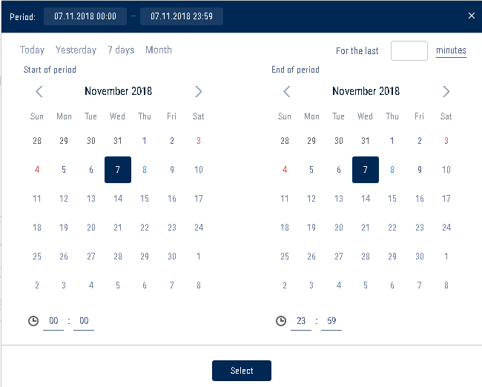

If a selected period includes a period of blocking, the report will not be generated. Select another period for report generation.
In case VH data recalculation for the period of report generation is not finished, the report will display information on a period of the processed data included in the report: The report is not final
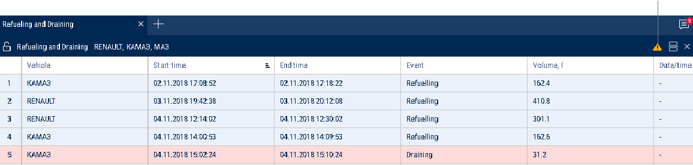
To display a final report on all data of the period of report generation, wait for VH data recalculation to be completed and refresh the report.

Settings of objects tree
The object tree configuration allows setting the parameters of the activity filters and pop-up information about the vehicle in the vehicle object tree and cartographic reports.

Hover over any vehicle/group of vehicles or activity filter, right-click and select “Object Tree Settings”.
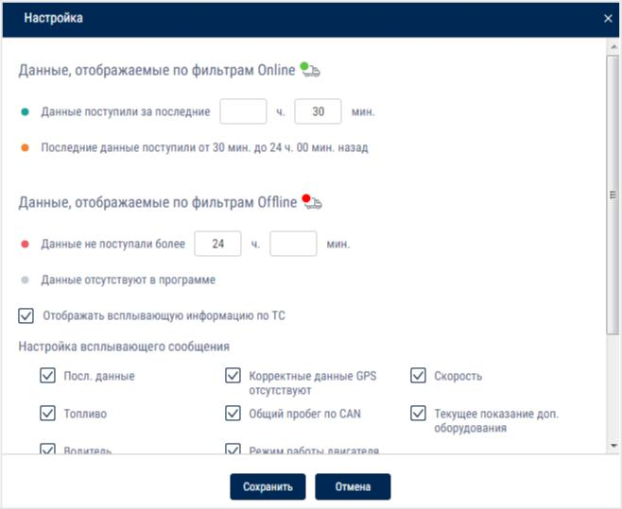

In the “Data displayed under Online and Offline Filters” section:

Specify the time intervals for receiving data from the terminals according to which the vehicle's activity filters will operate

Data | The marked vehicles' terminals transmitted data to
received for | Omnicomm Online within the set period of time
last
Last | The marked vehicles' terminals transmitted data to
data | Omnicomm Online within the time interval between the set values
received for | “Data received for the last” and “Data not received for more than”
period
Data not | The marked vehicles' terminals have not transmitted data to
received for | Omnicomm Online beyond the set period of time
more than
Data | The marked vehicles' terminals have never transmitted any data to
absent in | Omnicomm Online
program

Vehicles will be displayed according to the selected activity filter:

The vehicles transmitted data to Omnicomm Online during the selected period of time
The vehicles transmitted data to Omnicomm Online within the interval of time between the values set in “Data received for the last” and “Data not received for more than”
The vehicles did not transmit data to Omnicomm Online beyond the selected period of time
The vehicles have never transmitted data to Omnicomm Online
The total number of vehicles

Setting of VH pop-up information
Check the “Display pop-up vehicle information” box to display information on the vehicle in cartographic reports:

Ignition status:
Ignition on
Ignition off
Open street view
Open video
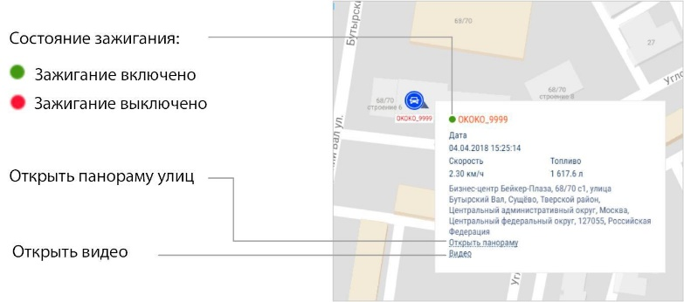

In the “Pop-Up Message Settings” section, select the information to display:

Latest data - the date and time when the latest data was received from the vehicle are displayed in the "Location" report and in the vehicle tree. The date and time of the event are displayed in the "Track" report

Correct GPS data absent – date and time when the latest valid GPS data was received. "GPS data not available from..." is displayed:

if there is no valid GPS data for 60 seconds after the latest data was received (for the "Location" report and the vehicle tree)

if the event point has invalid GPS data and the previous point has valid data (for the “Track” report)

Speed - vehicle speed

Fuel – fuel volume in the main and additional tanks

Total mileage as per CAN – total vehicle mileage according to CAN bus data

Current auxiliary equipment readings - current value or status of the auxiliary equipment

Driver – driver registered on the vehicle

Engine operation mode - engine operation mode value. Possible values: idle operation or load. Displayed only in case of engine operation at the time when the pop-up information was generated.

In the "Address Display Settings" section, select:

Display the address - turn on to display the address of the current vehicle location

All - turn on to display the complete vehicle address

Abbreviations - turn on to abbreviate address parameters (such as st., ave.)

Select the parameters to display in the address:

Country

Region

City/town

Street

Building

Zip code
Setting of VH icons
The vehicles are displayed as icons in the cartographic reports.
Select VH, for which it is required to set an icon, press the right mouse button and select “Select icon”.
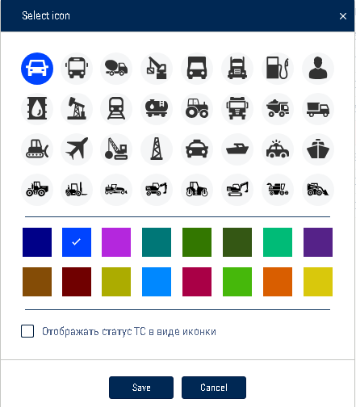
Select icon, background icon and track color of VH.
"Display vehicle status as an icon"– put a check to display the vehicle status as an icon in the cartographic reports.
Click “Save”.

Report pin-up (report fixation)
Select an object from the list for which it is required to generate report or change a period of report generation. If it is required, get the report memorized.
Un-pinned report If another object or period is chosen, the report will be automatically rebuilt.
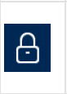 Pinned up report If another object or period is chosen, the pinned up report will not change.
User reports
User reports User reports are created on the basis of the standard reports, provided with feature of displayed parameters setup.
User reports in the list of reports are located under the reports, on the basis of which they were created.
To create user report do the following:
- Select an object, for which it is required to create a user report.
- Press “Add report” button and select a report.
- Choose information to be displayed in the report. Press button “Save as”
The window will open in which it is required to enter a user report name:
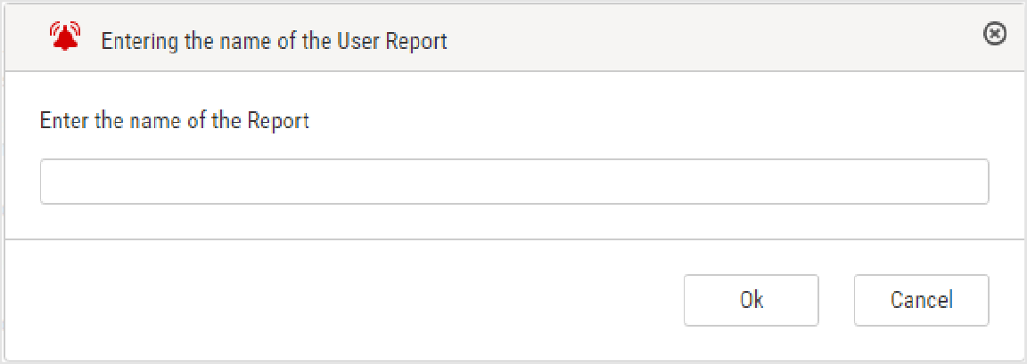

Reports

Executive's Desktop
The Executive's Desktop is a report containing overall information on all VHs of a user regardless of the VH selected.
Click the “Add” report button and select “Executive's desktop”.
Current values
Forecasted values

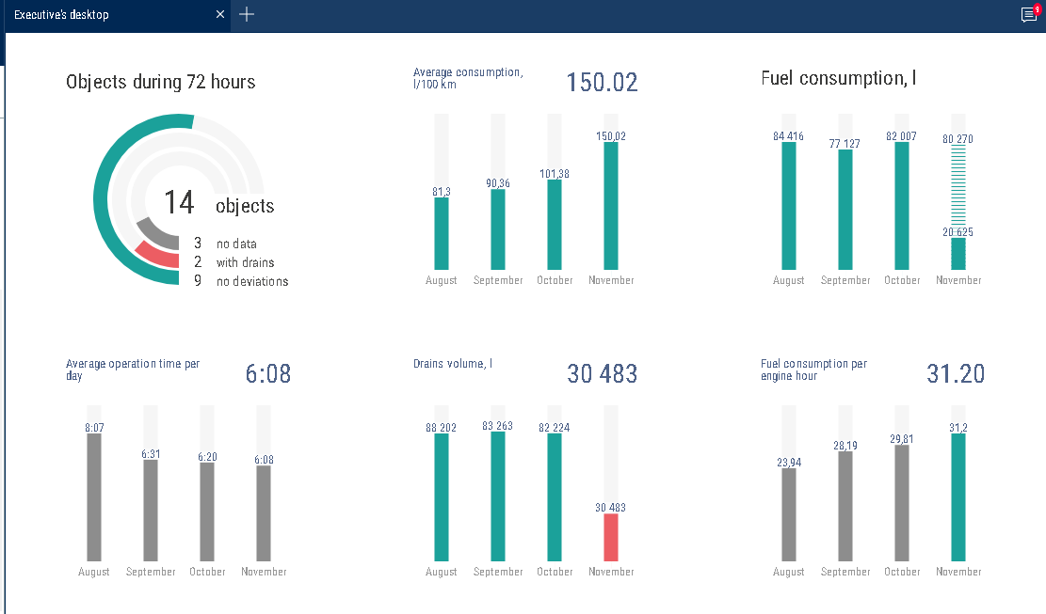

The report data are updated once in 30 minutes.
“Objects during 72 hours” is a quantity of the user's VH on Omnicomm Online during the last 72 hours:
“No data” is a number of VH om which the data are absent. “With drains” is a number of VH on which a drain was identified.
“No deviations” is a number on VH on which the data were not received or a drain was not identified.
“Average consumption, l/100 km” is an average consumption on all VH of the user. It is calculated with the indicators from this report by the formula: Fuel consumption/Mileage * 100
“Fuel consumption, l” is a total fuel consumption for all VH.
Predicted value is calculated as of the end of month proportionally to the current value. It is not displayed with the current consumption of less than 100 liters.

“Average operation time during a day” is an average number of hours of all VH during the day.
“Drains volume, l” is a total volume of drains for all VH.
“Mileage, km” is a total mileage for all VH of a user. The values are rounded up to the nearest whole number (1 km).
The predicted value is calculated as of the end of month proportionally to the current value. It is not displayed with the current mileage less than 1000 km.
The values for the current month are displayed after the set number days from the month beginning. The time shall be set by the web-site administrator, the default value is 7 days.

Fuel

Refueling and draining
- Select one or several objects.
- Select a period of time for report generation.
- Press button “Add report” and select “Refueling and draining”.

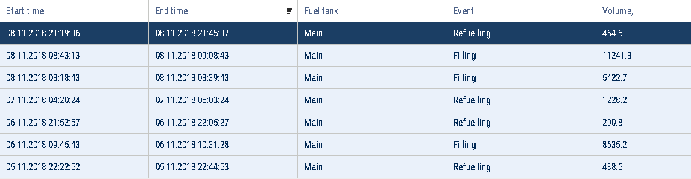
For vehicles equipped with video recording terminals:

- The video is available for viewing. Click on the icon to view the video.
- Video available for order.
- Video requesting in progress.
Select the information to be displayed in the report pressing the right mouse button and choosing “Report settings”

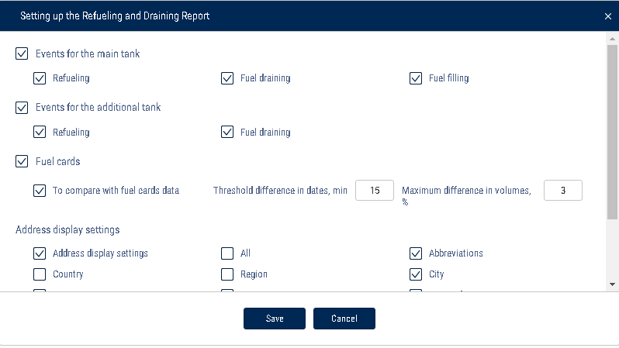

For fuel tankers of primary tank refueling and drains are displayed, for an additional tank — refueling and drains.
Exception of the events from the report is allowed for primary tank of vehicle. In section fuel cards specify following:
“Compare with fuel cards data” — turn on to compare fuel volume filled in VH in accordance with Omnicomm Online data with fuel card data.
“Threshold difference in dates, min” — specify allowed difference in date and time of refueling between Omnicomm Online and fuel card data.
Default value is 15 min.
“Maximum difference in volumes, %” — specify allowed difference in volume of fuel filled in between Omnicomm Online and fuel card data. Default value is 3%. There is an opportunity to apply color indication and data fit. To turn on color indication select “Select operations with color”.
With turned-off “Compare with data of fuel cards” parameter: White background of line is for refueling
Pink background is for fuel drain
Gray background of line is an excepted event of drain or refueling With turned-on “Compare with data of fuel cards” parameter:
Green background of line means a volume of refueling according to
Omnicomm Online data corresponds to refueling volume according to a fuel card taking in account values of parameters “Threshold difference in dates, min” and

“Maximum volume difference, %”;
Pink background is for fuel drain
Blue background of line means refueling has been performed without a fuel card or refueling according to Omnicomm Online does not correspond to fuel card data (considering value of “Threshold difference in dates, min” and “Maximum volume difference, %” parameters)
Gray background of line is an excepted event of drain or refueling
With turned-on display excepted events are displayed on grey line background with ticked “Exception”. Press button “Apply”.
- In the program window the list of refueling and drains within the selected period will be displayed.
In the "Address Display Settings" section, select:

Display the address - turn on to display the address of the current vehicle location

All - turn on to display the complete vehicle address

Abbreviations - turn on to abbreviate address parameters (such as st., ave.)

Select the parameters to display in the address:

Country

Region

City/town

Street

Building

Zip code

The report contains following data:
Volume, start and end time of refueling/drain according to Omnicomm Online data Fuel capacity (basic or additional)
Event (drain or refueling)
Exception tick if it is required to except drain or refueling from the report. This feature is available only to user to whom appropriate rights are assigned. Press button “Apply”.
Date/time of fuel card transaction: date and time of refueling according to the fuel card data
Volume of fuel card data refueling — volume of refueling according to fuel card data
Difference, l — difference in volume of fuel filled in between Omnicomm Online and fuel card data.
It is calculated by the formula: Difference, l=Volume according to fuel card data is a volume according to Omnicomm Online
Difference, % is difference in volume of fuel filled in between Omnicomm Online and fuel card data. It is calculated by the formula:
Difference, %=Volume according to fuel card data is a volume according to Omnicomm Online/(Fuel card data volume)*100%
The address where start of drain or refueling was performed. To cancel operation exception untick and press “Apply button”.
Upon changing of fuel parameters in VH profile and data recalculation the excepted events won't be returned.

Fuel volume
- Select a vehicle.
- Select a period of time for report generation.
- Press button “Add report” and select “Fuel volume”.
In the program window a report on fuel volume in the tank of VH for the selected period of time will be displayed.
In case there are two tanks installed in the VH, report on the fuel volume will be displayed for each tank:
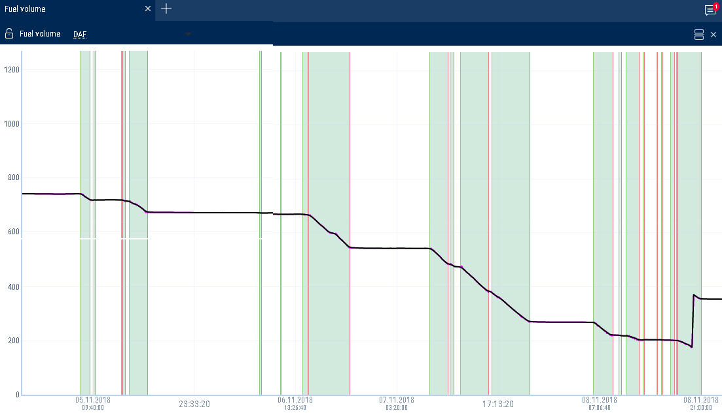

Press the icon and select the information to be displayed:

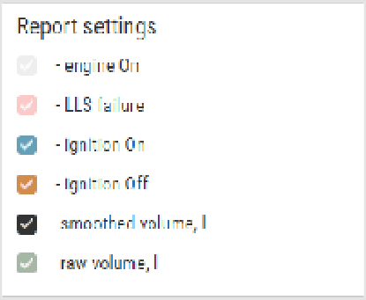

Green line is time of ignition turn-on

Red line is time of ignition turn-off

Gray background of diagram is an engine combustion period

White background is a period of time during which the engine did not work

Pink background is a period of time during which a failure of the LLS fuel level sensors took place.
Gray diagram is a diagram based on “raw” data.

Black color in diagram is a diagram based on the processed data.

If necessary, increase the diagram scale. Select a part of the diagram, to be increased holding the left mouse button.
To return to the original scale of the diagram refresh the report.
To display a pop-up tip with an accurate value of the fuel volume select a required spot in the diagram with a mouse pointer.

Fuel volume (engine hours)
- Select a vehicle.

- Select a period of time for report generation.

- Press button “Add report” and select “Fuel volume” (engine hours).

In the program window the report on VH consumption during engine operation will display:
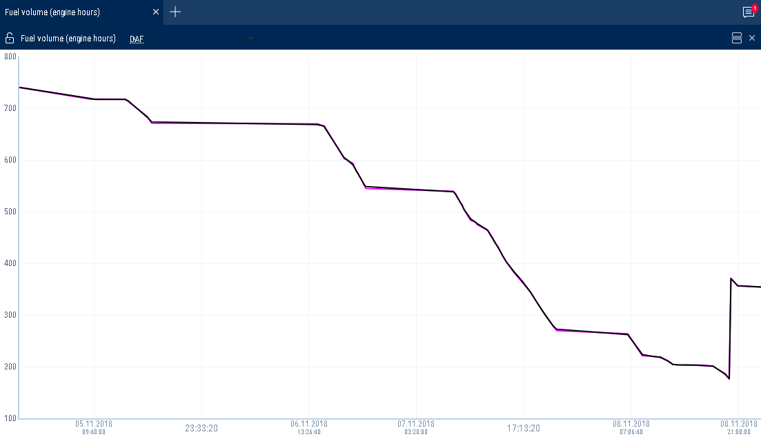

Press the icon and select the information to be displayed:

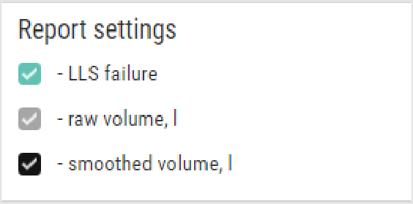

The following color designations are used in the report:

Purple graph color - the graph is generated on raw data

Black graph color - the graph is generated on “smoothed” data
If necessary, increase a diagram scale. Select a part of the diagram to be increased holding the left mouse button.

Fuel dispensing
- Select a fuel tanker.

- Select a period of time for report generation.

- Press button “Add report” and select “Fuel dispensing”.

In the program window the report on fuel dispenses by fuel tanker will be displayed:

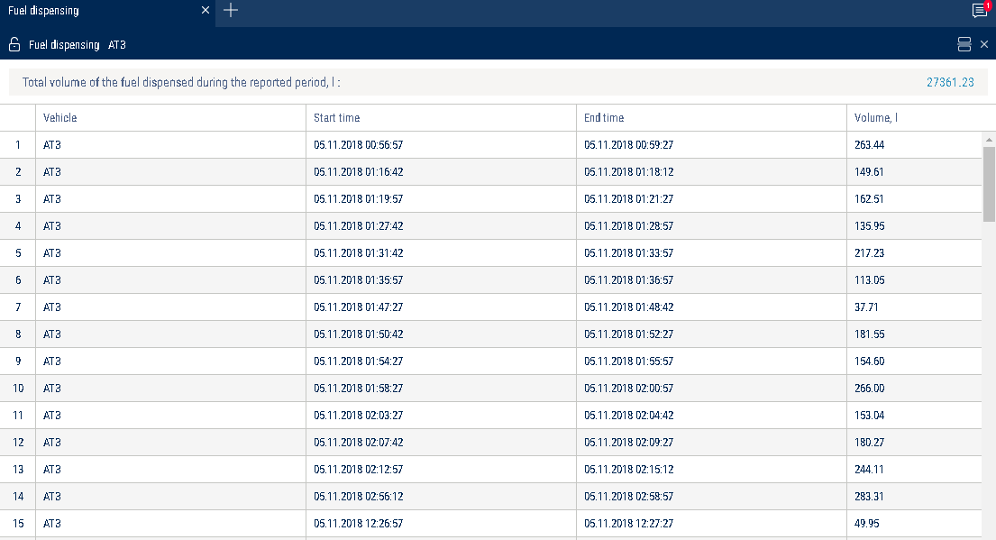

The report contains the following information:

Total volume of fuel dispensed for the selected period, (l)

Fuel dispensing start/end time, (dd/mm/yyyy hh:mm:ss)

Volume of dispensed fuel, (l)

Dispenses, filling and fuel volume drained from tank
- Select a fuel tanker.

- Select a period of time for report generation.

- Press button “Add report” and select “Fuel dispensing, fillings and drains”.

In the program window fuel tanker report will be displayed:

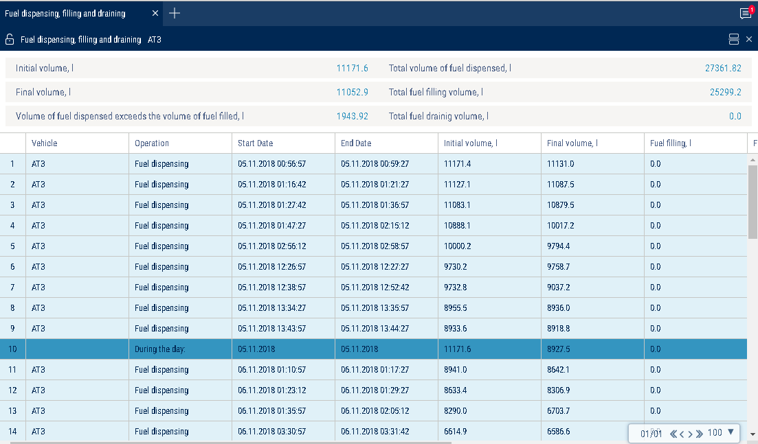

Report is provided with a feature allowing to sort the list by operation, start and end time of operation.
The report contains the following general information:

Initial volume, (l) is the volume of fuel in the tank at the start of the selected period

Final volume, (l) is the volume of fuel in the tank at the end of select period

Increase of dispense volume over fillings volume, (l) or potential drain, (l) is the difference between readings of LLS Fuel level sensor and counter is calculated by the formula:

“Difference between readings” = “Initial volume” - “Final volume” + “Volume of fillings” – “Volume of drains” - “Volume of dispenses”.
If the value “Difference between readings” is less than zero, the parameter “Excess of dispenses value over fillings value, l”
If value “Difference between readings” is less than one of maximum values: “Fuel draining threshold”, “Refueling threshold”, “1% of fuel tank volume” or “20 liters”, Omnicomm Online assumes “Increase of dispense volume over fillings volume, (l)” to be equal to zero.
If “Difference between readings” is over or equal to zero, Omnicomm Online renames the parameter and displays “Potential drain, l”.
Fillings total volume, (l) is a total fuel volume filled in the tank during the period Fillings total volume, (l) is a total fuel volume filled in the tank during the period Drains total volume, (l) is a total volume of all drains during the period
To set up report press right mouse button and select “Report settings”.
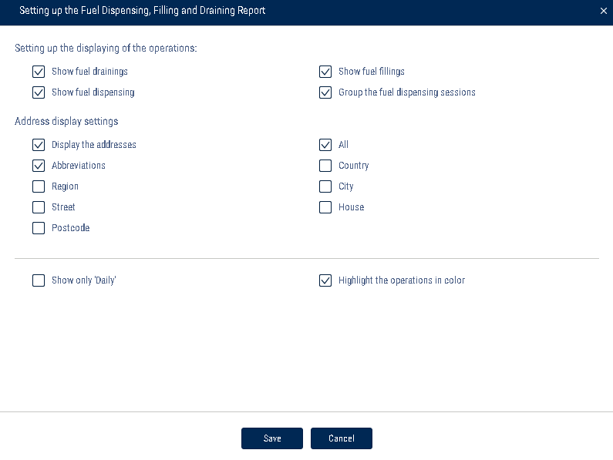

There is a feature allowing to apply color indication of fuel drains/fillings/dispense. To turn on color indication select “Select operations with color”. The following color designations are used in the report:
White background of line means fuel filling Pink background is for fuel drain
Blue background of line means dispense, drain+dispense; filing+dispense; drain/refueling start; end of drain/filling
If it is required to display the information only for one day select “Display ‘For one day only’”.
Dispenses display can be grouped. One group of dispenses includes all dispenses which took place during a time period specified in the VH profile. The group may include only one dispense, if no dispenses took place after this one.
Acсording to the LLS sensors readings for a group of dispenses an initial (the volume of the first dispense in a group) and end value of fuel volume in the tank (the volume
of the last dispense in a group) are recorded.
Comparison of cumulative volume of all dispenses in a group with change of volume in the tank is performed. If values are different by a value which greater than the allowed value, an additional drain or refueling performed during dispenses are recorded:
Decrease of volume in the tank is greater than cumulate value of all dispenses, additional drain of fuel is recorded (e.g. performed through lid and access holes in the tank).
Decrease of volume in the tank is less than total volume of all dispenses, an additional refueling of fuel to the tank (e.g. if fueling operator “twists” dispense counter in order it will correspond to paper fuel ticket with fueling nozzle being put to the hatch of their own tank).
If necessary the analysis of the motion of fuel and development of embezzlements and manipulations, group of deliveries it should be grouped so that they would be mapped into the report by one line. If it is necessary to examine all dispenses performed from fuel tanker, groups of dispenses can be ungrouped and only one dispense will be displayed in the line, and the size of table will increase.
To switch grouping select “Group dispenses”. Apply settings by pressing “Save”.
This report table the following information:
“Operation“ includes operations performed with fuel in the tank. “Fueling” is fueling to the tank.
“Drain” is drain from the tank.
“Dispense” is fuel dispense through fuel nozzle.
“Dispense + Drain” is simultaneous dispense of fuel through fuel nozzle and fuel drain from the tank.
“Refueling + drain” is simultaneous drain of fuel to the tank and dispense of fuel through fuel nozzle.
“Start” is a date and time of an operation. “End” is a date and time of the operation end.
“Initial volume” is a volume of fuel in the tank at the moment of the operation start.
“Dispense, (l)” is a volume of dispensed fuel upon fulfillment of the “Dispense” operation.
or “Refueling + dispense”

“Drain”, (l) is a volume of drained fuel when performing “Drain” or “Dispense + Drain” operation
“Refueling, (l)” is a volume of fuel filled to the tank.
“Address” is an address of dispense. It is displayed only for group fuel dispenses.
In the "Address Display Settings" section, select:

Display the address - turn on to display the address of the current vehicle location

All - turn on to display the complete vehicle address

Abbreviations - turn on to abbreviate address parameters (such as st., ave.)

Select the parameters to display in the address:

Country

Region

City/town

Street

Building

Zip code

Refueller Statement

- Select the refueller

- Select the time period for report generation

- Press the “Add report” button and select "Refueller Statement"

A report on the refueller will be displayed in the program window:
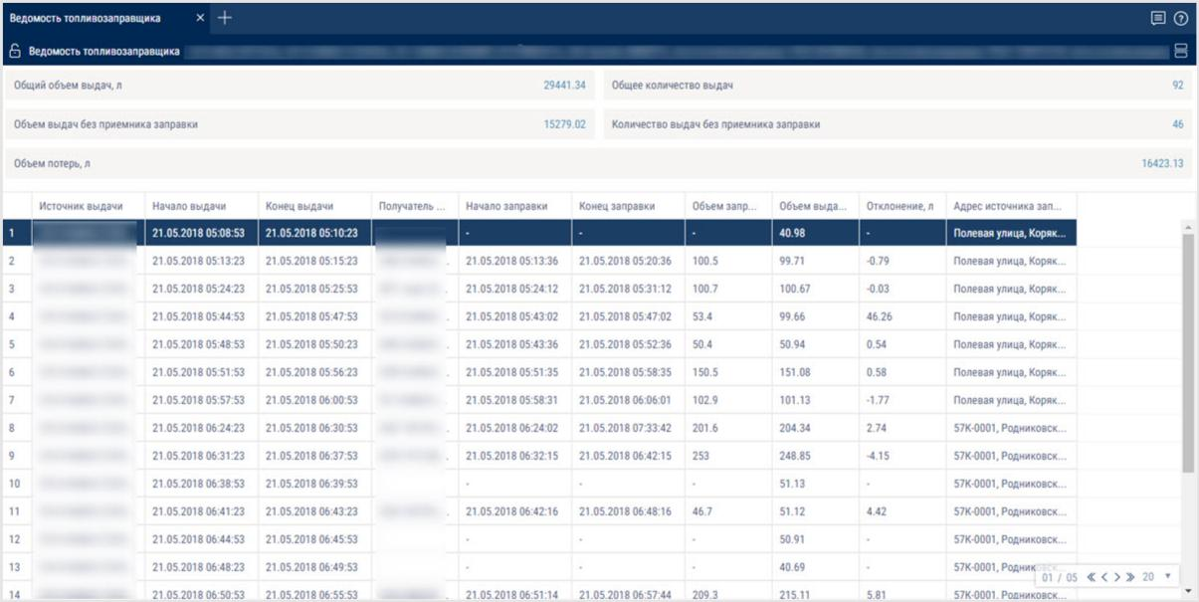

To select the information displayed in the report, right-click and select "Report settings":
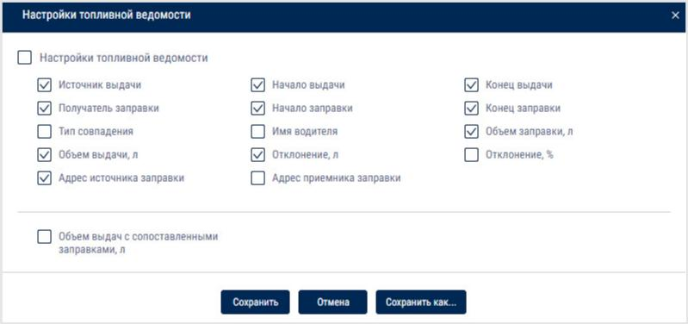

General information in the report:

"Total volume of dispensed fuel,l" - the total amount of fuel dispensed during the report period

“Total amount of dispensing” - the number of fuel dispensing operations for the report period

“Total volume of dispensed fuel without a refueling receiver” - the volume of fuel dispensed by a fuel tanker without a corresponding refueled vehicle

“Number of dispensings without a refueling receiver” - the number of dispensing operations performed by a fuel tanker without a corresponding refueled vehicle

“Volume of discharges compared to the relative refuelings, l” - the volume of fuel dispensed by the fuel tanker with a corresponding refueled vehicle

"Loss volume, l" - the difference between the volumes of dispensed and received fuel

The report contains the following information:

Dispensing source - name of the fuel tanker

Start of dispensing - date and time of the start of the fuel dispensing operation

End of dispensing - date and time of the end of the fuel dispensing operation

Recipient of refueling - name of the refueled vehicle

Refueling start - date and time of the start of refueling

Refueling end - date and time of the end of refueling

Match type - the method used to match the source of dispensing and the refueled vehicle. Possible options: coordinates and time, iButton key, RFID card, fuel card, document.

Driver's name - full name of the driver of the refueled vehicle. The driver's name is displayed depending on the type of match:

iButton key, RFID card - full name of the key or card holder

coordinates and time - full name of the driver registered on the refueled vehicle

Refilled volume - the volume of the fuel filled in the vehicle

Dispensed volume - the volume of the fuel dispensed by the fuel tanker

Deviation, l - the difference between the refilled volume and the dispensed volume in liters

Deviation, % - the difference between the refilled volume and the dispensed volume in percentage

Refueling source address - the address at which the start of fuel dispensing was recorded

Refueling receiver address - the address at which the start of vehicle refueling was recorded

The fuel dispensing log is associated with the following reports: "Fuel dispensing", "Fuel dispensing, filling, and draining", "Refueling and draining", "Fuel volume", "Events", "Log", "Track".

Fuel Balance

- Select one or several vehicles

- Select the time period for report generation

- Press the “Add report” button and select “Fuel Balance”
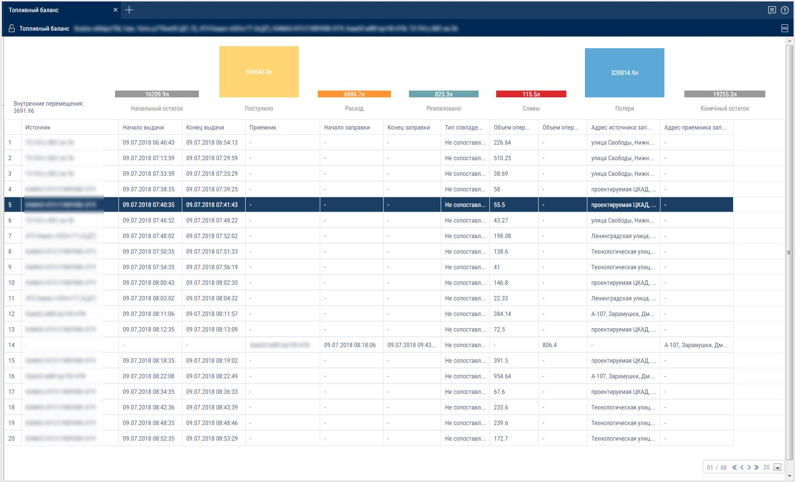

To select the information displayed in the report, right-click and select "Report settings":

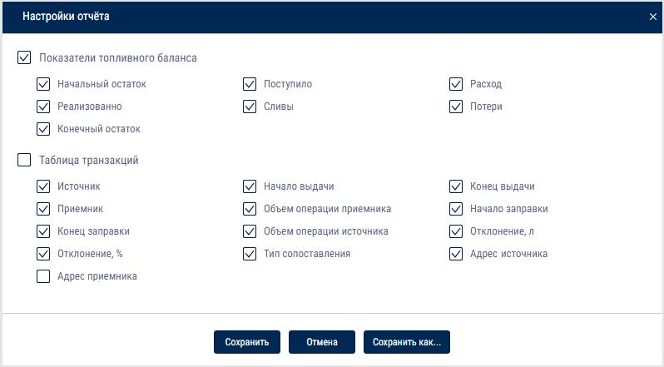

General information in the report:

“Internal displacements” - the total volume of the source fuel for the “dispensing” and/or “draining” events associated with the “refueling” and/or “filling” events of the selected vehicle, according to the report table

"Initial Balance" - the total volume of fuel in the main and auxiliary tanks at the start of the report period for the selected vehicles according to the reading of fuel level sensors

"Received" - the total volume of fuel including

the volume of positive deviations according to the report table

the volume of fuel of the receiver's refueling and filling events, that do not match or match the dispensing from a source that is not selected to generate the report

the volume of source events in which the "Refueling" and "Filling" events match the fuel card operations

the value of "Difference between readings" module = "Initial volume"

- "Final volume" + “Filling volume” - “Draining volume” - “Dispensing volume” (only when the value is negative)

"Consumption" - the total of actual fuel consumption for the main and additional tanks according to the fuel level sensors for the period for the selected vehicle

"Off-loaded" - the total amount of fuel according to the source events, associated with the vehicle's "Refueling" or "Refilling" events, not selected to generate the report

“Drainings” - the total volume of draining operations for the main and additional tanks according to the fuel level sensors, excluding the volume of discharges included in the calculation of the “Internal displacement” and “Off-loaded” parameters

"Losses" - the total volume of fuel including:

the volume of negative deviations according to the report table

the fuel volume of the source dispensing events that do not match the receiver's events according to the report table

the value of "Difference between readings" = "Initial volume" -

"Final volume" + “Filling volume” - “Draining volume” - “Dispensing volume” (only when the value is positive)

"Final Balance" - the total volume of fuel in the main and additional tanks at the end of the report period for the selected vehicles according to the reading of fuel level sensors

The table report contains the following information:

Source - the vehicle performing the dispensing or draining operation

Start of source operation - date and time of fuel dispensing or draining start. Format DD.MM.YYYY hh:mm:ss

End of source operation - date and time of fuel dispensing or draining end. Format DD.MM.YYYY hh:mm:ss

Receiver - the vehicle receiving the fuel as a result of the refueling or refilling operation

Start of recipient operation - date and time of vehicle refueling start. Format DD.MM.YYYY hh:mm:ss

End of receiver operation - date and time of the vehicle refueling end. Format DD.MM.YYYY hh:mm:ss

Match type - the parameters used to match the source and the recipient.

Possible options:

fuel card

RFID / iButton

coordinates and time

not matching

Volume of source operation, l - the volume of fuel dispensed by the source

Volume of recipient operation, l - the volume of fuel received by the recipient

Deviation, l - the difference between the volume of fuel received by the receiver and the volume dispensed by the source. Possible values: positive and negative numbers displayed taking the sign into account

Deviation,% - the deviation calculated using the formula:

- %*("Deviation, l" / "Volume of source operation, l")

Source operation address - the address at which the dispensing or draining of fuel by the source is recorded

Receiver operation address - the address at which the refueling or filling of fuel into the recipient is recorded

Movement
Standstills
- Select one or several objects.
- Select a period of time for report generation. 3.Press button “Add report” and select “Standstills”.
Determination of stoppages and standstills shall be performed taking in account the VH ignition or by GPS coordinates in accordance with the settings in the VH profile.
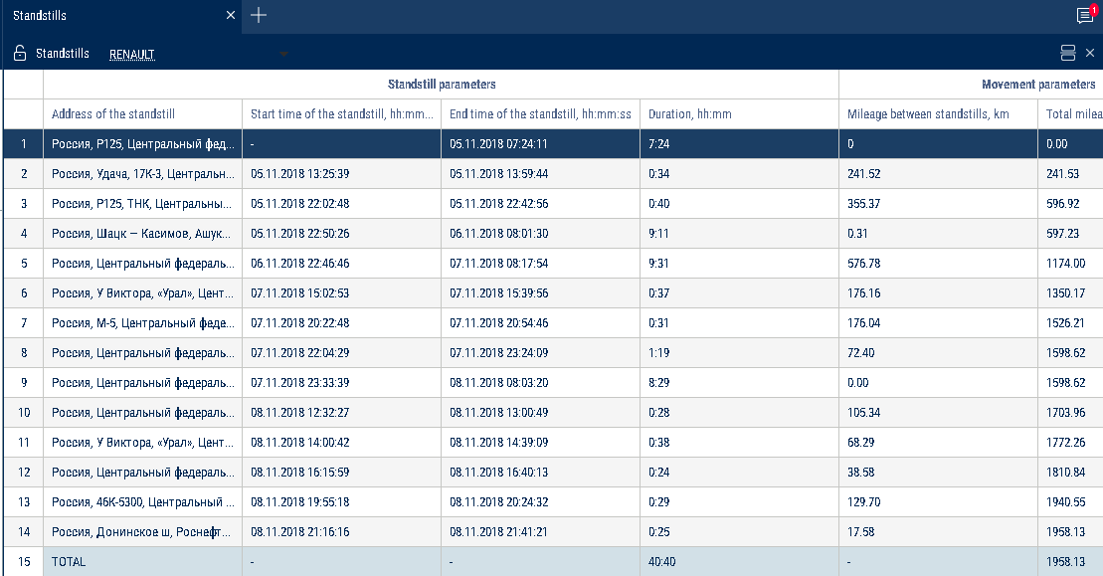
Select the information to be displayed in the report by pressing the right mouse button and choosing “Report settings”.

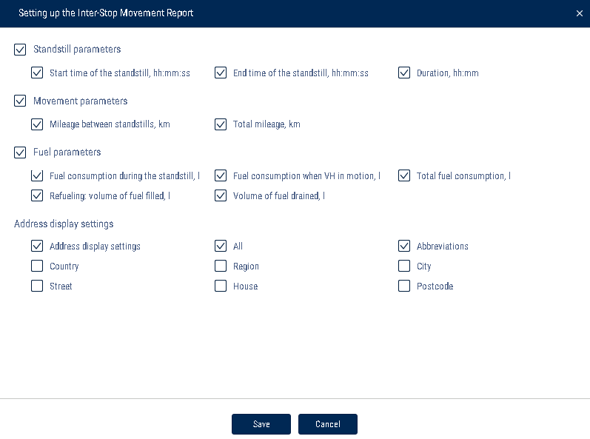

In the "Address Display Settings" section, select:

Display the address - turn on to display the address of the current vehicle location

All - turn on to display the complete vehicle address

Abbreviations - turn on to abbreviate address parameters (such as st., ave.)

Select the parameters to display in the address:

Country

Region

City/town

Street

Building

Zip code

A standstill is registered, when the following conditions are met: the ignition is off, the speed is less than 2 km/h, the time since the ignition was turned off has exceeded the value of “Trace the standstills longer than minutes” set in the vehicle profile, and at the current time the standstill is completed.

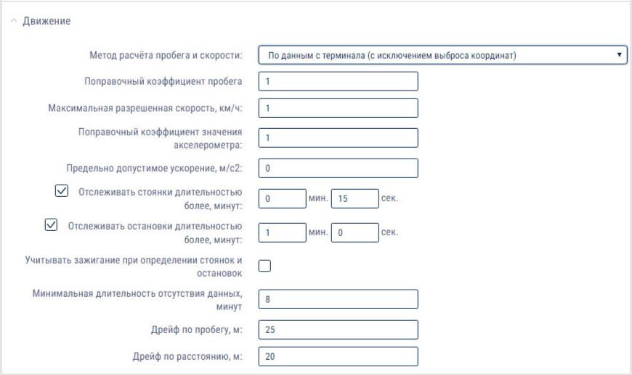

“Standstill address” – address, at which the parking was registered, i.e.

the “Trace the stoppages longer than, minutes” value was exceeded.

"Start time of the standstill, hh:mm:ss" - the date and time when the standstill started, i.e. the date and time when the standstill was recorded more than the value of “Trace the standstills longer than minutes” minus the value of “Trace the standstills longer than minutes” itself.

“End time of standstill, hh:mm:ss” – date and time of the end of the standstill or of the report period.

"Duration, hh:mm:ss" - the duration of the parking, determined depending on the selected report period.

Speed
1.Select a vehicle
2.Select a period of time for report generation
3.Press “Add report” button and select “Speed”
The program window will display a report on the VH speed:

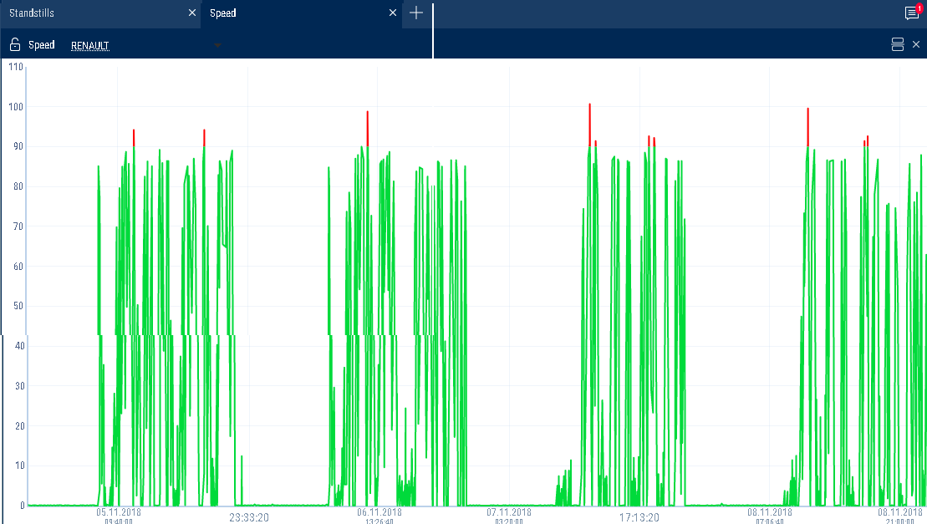

If a period between neighboring events recorded in the register is shorter than 8 minutes, ignition turn-off won't be displayed on the speed diagram.
The following color designations are used in the report:
Green diagram means that the VH speed is lower or equal to the maximum allowed speed value.
Red diagram means the speed exceeds the maximum allowed speed value.
If necessary, increase the diagram scale. Select a part of the diagram, which shall be increased withholding left mouse button.

Movement
To generate this report it is required to switch off “Take in account ignition when identifying standstills and stoppages” in the VH profile.
1.Select a vehicle
2. Select a period of time for report generation
3.Press “Add report” button and select “Movement”
The program window will display a report on the VH movement: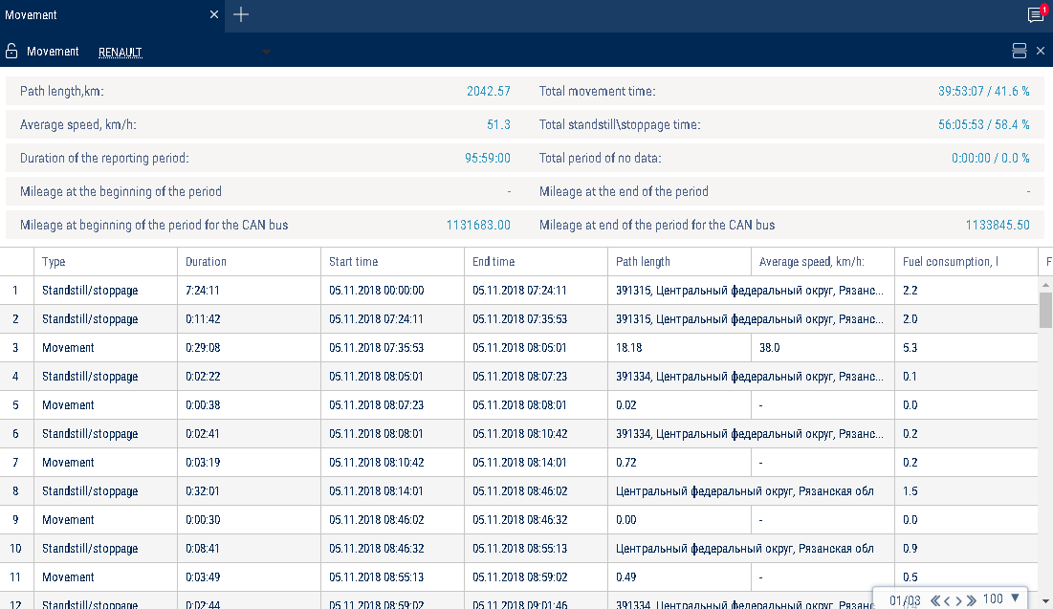

Select information to be displayed in the report by pressing the right mouse button and choosing “Report settings”:
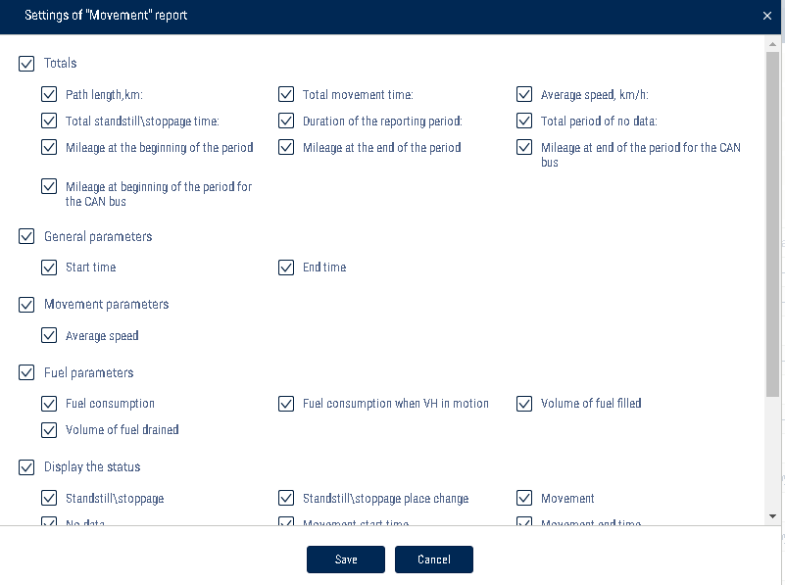

In the "Address Display Settings" section, select:

Display the address - turn on to display the address of the current vehicle location

All - turn on to display the complete vehicle address

Abbreviations - turn on to abbreviate address parameters (such as st., ave.)

Select the parameters to display in the address:

Country

Region

City/town

Street

Building

Zip Code

General information in the report:
“Track length, km” is a total length of the track for all report events
“Total time of movement” is total time, calculated for the events with a parameter “Track length, km” being different from 0
“The average speed of motion km/h” is a ratio of the parameter “Track length, km” to the “Total time of movement” parameter value
“Total time of standstills/stoppages” is a total time of standstills and stoppages in the report
“Duration of the accounting period” is a duration of the generated report period.
“Total time of data absence” is the total time, calculated for the events “data absence”
“Mileage at the beginning of the period as per CAN bus, km” - the CAN odometer value at the beginning of the period

“Mileage at the end of the period as per CAN bus, km” - the CAN odometer value at the end of the period

Use the mileage meter only during the configuration of "Vehicle profile"/ “Setting the initial values for VH monitoring”/"Correct to the mileage":

"Mileage at the beginning of the period, km" - the mileage calculated as the sum of the initial value of the odometer and the distance to the date of the beginning of the period

"Mileage at the end of the period, km" - the mileage calculated as the sum of the initial value of the odometer and the distance to the date of the end of the period

The report contains information on the following events:
- Standstill/stoppage
Start of a standstill is recorded, if the following conditions are met:
The VH speed is less than 2 km/h for all continuous events with “raw” data.
The distance between any events with “raw” data is less than 800 m.
The distance between the first and last event with “raw” data is greater than value of “Monitor stoppages longer than, minutes”.
The time period between the first and last event with raw data does not include periods of data absence.
End of a standstill is recorded, if the following conditions are met: Start of a standstill has been identified.
One of the standstill conditions has stopped being performed.
2. Change of a standstill place
The current event of the standstill start was identified.
According to the valid date the previous event was standstill end.
The event of data absence start has not been identified.
3.Data absence
The start of the data absence period shall be recorded, when the following conditions are met:
The time between the current event and the last event with the valid data is greater than the time set in the “Minimum period of data absence”.
If the current event is the first valid event with “raw” data, the date and time of the VH profile import shall be assumed the last event with the valid data.
The end of the data absence period shall be recorded, when the following conditions are met:
The start of data absence has been recorded.
The current event has valid data.
4.Movement
The movement shall be recorded, if the VH's speed is greater than 2 km/h.
For the events “movement” and “absence of data” the following information shall be provided: “Movement start time”
“Movement end time” “Duration”
“Track length, km”
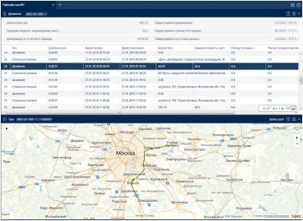
“Maximum recorded speed, km/h”
“Average speed, km/h”
To display the motion section on the map, add the “Track” report to the tab with the “Movement” report. In the table in the “Movement” report, select the row corresponding to the vehicle movement. In the “Track” report it will display the track section of the vehicle.

Необходимо добавить скрин движения с треком
To return to the entire track, click the left mouse button anywhere on the map.
Movement for the period
1.Select a vehicle.

2.Select a period of time for report generation.

3.Press button “Add report” and select “Movement for the period”.

In the program window the report on the VH movement by day will display:
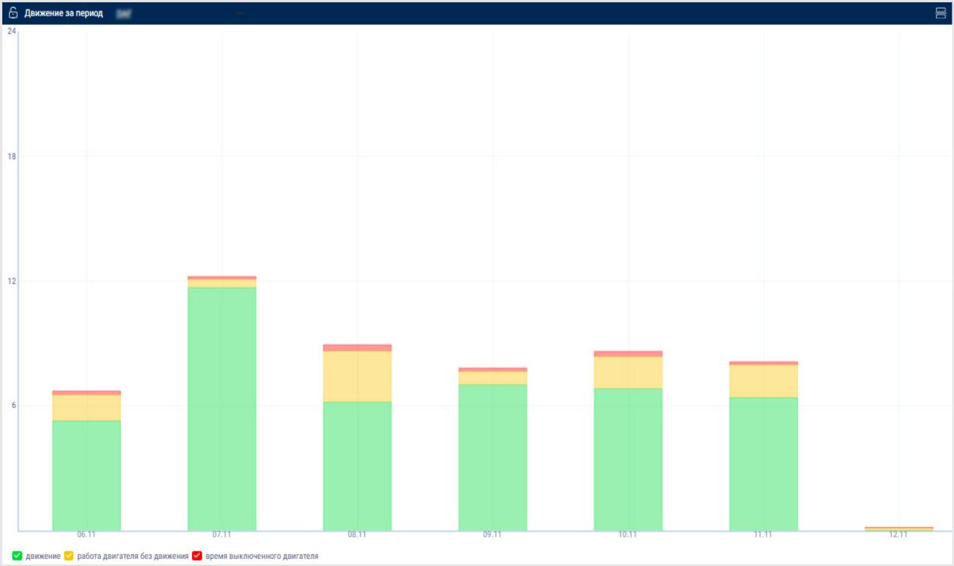

The following color-coding is used in the report:

Green - the total time that the vehicle was in movement for the day

Yellow - the total time of idle vehicle operation for the day

Red - the total vehicle downtime for the day, i.e. the time that the vehicle spent with the engine turned off

Select the information to display in the legend:

Cartographic
Track
The “Track” report allows a user to view of one selected VH for the selected time. 1.Select a VH.
2.Select a period of time for report generation. 3.Press “Add report” button and select “Track”.
A map with the VH's track for this period of time will be displayed in the program window:

Quantity of and information about the recorded events
Track player panel

Ignition status
Ignition on
Ignition off
Open street view

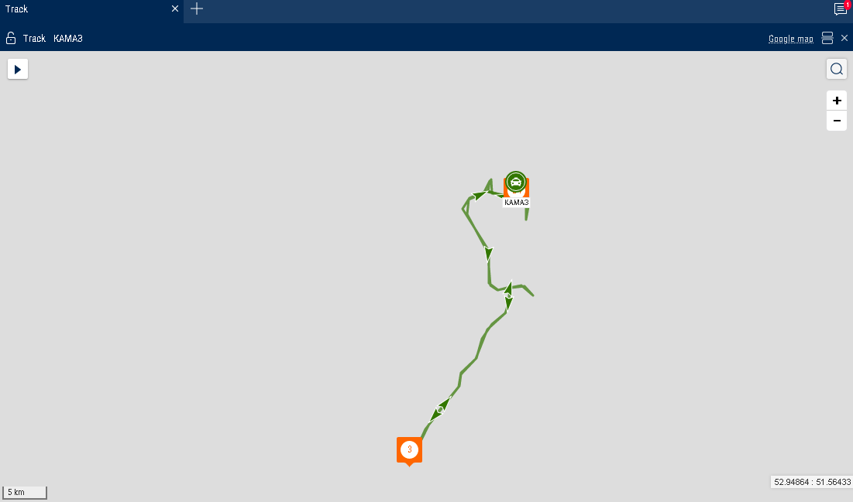

To display a tooltip press the icon .
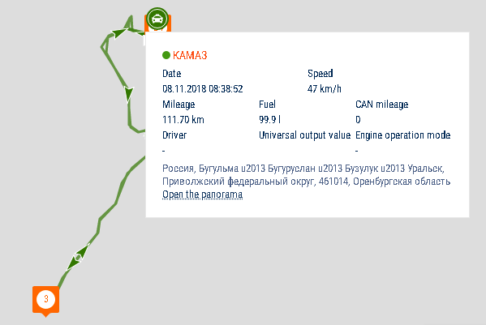

The tooltip contains the following information:
- “Date” is the date and time the VH presence in the selected part of the track.
- “Registration number” is the VH name.
- “Speed” is a speed of the VH in the selected place of the track.
- “Address” is the address where the VH was found in the selected place of the track.

- “Mileage” is a VH mileage starting from the track beginning.
- “Fuel volume in the primary tank” is a volume of fuel in the primary tank. It is not displayed, if the fuel level sensors are not connected or “0” number of sensors is set in the VH profile settings. The units of fuel parameters measurement (liters or gallons) shall be given according to the server settings.
- “Fuel volume in the additional tank” is a volume of fuel in the additional tank (if there is such). It is not displayed, if the fuel level sensors are not connected or “0” number of sensors is set in the VH profile settings. The units of fuel parameters measurement (liters or gallons) shall be given according to the server settings.
- “Ignition” is a position of the ignition key (on/off) in the selected place of the track.
- “GSM” is the state of GSM module (on/off).
“GPS data” are correct or incorrect data. If the data are incorrect, the date and time of receipt of the certain data are displayed.
“Total mileage as per CAN” – total vehicle mileage according to CAN bus data

"Current auxiliary equipment readings" - current value or status of the auxiliary equipment

“Driver” – driver registered on the vehicle

The format of the address and the content of the pop-up information about the vehicle can be configured in the object tree (see Object Tree Settings).

- To set up the report, press the right mouse button and select “Report settings”:

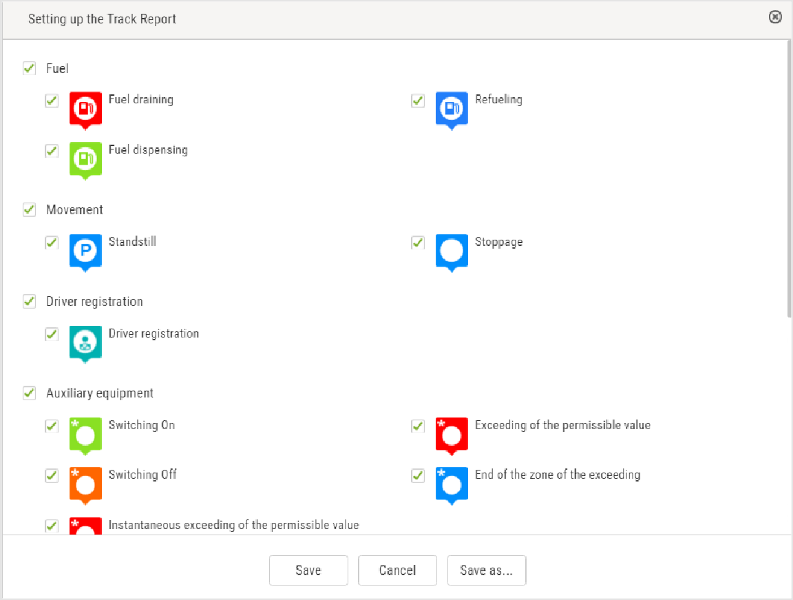
If necessary, you can turn on the option of displaying the color of the track based on the type of movement:
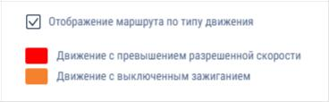

Measuring parameters between two points of the track

- Right-click on the track and select "Track Section Parameters"

- Select the starting point for the measurement on the track

- Select the end point for the measurement on the track. To clear the selection, click anywhere on the map (not on the track).

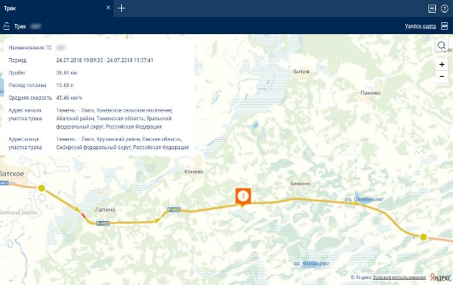

For a section of the track, the following information is displayed:

Vehicle name

Period

Mileage

Fuel consumption

Average speed

Track section start address

Track section end address

Exit the parameter measurement mode by pressing Enter or Esc.

To display track points, right-click and select "Track Detailing".

If you select one vehicle and a report period of 7 days or fewer, track points corresponding to all rows of the “Log” report will be displayed (at maximum scale).

The map in OpenStreetMaps mode has a feature enabling additional painting of necessary section of maps, please see www.openstreetmap.org for details.
If it is required to zoom in the map section, select it with the mouse cursor continously pressing “Shift” button.
To create a geofence using a track it is required to use the map control panel.

Location
A “Location” report allows to monitor movement of the VH in the real time mode. Information on the VH is refreshed upon receipt of the new data.
The location is recorded according to the valid GPS data (upon identification over 3 satellites).
For more effective tracking of moving objects in the real time mode we suggest that you use “VH tracking” mode. For more effective tracking of objects in geofences please use “Hide VH outside geofences” mode.
“Location” report in a normal mode
1.Select one or several VH.
2.Open “Mapping” tab and select “Location”.
In the program window the map with the VH location will be displayed:
Closing Panorama
Opening Panorama
Hiding all vehicles outside of geofences
Show/hide geofence names
Show/hide vehicle trace
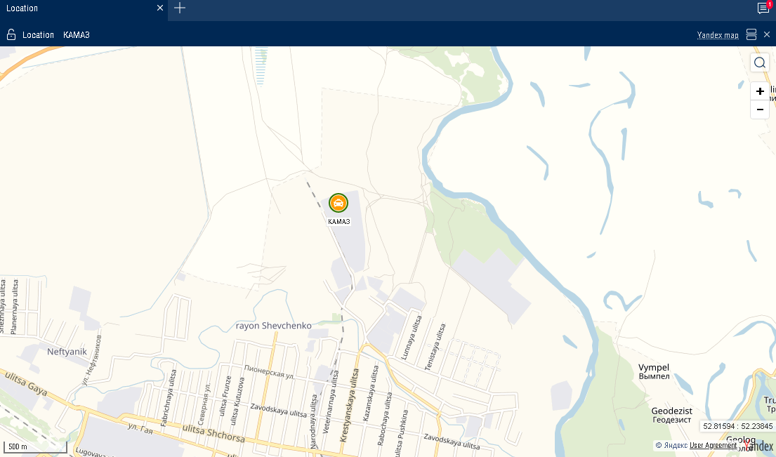

When the ignition is on, the color of the icon corresponds to that chosen when setting the vehicle icon. The arrow indicates the direction of the vehicle.
When the ignition is turned off, the color of the icon is orange.
To view information on the VH move the cursor to the VH icon. To pin the tooltip window with the information on VH, press the left mouse button.
This report contains the following information on the VH:
VH name is a name or registration number of the VH.
•Date is a date of the last received data in DD/MM/YYYY HH:MM:SS format.
•Speed, (km/h) is a speed of the VH at the moment of data transfer.
•Address is an address of the last location.
•Volume of fuel in primary tank is a volume of fuel in the primary tank at the moment of data transfer.
•Volume of fuel in the additional tank is a volume of fuel in the additional tank (if there is such) at the moment of data transfer.
•Ignition is on/off.
•The date and time of the last correct GPS data are displayed if within 60 seconds, there were not valid data. “Location” report in the mode of VH tracking
«“Total mileage as per CAN” – total vehicle mileage according to CAN bus data

"Current auxiliary equipment readings" - current value or status of the auxiliary equipment

“Driver” – driver registered on the vehicle

The format of the address and the content of the pop-up information about the vehicle can be configured in the object tree (see Object Tree Settings).

“Location” report in vehicle tracking mode

- “VH tracking” enables automatic actualization of map display, providing permanent display of the VH in center of the map section.
In case for generation of “Location” report several VH are selected, it is required to select one VH pressing the left mouse button on the icon of the VH in question. The name of the selected VH will be highlighted in red. In the vehicle menu, select to “Enable tracking of the selected vehicle”.

Vehicle trace
Vehicle tracking mode
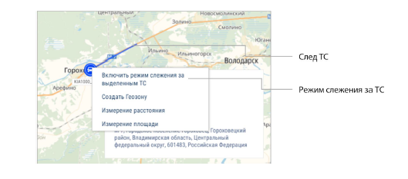

"Vehicle tracking mode" automatically adjusts the map, ensuring that the vehicle is always displayed in the center.

If several vehicles are selected to build the "Location" report, it is necessary to select one vehicle by clicking the left-clicking on the icon of the required vehicle. The name of the selected vehicle will be highlighted in red. In the vehicle menu, select "Turn on vehicle tracking mode".

Switching on the mode of the VH tracking enables recording of the report and when selecting another object or period the recorded report will not change. The report recording allows you to view reports on other objects simultaneously. After switching off of the VH tracking mode, the report is not automatically recorded.

“Location” report in the mode of the VH hiding outside the geofences
“Mode of VH hiding outside geofences” allows changing of the VH icons located outside the geofences:
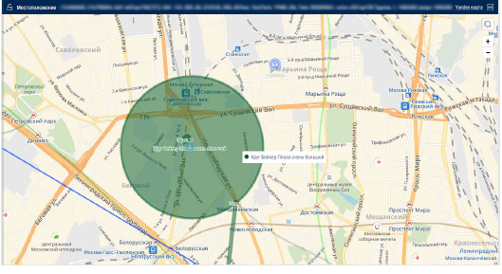

The full name of the geofence is displayed when you hover the mouse over it.

Statistics
Statistics

- Please select one or several drivers or VH.
- Please select a period of time for report generation. 3.Please press “Add report” button and select “Statistics”.
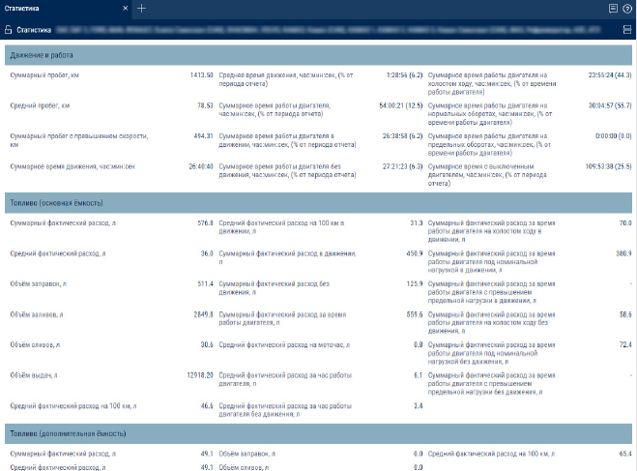
Select information to be displayed in the report by pressing the right mouse button and choosing “Report settings”:

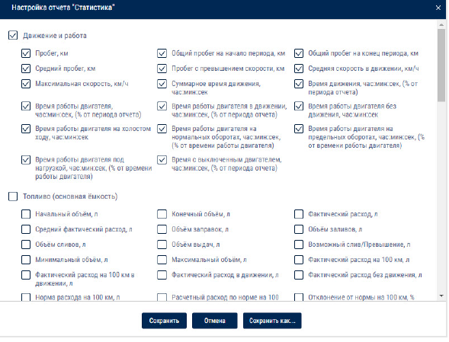

The program window will display a report with statistical data on a VH or driver for the selected period.
Description of the VH operation parameters calculation is given in Appendix B. In section “Movement and operation”:
- Mileage, km
- Average mileage, km
- Speeding mileage, km
- Average speed in motion, km/h
- Maximum speed, km/h
- Movement time, hour:min:sec, (% from the report period)
- Time of engine operation, hour:min:sec, (% from the period of report)
- Engine operation time when VH in motion, hour:min:sec, (% from the report period)
- Engine operation time when VH motionless, hour:min:sec
- Engine idle time, hour:min:sec
- Engine operation time at normal engine speed, hour:min:sec, (% from the time of
engine operation)
- Engine operation time at ultimate engine speed, the hour: min: it flogged, (% from the time of engine operation)
Engine OFF time, hour:min:sec, (% from the report period)
In section “Fuel” (main tank):
- Initial volume, l
- Final volume, l
- Actual consumption, l
- Average actual consumption, l
- Refueling volume, l
- Volume of fillings, l
- Fuel volume drained, l
- Volume of fuel dispensed, l
- Probable fuel draining/Excessive volume, l
- Minimum volume, l
- Maximum volume, l
- Actual consumption per 100 km, l
Actual consumption per 100 km in motion, l
Actual consumption in motion, l
- Actual consumption motionless, l
- Consumption rate per 100 km, l
- Estimated consumption according to rate for 100km, l
- Deviation from rate per 100 km, %
- Overconsumption against the rate per 100 km, l
Actual consumption per engine operation time, l
Actual consumption per motohour, l
- Actual consumption per hour of engine operation, l
- Actual consumption per hour of engine operation motionless, l
- Rate of consumption per hour of engine operation
- Estimated consumption by rate per hour of engine operation, l
- Deviation from rate per hour of engine operation, %

Overconsumption against the rate per 1 hour of engine operation, l

The actual consumption during the engine idle time in motion, l

The actual consumption during the time of engie operation under the rated load in motion, l

The actual consumption during the time of engine operation with exceeding of the maximum load in motion, l

The actual consumption during the engine idle time without motion, l

The actual consumption during the time of engine operation under the rated load without motion, l
The actual consumption during the time of engine operation with exceeding of the maximum load without motion, l
Volume of CO₂ emissions

Volume of CO₂ emissions for gasoline = 2392*actual consumption during the period Volume of CO₂ emissions for diesel = 2640*actual consumption during the period

In the "Fuel weight" (main tank) section:

Initial mass, kg
- Final mass, kg
- Actual consumption, kg
Mass of refueling, kg
Mass of draining, kg
Actual consumption per 100 km, kg
Actual consumption per hour of engine operation, kg
In section “Fuel” (additional tank):
- Initial volume, l
- Final volume, l
- Actual consumption, l
- Average actual consumption, l
- Refueling volume, l
- Volume of fillings, l
- Minimum volume, l
- Maximum volume, l
Actual consumption per 100 km, l
The actual consumption per hour of engine operation, kg

- In the “Fuel” section (auxiliary tank):

Initial volume, l

Final volume, l

Actual consumption, l

Average actual fuel consumption, l

Refueling volume, l

Draining volume, l

Minimum volume, l

Maximum volume, l

Actual consumption per 100 km, l

In Additional Equipment Operation Section:
Maximum value within the period

- Minimum value within the period
- Total value during the period
- Time of operation, hour:min:sec
- Downtime, hour:min:sec
- Operating time is greater than allowed value
- The operating time is shorter than the allowed value
- Mileage with auxiliary VH equipment ON, km
- Consumption with auxiliary VH equipment ON, l
- Consumption with auxiliary VH equipment ON per hour of operation, l
- Consumption with auxiliary VH equipment ON per 100 km, l
In section Counter values (from CAN-bus) at the end of the reporting period:
Value of odometer, km
- Readings of engine hours counter, hour:min
- Value of fuel flow meter, l
In the “Meter readings (CAN bus data) at the end of report period” section:

Odometer reading, km

Engine hour meter reading, hour:min

Fuel consumption meter reading, l

In the “Meter readings (CAN bus data) before maintenance service” section:

Mileage before Maintenance service, km

Engine hours before Maintenance service, hour
In section “Data from CAN during the period of report generation”:

Mileage, km
- Engine hours, hour:min
- Consumption of fuel, l

In the “iQFreeze work” section:

Time of refrigerator operation, hour:min:sec, (% from the report period)

Engine hours, hour:min:sec, (% from the report period)

Total fuel volume consumed, l

Consumption with increased rpm per 100 km, l Consumption with increased rpm per engine hour, l Consumption with lowered rpm per 100 km, l

Consumption with lowered rpm per engine hour, l

Fuel consumption per motor hour (CHU), l, is calculated using the following formula: Fuel consumed

total, l / Motor hours, hour:min:sec, (% of report period)

Fuel consumption in the “Stop” refrigerator operation mode, l

Fuel consumption in the “Heating” refrigerator operation mode, l

Fuel consumption in the “Cooling” refrigerator operation mode, l

Fuel consumption in the “Defrosting” refrigerator operation mode, l

To view a detailed report on the refrigerator errors, click Number of errors during the period.

To view a detailed report on the reefer door opening events, click Number of door openings notifications.

In the “TPMS” section:

Mileage without data from the tire pressure control system on at least one wheel, km (% from mileage for the period)

Mileage with data from the tire pressure control system, km (% from mileage for the period)

Mileage with violation of normal pressure in at least one wheel, km (% from mileage for the period)

Economy of tire cover resoursce for the period (maintaining the target pressure), km

Fuel saved during the period (maintaining the target pressure), l

In the "Technical work parameters display" section:

“Type of equipment” - select the type of equipment for which to display technological parameters.

For the TG series Grader equipment:

Duration of operation by gear, h

Gear 1

Gear 2

Gear 3

Gear 4

Gear 5

Gear 6

Neutral

Limp mode

No information on the gear

Total

Transmission. Operation with errors, h

Error code with duration

No errors with duration

Engine. Operation with errors, h

Error code with duration

No errors with duration

Consolidated report
- Select a VH.
- Please select a period of time for report generation.
- Press “Add report” button and select “Consolidated report”.

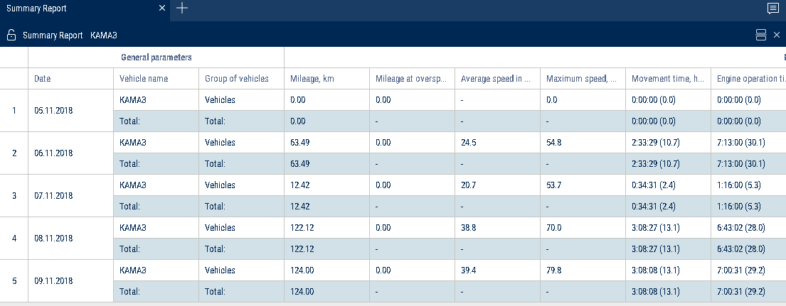

Summary report groups by vehicle and by date.
To set up the report, press the right mouse button and select “Report settings”:
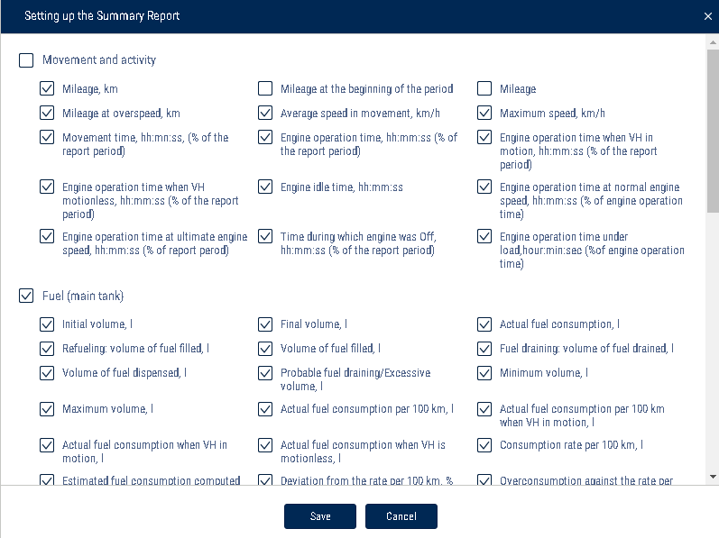
The Summary Report is built for one or several vehicles and includes all parameters of the “Statistics” report, except for the parameters calculated for multiple vehicles and listed below:

In the “Movement and Activity” section:

Use the mileage meter only during the configuration of "Vehicle profile"/ “Setting the initial values for VH monitoring”/"Correct to the mileage":

Mileage at the beginning of the period, km - the mileage calculated as the sum of the initial value of the odometer and the distance to the date of the beginning of the period

Mileage at the end of the period, km - the mileage calculated as the sum of the initial value of the odometer and the distance to the date of the end of the period

- In the “Meter readings (CAN bus data)” section:

CAN odometer reading at the beginning of the period, km - CAN bus odometer reading at the beginning of the period

CAN odometer reading at the end of the period, km - CAN bus odometer reading at the end of the period

The vehicle fuel saving parameters are displayed in accordance with the established standard.

Shifts report
- Select a VH.
- Please select a period of time for report generation.
- Press “Add report” button and select “Shifts report”.
If, according to the schedule the shift continues on the next calendar day and the selected period does not include this day, the shifts report will include the period up to the end of shift (i.e. the report will include the next day).
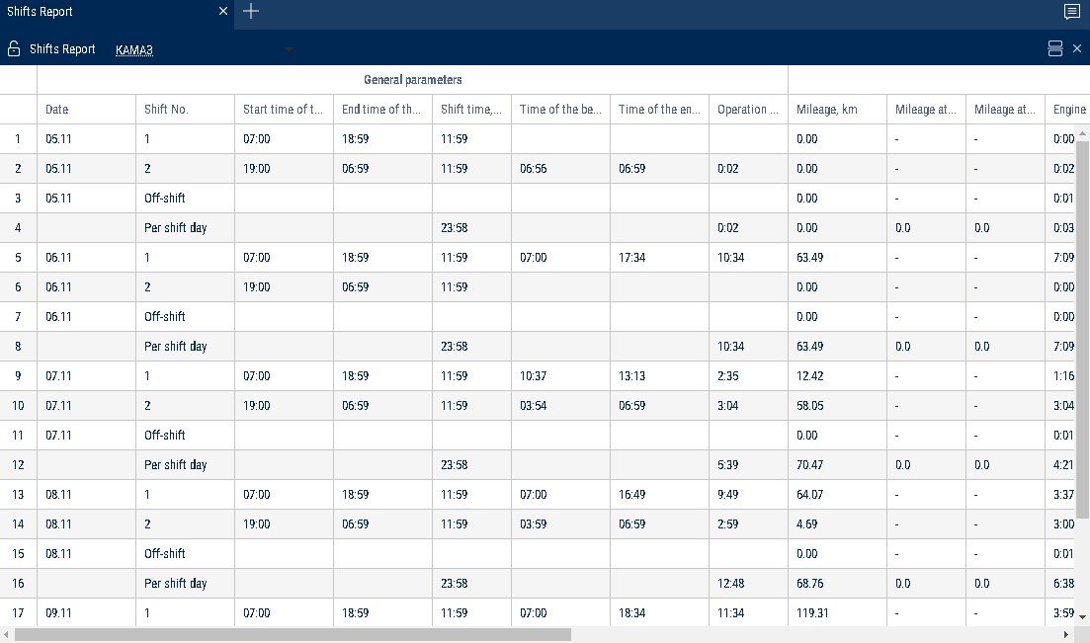

Set up the shifts schedule by pressing the right mouse button and selecting “Shifts setup”. The window will open, in which you will see a line with schedule to be added.
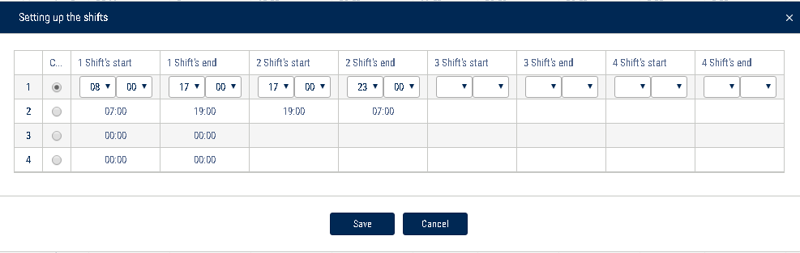

In the fields “Shift 1 start”, “Shift 2 start”, “Shift 3 start”, “Shift 3 start” enter the time in hh:mm format, from which the start of the first, second, third and fourth shifts will be accounted.

In the fields “Shift 1 end», “Shift 2 end”, “Shift end 4” enter the time in hh:mm format starting from which the end of shift will be accounted.
In column “Current” select the checkbox. Press “Save” button.
The shifts report can be different from the report for a vehicle for a day as the shifts report is generated for shifts day according to the set shifts schedule and the report for a vehicle for the selected period from 00-00 to 23-00.
To set up the report, press the right mouse button and select “Report settings”:
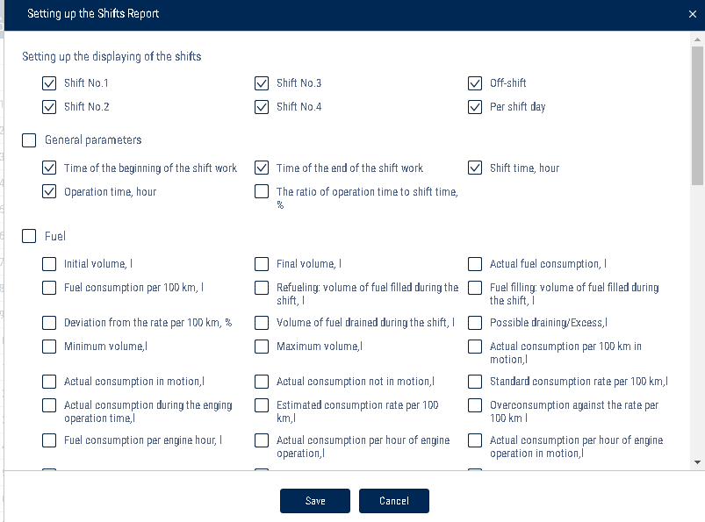
The report contains the following information:
Date is a day/month for which the report is generated.
Shift number is a number of shift according to the schedule.
Time of shift start, (hh:mm) is time of shift start according to the shifts schedule.
End time of the shift, (hh:mm) is time of the shift end according to the shifts schedule.
Start time of the shift work is an actual shift start which is determined by the first iginition switch during the shift.
End time of the shift work is an actual end of shift which is determined by the last switching on of ignition during the shift.
Initial volume, (l) is a volume of fuel at the start of the shift. Final volume, (l) is a volume of fuel at the end of shift.
Actual consumption, (l) is an actual consumption of fuel during the shift. Consumption per 100 km, (l) is an average consumption of fuel per 100 km. Fuel volume refueled per shift, (l) is a volume of fuel refueled during the shift. Fuel volume drained, (l) is a volume of fuel drains during the shift.
Overconsumption against the rate per 100 km, (l) is a difference between actual consumption and consumption against the rate per 100 km. The value can be negative.
Consumption per one hour of engine operation, (l) is consumption of fuel calculated in accordance with engine operation per shift.
Deviation from the rate per engine hour, (%) is a difference between the actual and rated fuel consumption per hour of engine operation during the shift.
Overconsumption against the rate per hour of engine operation, (l) is a difference
between an actual consumption and rated consumption per hour of engine operation during the shift: “overconsumption against the rate per engine hour” = “actual consumption” - “rated consumption per engine hour”. The value can take negative values
Deviation against the rate per 100 km, (l) is a difference between actual consumption and rated consumption per 100 km.
Mileage, (km) is a VH mileage per shift.
Time of engine operation, (hh:mm:ss) is a number of engine operation hours per shift.
Movement time, (hh:mm:ss) – is time of movement per shift which is calculated based on conditions: revolutions level is over 10 rev/min, speed is over 2 km/h and ignition is ON.
Engine OFF time, (hh:mm:ss)
Engine operation time under load, (hh:mm:ss) is time per shift during which the level of engine revolutions was higher than idle revolutions level and lower than engine RPM level limit which are set in the VH profile.
Average speed in movement, (km/h) is an average VH motion speed during the shift.

CAN odometer reading at the beginning of the period, km - CAN bus odometer reading at the beginning of the period

CAN odometer reading at the end of the period, km - CAN bus odometer reading at the end of the period

Use the mileage meter only during the configuration of "Vehicle profile"/ “Setting the initial values for VH monitoring”/"Correct to the mileage":

Mileage at the beginning of the period, km - the mileage calculated as the sum of the initial value of the odometer and the distance to the date of the beginning of the period

Mileage at the end of the period, km - the mileage calculated as the sum of the initial value of the odometer and the distance to the date of the end of the period

Work

Engine revolutions
- Select a VH.

- Please select a period of time for report generation.

- Press the button “Add report” and select “Engine revolutions”.

In the program window the report on VH engine revolutions will display.
If a period between neighboring events recorded in the register is shorter than 8 minutes, ignition turn-off won't be displayed on the revolutions diagram.

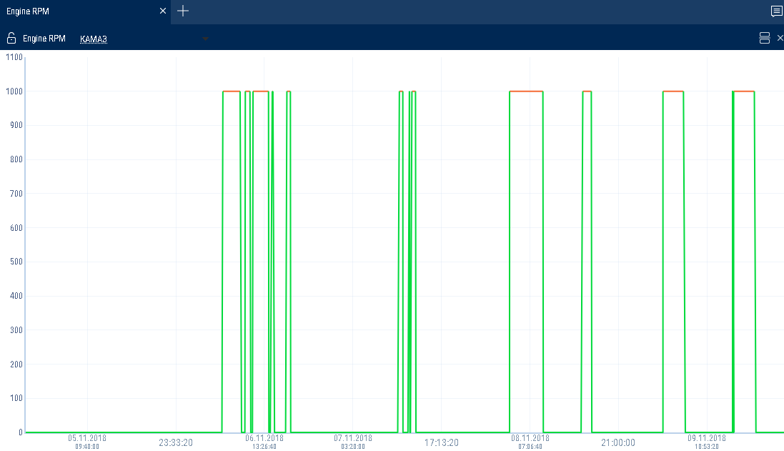

The following color designations are used in the report:
Green diagram means level of idle revolutions of the VH engine. The level of idle revolutions shall be set in the VH profile.
Yellow diagram means normal load, level of engine revolutions is greater than level idle revolutions and less than level of ultimate revolutions. The level of idle revolutions and engine RPM level limit shall be set in the VH profile.
Red diagram means ultimate load, level of revolutions greater than ultimate engine speed. The engine RPM level limit is set in the VH profile. If necessary, increase the diagram scale. Select a part of the diagram, which shall be increased pressing the left mouse button continuously.
To return to the original diagram scale, refresh the report.
To display a pop-up tip with an accurate value of engine RPM select a required spot in the diagram.
Revolutions values from 0.0 to 1.0 mean there is no connection to revolutions sensor, please contact specialists who installed on-board equipment. In case the values exceed 10 000 RPM, contact the specialists who installed on-board equipment, in order to get the “Correction coefficient of revolutions sensor” corrected.

Onboard voltage
- Select a VH.

- Please select a period of time for report generation.

- Press the button “Add report” and select “Onboard voltage”.

In the program window the report with data on onboard voltage of VH for the selected period will open.
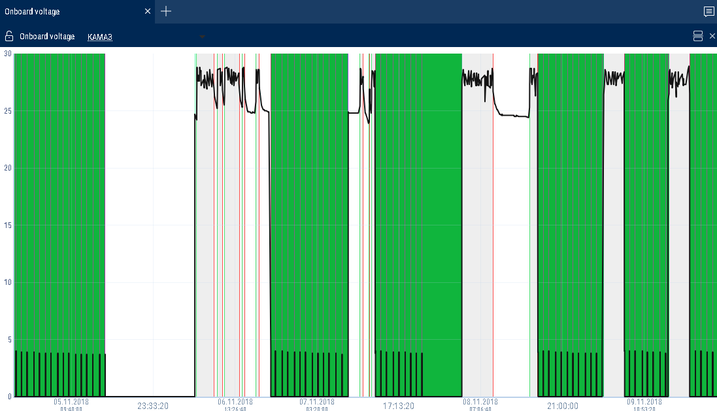

Press the icon and select the information to be displayed:

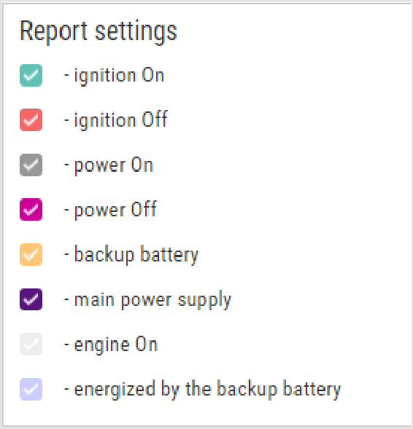

If time between the neighboring events is greater than the double value of data collection timer, the value of power voltage for this period shall be displayed equal to zero.
To display a pop-up tip with an accurate value of VH on-board network voltage select a required spot in the diagram with the mouse pointer.

Auxiliary equipment operation
One report can display up to four diagrams on operation of auxiliary equipment (for Omnicomm Profi Terminals).

- Select a VH.

- Please select a period of time for report generation.

- Press the button “Add report” and select “Auxiliary equipment”.

In the program window the report on operation of additional equipment will display.
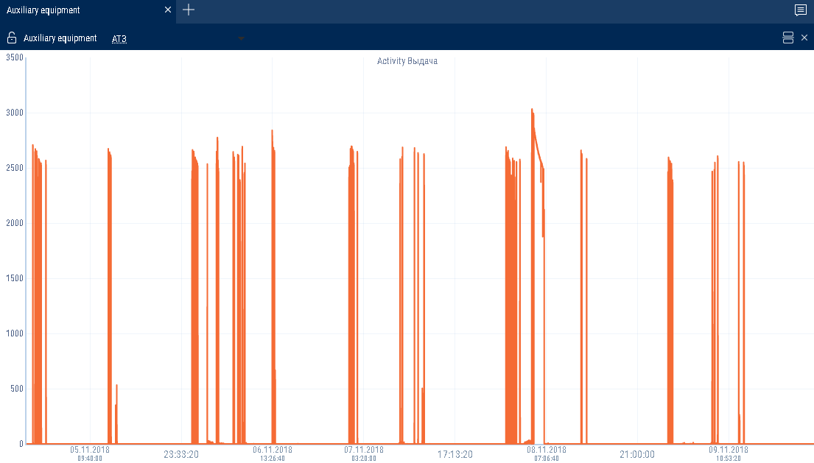

The following color designations are used in the report:

Red diagram means value higher than the ultimate value set in the VH profile.

Green diagram means that the value does not exceed ultimate value set in the VH profile.

To display a pop-up tip with an accurate value of fuel volume select a required spot in the diagram with a mouse pointer.
Refrigerator state
1.Select a VH.

2.Please select a period of time for report generation.

- Press the button “Add report” and select “Refrigerator state”.
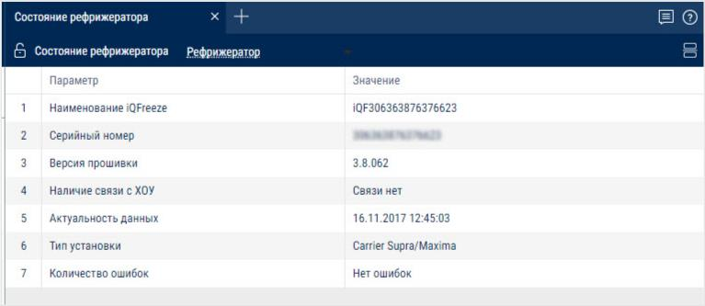
In the program window the report on operation of refrigerator state will display.

The report contains the following information:

iQFreeze name – iQFreeze name in the Bluetooth network

Serial number – iQFreeze serial number

Firmware version – iQFreeze firmware version

Connection with CHU – availability of connection with cooling and heating unit. Possible options: "No connection", "Connection available"

Relevance of data – the date and time of raw data received from iQFreeze

Unit type – CHU type. Possible options: ThermoKing SLX, Carrier Supra/Maxima, Zanotti, ThermalMaster 5100/8100, Carrier Vector 1850

Unit serial number – CHU serial number

Number of errors – number of CHU errors

CHU temperature – actual temperature in the CHU section. Possible values: from -128.00 to +128.00

Set-point temperature – set-point temperature in the CHU section. Possible values: from -128.00 to +128.00

CHU temperature section 2 (3) – actual temperature in section 2 (3). Possible values: from -128.00 to +128.00

Set-point temperature section 2 (3) – set-point temperature in section 2 (3). Possible values: from -128.00 to +128.00

Door status – status of the CHU door. Possible options: open, closed

Coolant temperature – CHU coolant temperature. Possible values: from -128.00 to +128.00

Engine RPM – status of the CHU engine RPM. Possible options:

stop, low, high

Compressor configuration – configuration of the CHU compressor. Possible options: Start/Stop, Continuous

System status – CHU system status. Possible options: stop, heating, cooling, defrosting

Battery voltage – CHU battery voltage. Possible values: from 0.00 to +99.00

Ambient air temperature – CHU ambient air temperature. Possible values: from -128.00 to +128.00

Engine hours – Engine hours of CHU from the engine. Possible values: from 0.00 to 1000000.00

Refrigerator work
1.Select a VH.

2.Please select a period of time for report generation.

3.Press the button “Add report” and select “Refrigerator work”.

In the program window the report on operation of refrigerator work will display.

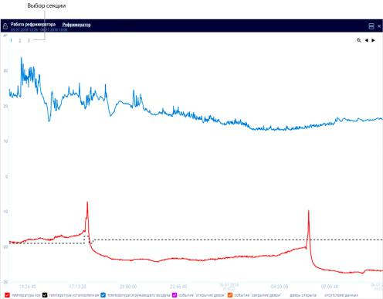

Select the information to display in the legend:

To build graphs with divisions into sections, click the right button and select “Analyze by section”.

Pressure in tyres
1.Select a VH.

2.Please select a period of time for report generation.

3.Press the button “Add report” and select “Pressure in tyres”.

In the program window the report on operation of pressure in tyres will display.
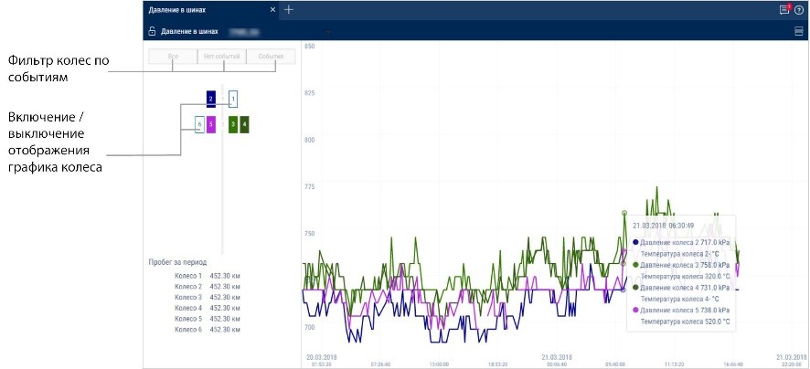
Filter wheels by events
Display/hide the wheel graph
To display the mileage of each wheel for the period, right-click and select "Show mileage".

Events and violations

Violations
- Select a driver or vehicle.

- Select a period of time.

- Press the “Add report” button and select “Violations”.
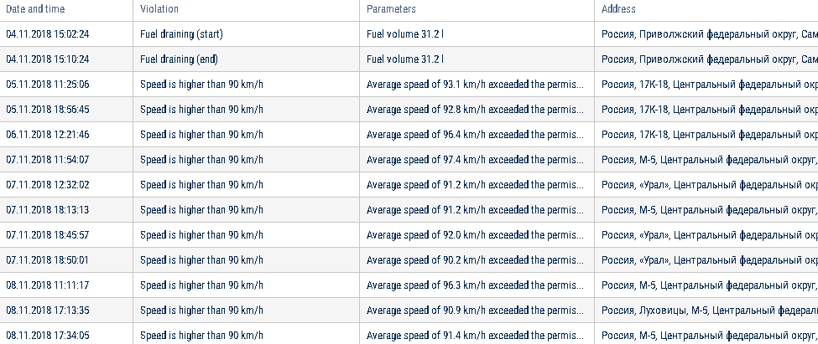
For vehicles equipped with video recording terminals:

The video is available for viewing. Click on the icon to watch the video.

The video can be requested.

Video requesting in progress.

Select information to be displayed in the report by pressing the right mouse button and choosing “Report settings”:

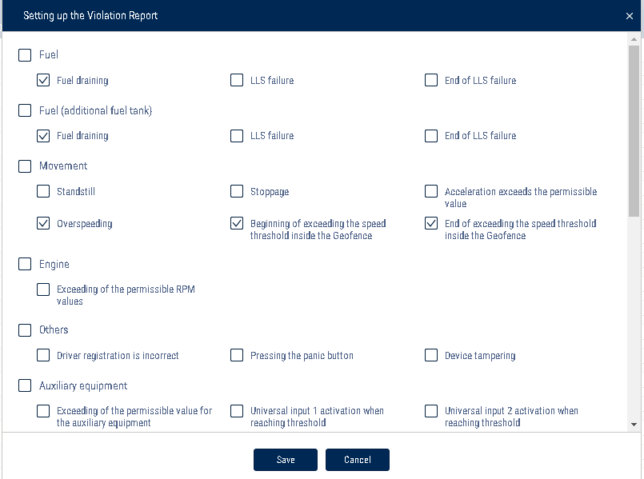

In the sections “Fuel” and “Fuel (additional tank)”:
- Drain is a volume of drained fuel exceeding value “Fuel draining threshold” set up in the VH profile.
- Fuel level sensor failure is a date and time of start of LLS liquid level sensor failure.
- End of fuel level sensor failure is a date and time of LLS liquid level sensor failure. In the “Movement” section:
- Standstill is a standstill over quantity of minutes set in the VH profile. Standstill shall be recorded upon the following conditions: ignition is ON and speed is less than 2 km/h.
- Stoppage shall be recorded upon the following conditions: ignition ON and speed is less than 2 km/h. The address shall not be recorded for stoppages.
- Acceleration exceeds allowed one — excession of the maximum allowed acceleration set in the VH profile.
- Exceeding speed limit is exceeding maximum allowed speed set in the VH profile.
- Start of speed limit excess in geofence is date and time of start of the allowable speed exceed when the VH is in the geofence.
- End of speed limit excess in geofence is date and time of speed limit excess, when
the VH is in the geofence.
In the section “Engine”:
- Exceeding of the permissible RPM value means exceeding of maximum allowed level of engine RPMs set in the VH profile.
In section “Other”:
- Incorrect registration of a driver is an application of the I-Button with the identification number not registered in Omnicomm Online or application of the I- Button with the identification number registered for a driver, which has a “Fired” status in Omnicomm Online.
- Device tampering is actuation of a device-tampering sensor (only for Omnicomm Profi 2.0 Terminal).
- Pressing panic button is actuation of the panic button.
In the section “Auxiliary equipment”:
- Exceeding allowed value for auxiliary equipment set in the VH profile.
- Actuation of UI1 in discrete mode is control over actuation of universal input No. 1 of discrete type taking in account VH speed. In case there is no actuation, a violation will be recorded.
- Actuation of UI2 in discrete mode is control over actuation of universal input No. 2 of discrete type taking in account VH speed. In case there is no actuation, a violation will be recorded.
In section “Routes”:
- Beginning of the trip is a deviation from the planned start of the trip, if the planned time of the trip start is set in the settings.
- Visiting the control points is deviation from planned visiting of the control points, if the planned time of visiting is given in settings of the control points and control of control points visiting is ON.
- Overriding route borders — exiting geofence limiting the route
- Trip completion — deviations on trip completion : deviation from trip completed to scheduled trip completion, completion of trip upon maximum allowed duration of trip control, the trip did not take place, the trip was forced to be completed.
- In the "Safe driving" section:

- Movement with lights off

- Movement with unfastened seatbelts

- Exceeding of maximum speed limit

- Exceeding of allowed speed limit

- Short-term exceeding of maximum speed limit

- Short-term exceeding of allowable speed limit

- Positive acceleration threshold exceeding

- Negative acceleration threshold exceeding

- Lateral acceleration threshold exceeding

- Vertical acceleration threshold exceeding

- Allowed turning speed exceeding

- Maximum turning speed exceeding

- Traffic violation Overspeeding

- Long idling

- Movement with cold engine

- Movement with overheated engine

- Low engine speed movement

- High engine speed movement

- No valid GPS data

- A description of data sources for safe driving parameters is provided in Omnicomm Online. Administration Guide. "Bad habits" section.

- “Display event addresses” - check the box to display the address where the violation was recorded.

- “Duration threshold” - enter the time period for which it is allowed to exceed the maximum allowable or the maximum speed, without a violation being recorded.

- Duration threshold is used for the following events:

- Speed threshold exceeded briefly

- Exceeding of maximum speed limit

- Exceeding of allowed speed limit

- Short-term exceeding of maximum speed limit

- Short-term exceeding of allowable speed limit

- Traffic violation Overspeeding

The report contains the following information:
- Vehicle means a registration number or a unique vehicle name.
- Date and time are date and time when Omnicomm Online has identified a violation.
- Violation is one of violations selected to be displayed in the report.
- Parameters mean a parameter typical for a particular type of violation. For example, in

case of discharge is a volume of fuel and time during which the discharge took place.
- Address is a address at which Omnicomm Online has identified a violation.

In the "Address Display Settings" section, select:

Display the address - turn on to display the address of the current vehicle location

All - turn on to display the complete vehicle address

Abbreviations - turn on to abbreviate address parameters (such as st., ave.)

Select the parameters to display in the address:

Country

Region

City/town

Street

Building

Zip code

Events
- Select an object.
- Please select a period of time for report generation. 3.Open “Reports” tab and select “Events”.

For vehicles equipped with video recording terminals:

The video is available for viewing. Click on the icon to watch the video.

The video can be requested.

Video requesting in progress.

In the program window a report on the object events for the selected period will be displayed:
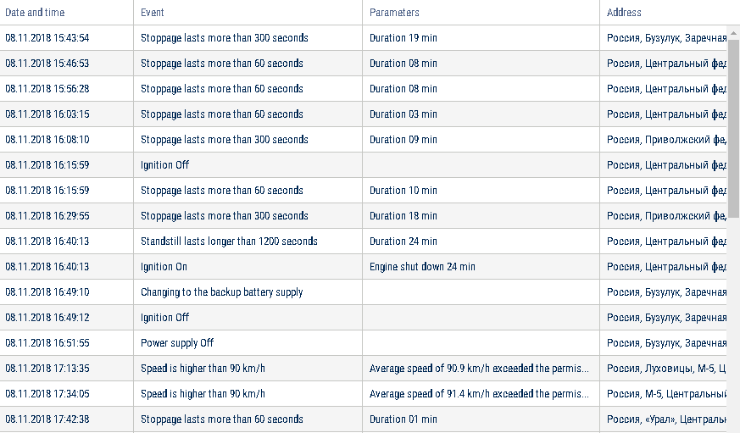
Select information to be displayed in the report by pressing the right mouse button and choosing “Report settings”:

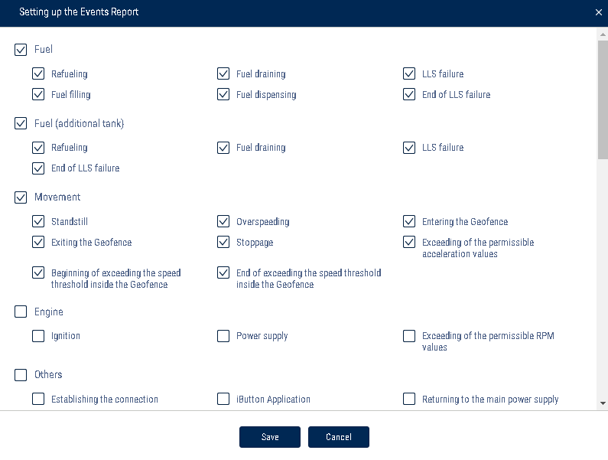

This report contains the following information: The section “Fuel” and “Fuel (additional tank)”:
- Start/end date and time of refueling
- Volume of fuel refueled, (l)
- Start/end date and time of fuel filling, (l)
- Volume of filled fuel, (l)
- Start/end date and time of drain
- Volume of drained fuel, (l)
- Volume of dispensed fuel, (l)
- Fuel level sensor failure
- End of fuel level sensor failure “Movement” section:
- Standstill is a standstill over quantity of minutes set in the VH profile. A standstill is recorded, if the following conditions are met: ignition is turned off, speed is less than 2 km/h, time from the moment of ignition turn-off has exceeded value “Standstills threshold” set in the VH profile.

- “Date and time” displays date and time of standstill end, i.e. “Standstill over” shall be recorded only after the standstill end.
- Speed higher than the value, set in the VH profile, (km/h)
- Entering geofence
- Exiting geofence
- Beginning of speed exceeding threshold in geofence Switching on control over speed exceeding in geofence and setting-up value of allowed speed shall be performed in the geofence profile.
- End of speed exceeding threshold in geofence.
- Stoppage shall be recorded upon the following conditions: ignition ON and speed is less than 2 km/h, the address shall not be recorded for stoppages.
- “Date and time” displays date and time of stoppage end, i.e. “Stoppage” shall be recorded only after the stoppage end.
- Exceeding acceleration, set up in the VH profile
“Engine” section.
- Date and time of ignition switching on/switching off.
- Time during which the ignition was off. Duration of the ignition off time shall be calculated from the moment of ignition turning off to the moment of ignition switching on.
- Permissible revolutions exceeding set up in the VH profile
“Other” section:
- “Connection“ displays date and time of the Terminal connection with the communication server.
- Alarm button pushing.
- Driver registration Driver assignment shall be performed with a single I-Button key, with identification number registered on Omnicomm Online to I-Button reader or when assigning a driver to a VH. In case of application of the I-Button key with the same identification number Driver registration event will not be recorded.
- I-Button application The event is recorded upon application of the I-Button key with identification number registered on Omnicomm Online. If identification number of I- Button is not registered on Omnicomm Online, the event shall be highlighted in pink.
- Completion of the driver assignment Completion of registration shall be performed upon application of I-Button key with identification number registered on Omnicomm Online and not corresponding with the previous one, or upon driver deassignment from the VH.
- Device opening.

- Main power supply restoration.
- Switching to supply from backup battery (Omnicomm Profi terminals only)
“Auxiliary equipment” section.
- Date and time of switching on/auxiliary equipment switching off.
- Exceeding allowed value for auxiliary equipment.
- Exiting zone of allowable limit excess for auxiliary equipment.
Adress at which the event took place, if address display was switched on during setup. If an identification number of I-Button key does not belong to any of drivers created on Omnicomm Online, or a driver was discharged, in the line highlighted pink “Driver registration” will be displayed. Driver is unknown”. Contact Omnicomm Online to edit a profile of a Driver who owns an I-Button key (see “Omnicomm Online Administrator”).
The "Routes" section:

Going beyond the route boundaries

Start of the trip

Visiting control points

End of the trip

The “iQFreeze” section:

Changing the set-point temperature

Door closing

Switching to increased rpm

Changing the refrigerator operating mode

Setting the predetermined temperature

The temperature is outside of the tolerance range

Switching to reduced rpm

Data transfer interruption

Door opening

The temperature is back within the tolerance range

Reefer operation error

The “TPMS” section:

Pressure drop in the tire

Temperature rise in the tire

Possible axis geometry violation

Pressure rise in the tire

Temperature normalized in the tire

No data from the Tire Pressure Monitoring System

Pressure restored

Sudden loss of pressure

The “Safe Driving” section:

Movement with lights off

Exceeding of allowed speed limit

Positive acceleration threshold exceeding

Vertical acceleration threshold exceeding

Traffic violation Overspeeding

Movement with overheated engine

No valid GPS data

Movement with unfastened seatbelts

Short-term exceeding of maximum speed limit

Negative acceleration threshold exceeding

Allowed turning speed exceeding

Long idling

Low engine speed movement

Exceeding of maximum speed limit

Short-term exceeding of allowable speed limit

Lateral acceleration threshold exceeding

Maximum turning speed exceeding

Movement with cold engine

High engine speed movement

A description of data sources for safe driving parameters is provided in Omnicomm Online. Administration Guide. "Bad habits" section.

In the "Address Display Settings" section, select:

Display the address - turn on to display the address of the current vehicle location

All - turn on to display the complete vehicle address

Abbreviations - turn on to abbreviate address parameters (such as st., ave.)

Select the parameters to display in the address:

Country

Region

City/town

Street

Building

Zip code
Driving analysis
The “Driving Behavior Analysis” report displays exclusively the violations that were recorded in accordance with the list of bad habits, see the Omnicomm Online. Administration Guide. "Bad habits" section. In order to display a violation, all the conditions of a bad habit must be recorded simultaneously (event, weather conditions, time of the day).

- Select drivers, vehicles or geofences

- Select a time period

- Press the “Add report” button and select “Driving Behavior Analysis”

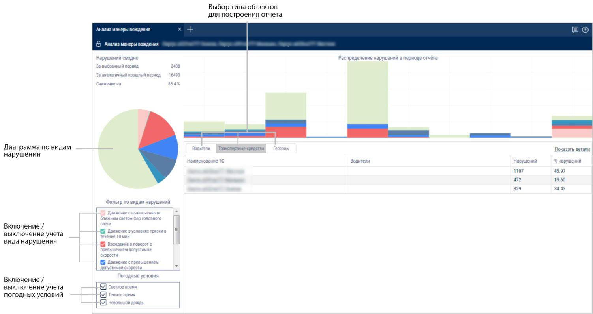

The graph shows the trends in drivers’ violations by points over time.

The circular diagram shows the distribution of violations by type.

The table report contains the following data:

Driver – details of the driver registered on the vehicle

Vehicle name – name of the vehicle

Omnicomm Online 81

Отчеты

Geofence – name of the geofence, where the violation has been registered

Violations – number of registered violations during the period

% – percentage of total points for violations of all objects over the selected time period

Points - the number of points corresponding to each violation according to the bad habits settings

To display habits, for which violations have been registered, click on Show details.
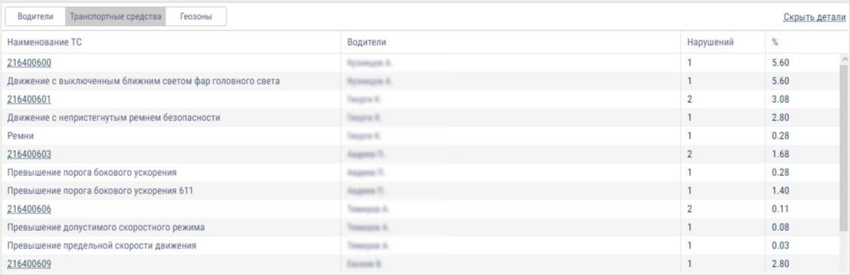

To display a report for an individual object, double-click on the vehicle name, driver or geofence. A report on the selected object will open:
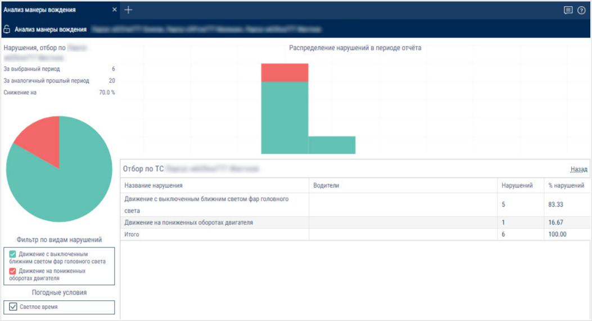

To return to the list of objects, click “Back”.

To save the report to a file, right-click and select "Export to .xls".
Other
Current state
1. Select the vehicles

2. Press the “Add report” button and from the “Reports” list select "Current status"
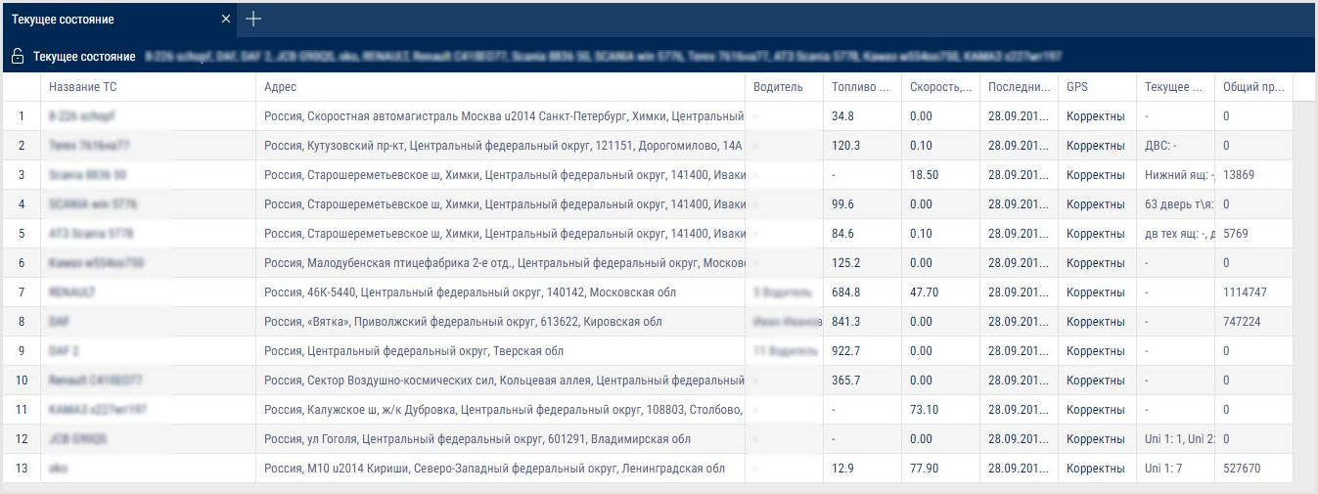

The report contains the following information:

Vehicle name

Address - address of the last identified vehicle location

Driver

Fuel main/add. – fuel volume in the main and additional tanks

Speen - current speed

Latest data

GPS - validity of the GPS data. Possible options: Correct, GPS data not available

Current auxiliary equipment readings

Total mileage as per CAN, km

The address format can be set up in the object tree (see. Object tree settings).
Geofences
- Select a vehicle or geofence.
- Please select a period of time for report generation.
3.Press button “Add report” and select “Geofence visiting”.
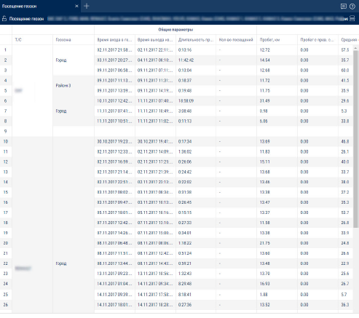
To select the information displayed in the report, right-click and select "Report settings":

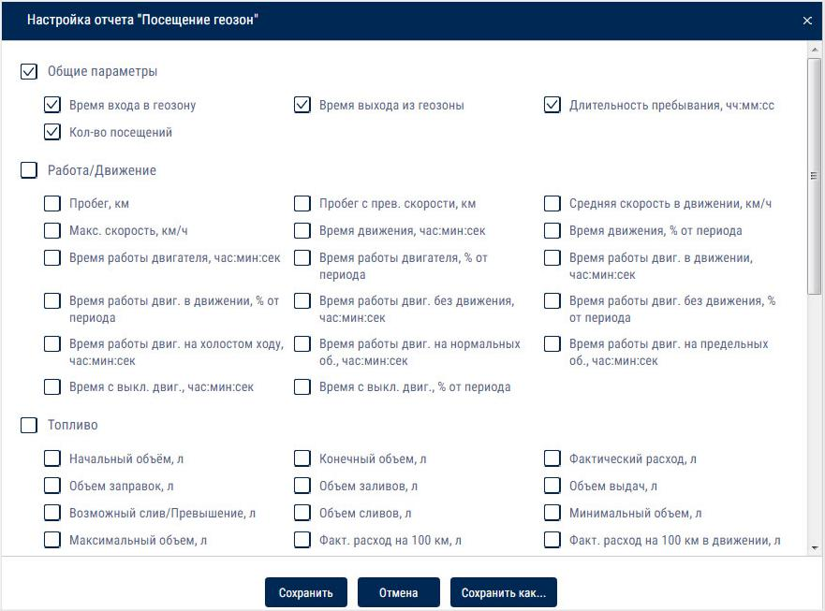

“Total values only” - if enabled, only the total values of parameters will be displayed in the report. The times of entering and leaving the geofence will not be displayed.

"Group by the second column" - enables grouping by geofence name. When grouping by the second column is disabled, the items are grouped by the time of entering a geofence

"Movement outside of geofences" - enables displaying vehicle movement parameters outside of geofences

Right-click the mouse to enable the display of parameters outside geofences and additional grouping by geofences:

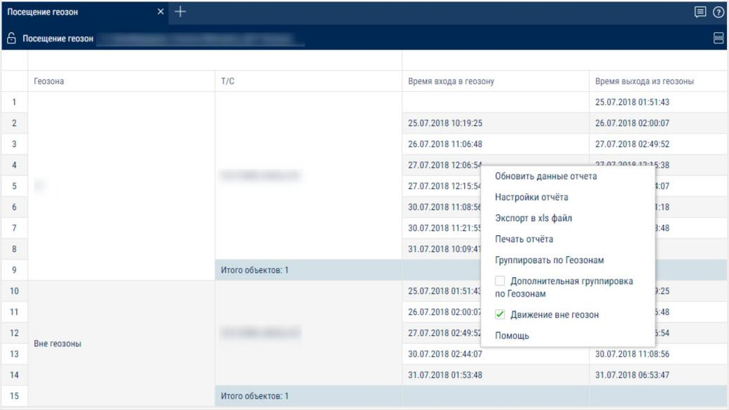

This report contains the following information on the VH:
- VH name is a registration number of name the VH.
- Geofence is a geofence name.
- Time of entrace to geofence is date and time of entrace to thegeofence ddmmyyyy hh:mm
- Time of exit from the geofence is date and time of exit from the geofence of
ddmmyyyy hh:mm
- Duration of stay is time during which the VH was in the geofence, hh:mm
- Number of visits is a number VH geofence entries within the selected period of time
- Mileage, km is a mileage of the VH in the geofence
- Speeding mileage, km is a VH speeding mileage in the geofence
- Average speed in movement, (km/h) is an average VH motion speed in the geofence
- Movement time is time during which the VH was moving in the geofence, hh:mm:ss
- Downtime is time during which the VH's downtime was identified when the VH was in the geofence, hh:mm:ss
- Downtime, (hh: mm: ss) is time within a period which will be calculated using a formula:
“Downtime” = “time of operation under rated load” – “idle time within period” – “overultimate load time”
- General consumption, l is general consumption of the VH when the VH is in the geofence
- Volume of refuellings, l is a volume of fuel refuelled when the VH is in the geofence
- Fuel volume drained, l is volume of fuel drained when the VH is in the geofence Calculation of the VH presence in the geofence:
- If at the period the VH was in the geofence, duration of the stay in the geofence shall be calculated from the period start and to the moment of escape from the geofence or end of period depending on which of these events took place earlier. I.e. if a moment of exit from the geofence is earlier than an end of period, the duration shall be calculated from the period start to the moment of exit from the geofence. In “Time of entrance to the geofence” field the dash “-” will be displayed.
- If at the period end the VH was in the geofence, duration of the stay in the geofence shall be calculated from the entry to the geofence or a period start depending on which of these events took place later and till the period end. If the moment of entry to the geofence is later, that the period start, duration of stay shall be calculated from the moment of entry to the geofence to the period end. In the field “Time of entry to the geofence” dash “-” shall be displayed.
- If the period end is greater than the current time, when calculating duration the current time instead of period end shall be used.
- Treated area, ha
- Productivity, ha/hr

- Rated consumption, l/ha

Log
Report “Log” allows review of “raw” data received by Omnicomm Online from the terminals.
- Select a VH.
- Please select a period of time for report generation.
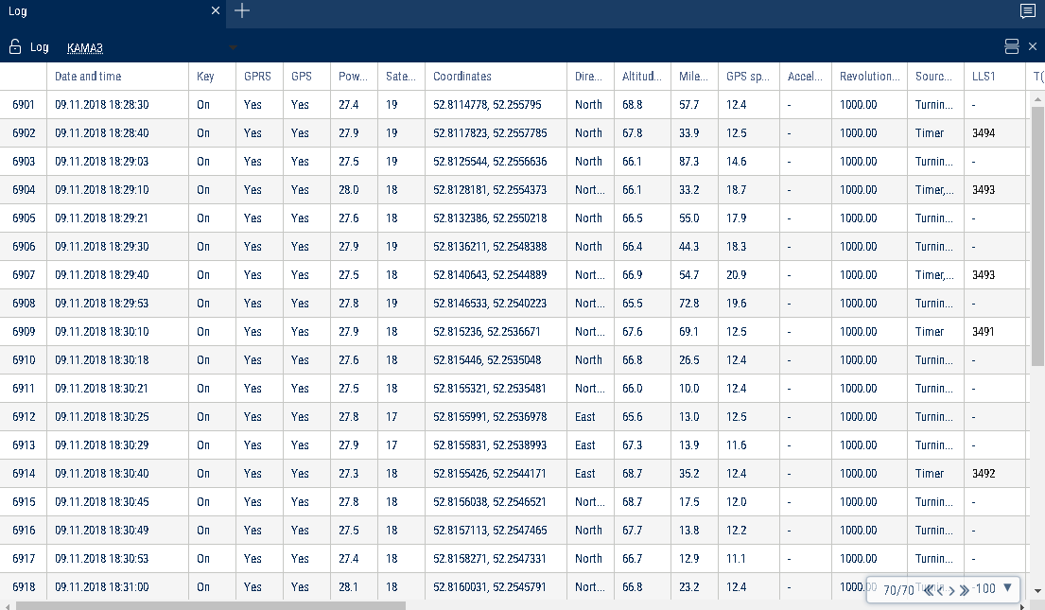
Select information to be displayed in the report by pressing the right mouse button and choosing “Report settings”:
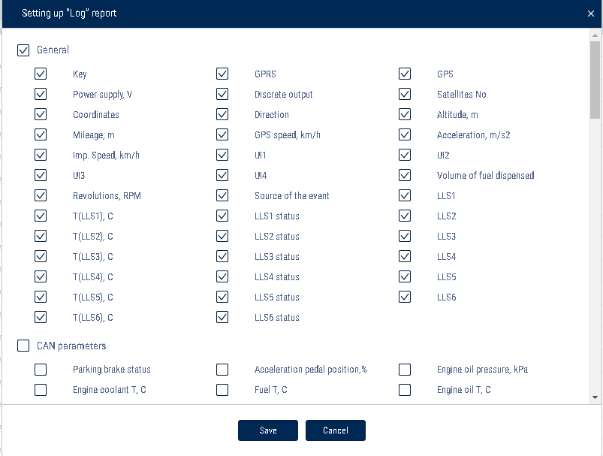
To change a column width select with the mouse pointer a column border and move it holding the left mouse button.
Report contains the following information on the selected vehicle:
- Date and time is date and time of the event.
- Ignition is a state of ignition at the certain moment (On or Off).
- GPRS is presence or absence of GPRS at the given moment.
- GPS is presence or absence of data from GPS at the given moment.
- Number of satellites is a number of satellites based on which GPS data were determined at the given moment.
- Coordinates are coordinates (latitude and longitude) of the vehicle location at the given moment, measured in degrees or message “Connection of on-board equipment” at the moment of connection of the terminal with the Communicaton server. If the number of satellites for coordinates determination is less than 4, coordinates are displayed grey.

- Direction is direction of vehicle motion (N (North); NE (Northeast); E (East); SE (Southeast); S (South); SW (Southwest); W (West); NE (Northwest)).
- Height, (m) is altitude of the VH above the sea level.
- Mileage, (km) is path travelled by the car.
- Speed GPS, (km/h) is VH speed at the given moment determined by GPS.
- Speed pulse is a value of speed in kilometers per hour by the data from the regular meter or read from the CAN-bus depending on the speed input settings on Omnicomm online software.
- Acceleration (m/s2) is a value of VH acceleration.
- Revolutions means level of revolutions per minute by data from tachometer or read from the CAN-bus depending from the settings on Omnicomm Configurator software.
- ON voltage is voltage of VH onboard network (V). For Omnicomm Profi in case of operation from reserve battery, voltage of reserve battery (RB).
- Data on CAN-bus.
- Values from four universal inputs.
- LLS1, LLS2, LLS3, LLS4, LLS5, LLS6 is code from the first to the sixth by LLS fuel level sensor. If there is no calibration table for this sensor, “0” is displayed grey.
- T (LLS1), T (LLS2), T (LLS3), T (LLS4), T (LLS5), T (LLS6) is temperature (C°) output from the first to the sixth sensor of LLS fuel level sensor. If there is no calibration table for the sensor, “0” is displayed grey.
- LLS1 status, LLS2 status, LLS3 status, LLS4 status, LLS5 status, LLS6 status:
- Ready, the sensor is connected and shows correct data
- No, the sensor is not connected or adaptive data collection in the Terminal is on
- Error, the sensor is connected, but shows incorrect data
- Not ready, the sensor is ready, but power supply to the sensor started less than 15 seconds ago
- “Volume of fuel dispensing”, (l) (for fuel tanker only) is volume of fuel dispensed through fuel nozzle.
“The source of event” is condition for creation of an event by the Terminal (turning point, timer)

The "CAN parameters" section:

Parking brake status

Accelerator pedal position, %

Engine oil pressure, kPa

Engine coolant temperature, °C

Fuel temperature, °C

Engine oil temperature, °C

Daily fuel consumption, l

Instantaneous fuel economy, km/l

Engine rpm

Daily mileage, km

Total mileage, km

Total time of engine operation, h

Overall fuel consumption, l

Position of the service brake pedal

Clutch pedal position

Cruise Control status

Axle load, kg

Status of the service brake pedal

Status of the clutch pedal

Mileage before the next maintenance, km

Engine operation time before the next maintenance, h Instantaneous speed, km/h Doors status

Seatbelts status

CAN rpm

OBDII. Mileage after error reset, km

OBDII. Time after error reset, h

OBDII. Fuel level, %

OBDII. VIN ТС

OBDII. Check Engine error

The “iQFreeze” section:

CHU temperature

Refrigerator temperature in section 2

Refrigerator temperature in section 3

Set temperature

Set temperature 2

Set temperature 3

Ambient temperature

Coolant temperature

Engine rpm

Compressor configuration

System status

Door status

Battery voltage

Battery current

Operating hours from the engine

Operating hours from the onboard network

Unit serial number

Trailer serial number

Number of errors

Code of the main error

2nd, 3rd, 4th, 5th, 6th level errors

IQFreeze serial number

IQFreeze firmware version

IQFreeze Bluetooth name

Unit type

Connection to CHU

Digital inputs No.1, No.2

The “Tire Pressure Monitoring” section:

Wheel number: current pressure, kPa

Wheel number: current temperature

Wheel number: wheel sensor connection status

Wheel number: sensor battery charge

Wheel number: reason for sending. Possible values: recurrent sending, air leakage, rapid air leakage, tire re-inflated

The “Safe Driving” section:

Violation source

Speed threshold, km/h

RPM threshold, rpm

Acceleration threshold, m/s²

Lateral acceleration threshold, m/s²

Braking acceleration threshold, m/s²

Vertical acceleration threshold, m/s²

Acceleration along the X-axis, m/s²

Acceleration along the Y-axis, m/s²

Acceleration along the Z-axis, m/s²

Accelerometer status

The "GenComm generators" section:

Oil pressure, kPa

Coolant temperature, °C

Voltage of the charging generator, V

Frequency of the output voltage, Hz

L1, L2, L3 voltage, V

L1-L2, L2-L3, L1-L3 line voltages, V

L1, L2, L3 currents, A

L1, L2, L3 active power, W

L1, L2, L3 total powers, kVA

L1, L2, L3 reactive power, kvar

Power factor

Motor hours

Total energy generated, kW⋅h

Fuel volume, %

Charge current, A

Battery voltage, V

Revolutions, rpm

Diesel status

Status of the diesel-driven generator set

Optional parameters:

FLS PMP-201, Struna+

The "Display of technological operation parameters" section:

“Type of equipment” - select the type of equipment for which to display technological parameters.

Possible options: TG series Grader and WX200, TX210 Excavator.

For the TG series Grader the following parameters are displayed:

ICE. Coolant temperature, °C

ICE. Charge air temperature, °C

ICE. Oil pressure, bar

ICE. Charge air pressure, bar

ICE. Crankshaft rotation speed, rpm

Gearbox. Oil pressure in the lubrication system, bar

Gearbox. Oil pressure in torque converter, bar

Gearbox. Error codes

Gearbox. Oil temperature

Gearbox. Speed, km/h

Gearbox. Number of the current gear

Gearbox. Operating mode

Electrical system. Voltage, V

ICE. Oil temperature, °C

ICE. Fuel rail pressure, bar

ICE. Error codes

Hydraulic system. Oil temperature, °C

Hydraulic system. Oil pressure, bar

To change the width of a column, select the border of the column and drag it while holding the left button of the mouse.

Display parameters as a graph

- Select a column with a parameter

- Right-click and select "Display as a graph"

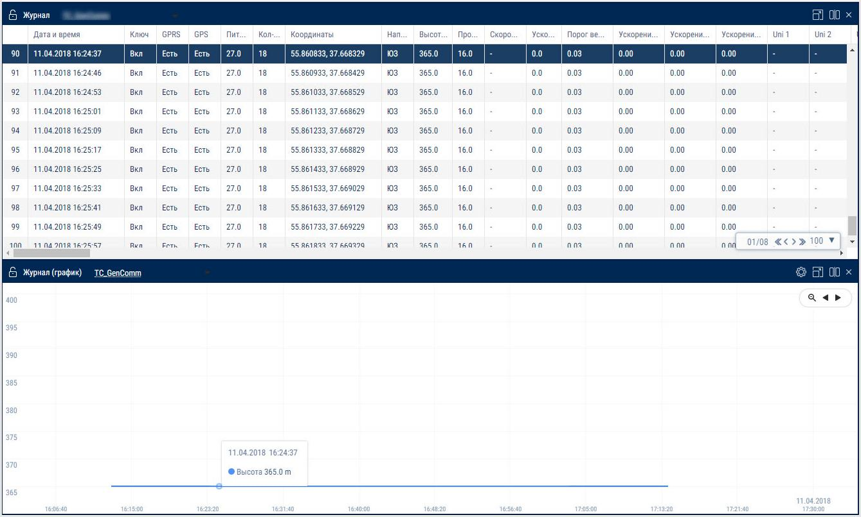

When a point is selected on the graph, the corresponding row in the “Log” report is automatically highlighted.

Hiding rows with parameter values that are equal to zero or missing

- Select a column that contains rows with valid and missing parameter values.

- Right-click and select "Hide rows with empty cells"

- Rows with missing values will be hidden in the report. To show rows again, right-click and select "Reset all filters".

Let's take the column with the parameter "oil pressure in the engine" as an example.

To hide the empty cells:

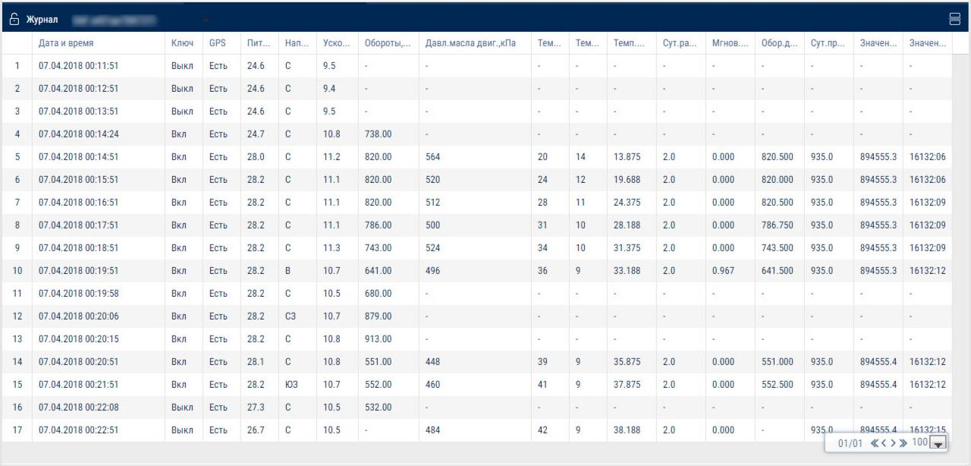

After the empty cells have been hidden:
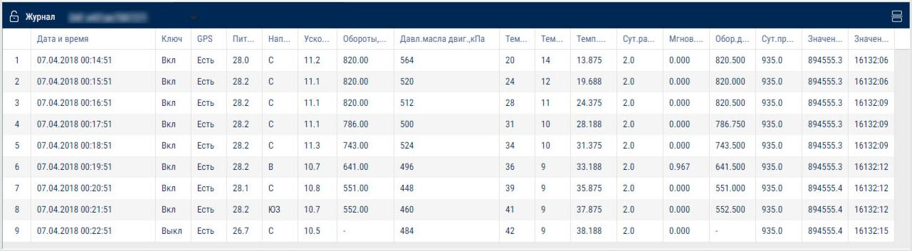

Parameters for which the option of hiding rows does not apply:

Row number

Date and time

Ignition key position

GSM connection

GPS data validity

Digital output status

Event source

Sensor level code

Sensor temperature

Sensor readiness

Coordinates

GPS speed

Pulse speed

Dispensed fuel volume

Power

Battery charge percentage

Direction

Number of satellites

Height

Mileage

UI1...UI4

Drivers registration
- Select a vehicle or a driver.
- Please select a period of time for report generation. 3.Press “Add report button” and select “Driver registration”.
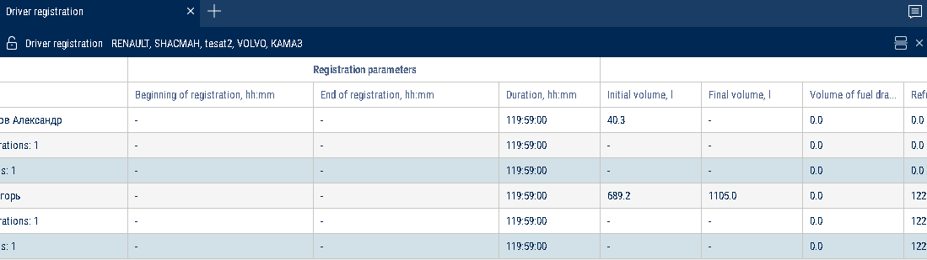
To set up the report, press the right mouse button and select “Report settings”:

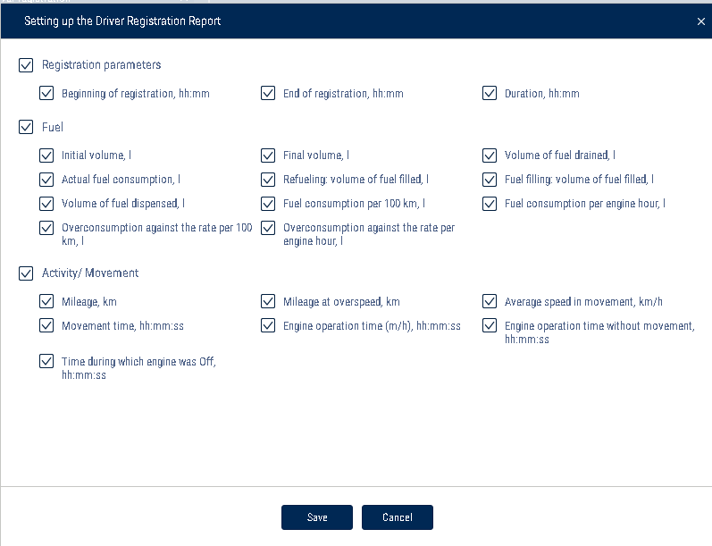

This report contains the following information:
- VH name is a registration number of name the VH.
- Driver, last name and first name of the driver assigned to VH.
- Registration start is date and time of the driver assignment to the VH. If “-” is specified, assignment of the driver to this VH was performed before the selected period of the report generation.
- Deassignment is date and time of the driver deassignment from the VH. If “-” is specified, deassigment of the driver from the VH is scheduled later than end of the selected period of report generation.
- Duration, hh: mm: ss is duration of driver assignment to the VH within the selected period.
- Initial volume, (l)
- Final volume, (l)
- Actual consumption during the period, (l)
- Refuellings volume, (l)
- Fuel volume drained, (l)

- Consumption per 100 km, (l)
Description of the fuel parameters calculation is given in the Appendix.

Task status

- Select the vehicle or the driver

- Select the time period for report generation

- Press the “Add report” button and select “Task status”

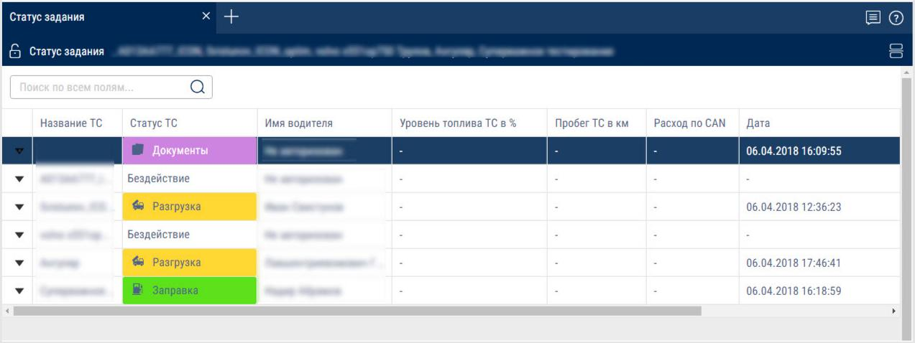

Possible status values:
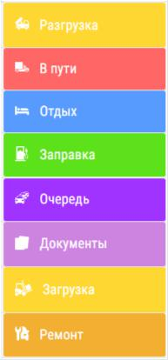

To select the information displayed in the report, right-click and select "Report settings":

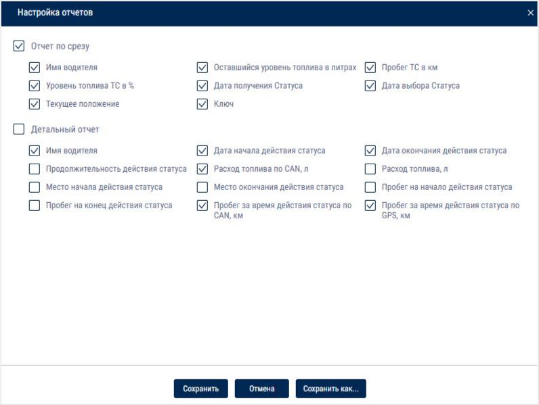

The "Current Report" section - information at the current time:

Driver's name - the name of the driver registered at the identification

Remaining fuel level in liters

Vehicle mileage, km

Fuel level of the vehicle in %

Date the status was received

Date the status was selected

Current position

Key - ignition key status Possible values: on, off

The "Detailed Report" section - information about the statuses for the period of report generation:

Driver's name

Date when the status became effective

Status expiry date

Duration of the status

Fuel consumption per CAN, l

Fuel consumption, l

Location where the status became effective

Status expiry location

Mileage at the beginning of status activation

Mileage at status expiry

Mileage during the period of status activation as per CAN, km

- Mileage during the period of status activation according to GPS, km
To send a message to drivers:

- Select a vehicle

- Right-click and select "Send a message to the driver". Maximum message length: 128 characters.

Adding vehicles to send a message

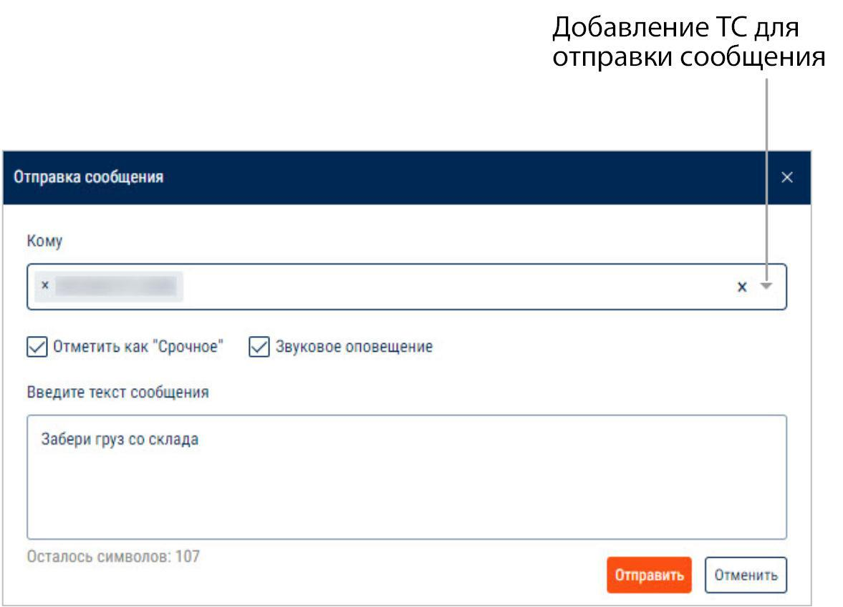

If necessary, you can select multiple vehicles to simultaneously send them the message.

Communication with the driver

- Select the vehicle or the driver

- Select the time period for report generation

- Press the “Add report” button and select “Communication with the driver"

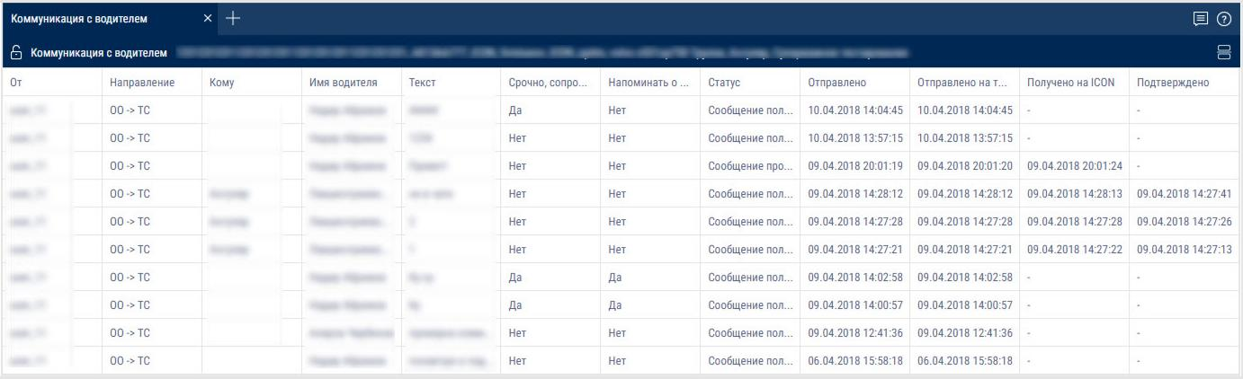

To select the information displayed in the report, right-click and select "Report settings":
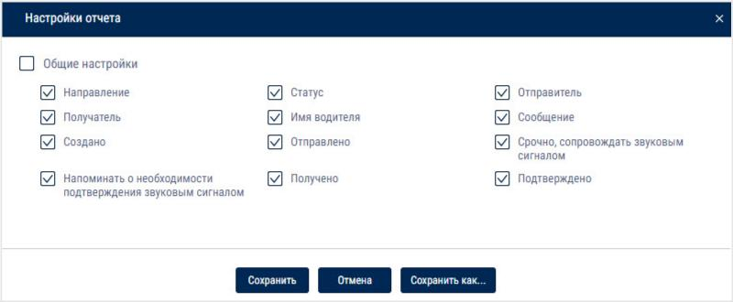

- In the "General Settings" section:

Direction - the direction of the message. Possible options:

From OO to the vehicle - when sending a message from Omnicomm Online to the terminal

From the vehicle to OO - when sending a message from the mobile app to change a status or to send a message to the dispatcher

Status - the status of the message. Possible options:

The message has been read on ICON.

The message has been confirmed on ICON.

The message has not been confirmed on ICON.

Could not find the message on ICON.

The message has been sent to ICON.

The message has been received on ICON.

Sender - name of the user or vehicle, depending on the direction the message was sent in

Recipient - name of the user or vehicle, depending on the direction the message was sent in

Driver's name - the name of the driver registered at the authorization

Message - the text of the message

Created - date and time when the message was created in Omnicomm Online

Sent - date and time when the message was sent to the terminal

Urgent, include a sound signal - play a sound signal when the message arrives

Remind to confirm the message using a sound signal

Received - date and time when the message was received by the terminal and displayed on the Omnicomm ICON display. If the message has not been received, "-" will be displayed.

Confirmed - date and time when the message was confirmed as read on the Omnicomm ICON display. If the message has not been confirmed, "-" will be displayed.

Multimedia
1.Select one or several VH. 2.Select a period of time.
- 3.Press “Add report” button and select “Multimedia”.
Open the "Pictures" and "Video" tab
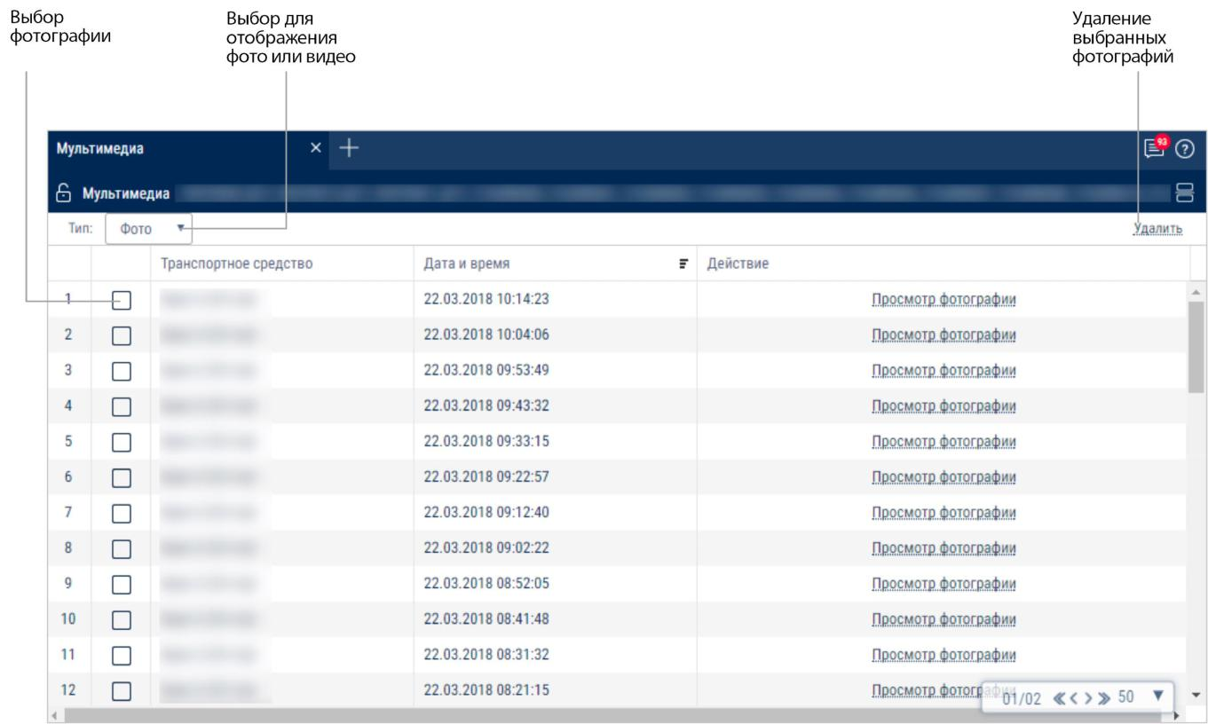

Choosing a picture

Choosing a picture or video to display

Delete selected pictures

When choosing pictures:
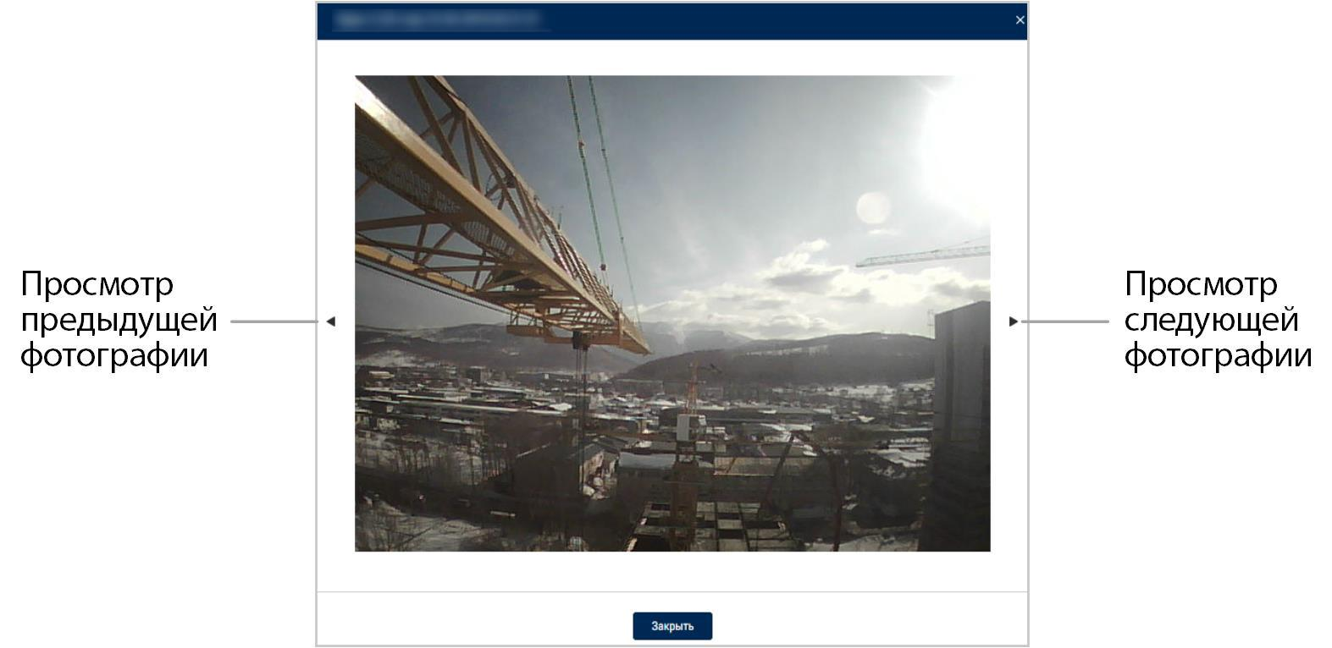

View the previous picture
View the next picture

To save a picture, right-click and select "Save image as".

When choosing videos:
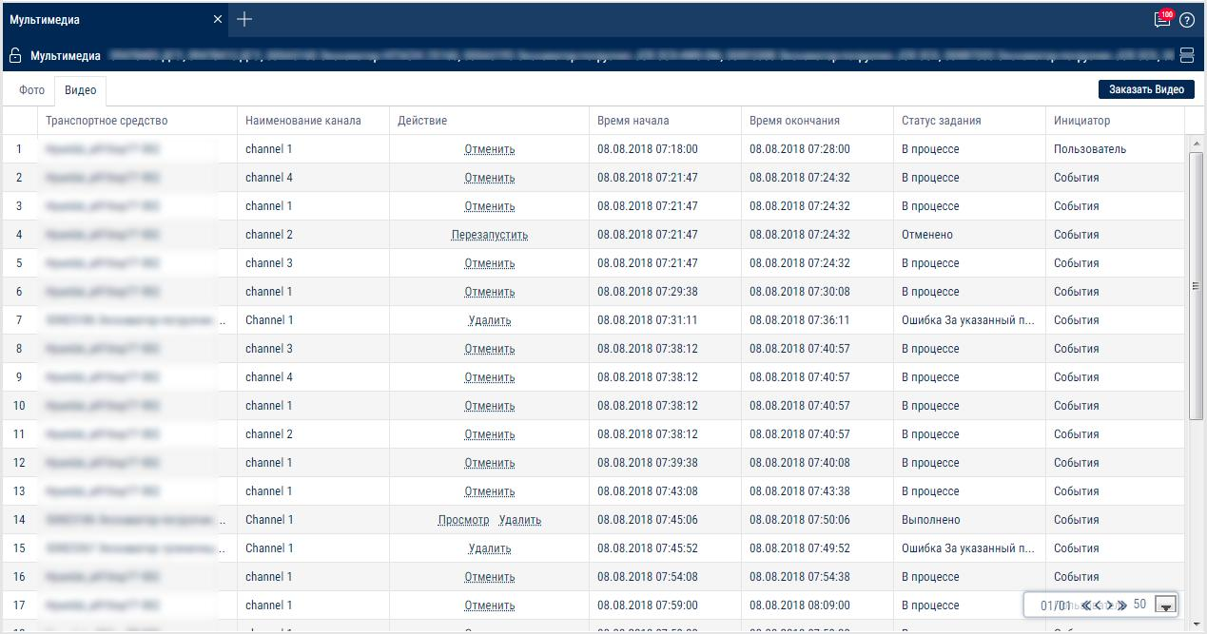

The report contains the following information:

Vehicle - the name of the vehicle

Channel name - the name of the camera with which the video was recorded.

Action - actions that can be performed with the video clip. Possible values:

Watch - play the video

Delete - delete the video

Cancel - cancel video request

Restart - request the video again after canceling or after an error

Video clip start and end time

Task status. Possible values:

Completed - the video has been uploaded to Omnicomm Online

In progress - the video is being uploaded Canceled - the video request has been canceled

Error - an error occurred when processing the video Possible errors:

Task timeout

No video available for the selected period of time

A task with these parameters has been created before

No task request has been found

Conversion error. 5 attempts (video conversion error)

Video terminal not found

Video terminal not available (no connection with the terminal)

Profile settings error

No space on disk (there is not enough space on the disk and the old data deletion option is turned off)

Initiator. Possible values:

User - the video was uploaded upon user request Event - the video upload was triggered by an event

To play the video click "Watch" :

Saving video to PC
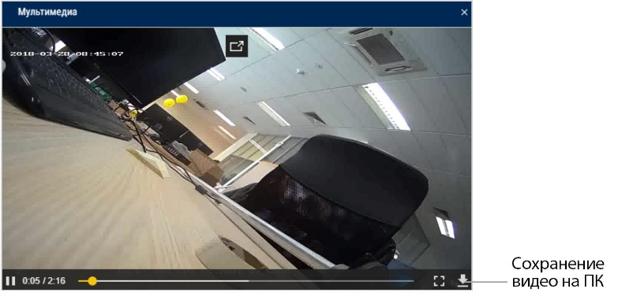

To request video click the "Request video" button. A window will open:

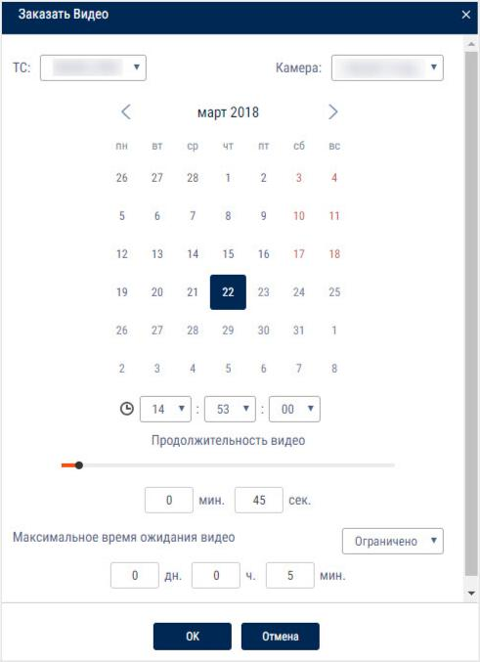

Vehicle - select the vehicle

Camera - select the name of the camera connected to the selected vehicle

Select the date and time of the video clip to upload.

Duration - select the duration of the video clip.

Possible values - from 30 sec to 10 min.

Maximum video waiting time. Possible options:

Limited - specify the time after which the video download task will be automatically canceled

Unlimited - the video downloading task will wait for the execution for an unlimited amount of time

To automatically request a video in Omnicomm Online by event, configure it in the “Administration”/“Rules for automatic creation of a task” section.

Photographs are related to “Track” report. When opening two reports and selecting “Photographs” line of the report the place on the map where the photographs were taken is highlighted automatically and a help message with information on VH is displayed (dates, time, VH speed, address, mileage and state of ignition).
To save a photograph press the right mouse button on the photograph and select “Save image as”.

Group work
- Please select one or several VH or drivers.
- Please select a period of time for report generation. 3.Press “Add report” button and select “Group work”.

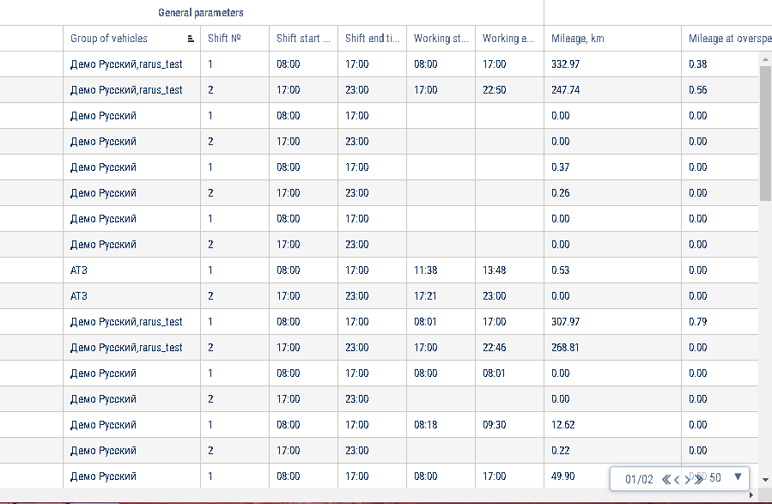

Set up the shifts schedule by pressing the right mouse button and selecting “Shifts setup”. The window will open, in which you will see a line with schedule to be added.
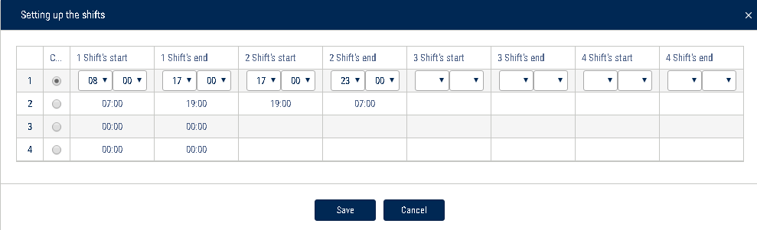
In the fields “Shift 1 start”, “Shift 2 start”, “Shift 3 start”, “Shift 3 start” enter the time in hh:mm format, from which the start of the first, second, third and fourth shifts will be accounted.

In the fields “Shift 1 end», “Shift 2 end”, “Shift end 4” enter the time in hh:mm format starting from which the end of shift will be accounted.
In column “Current” select the checkbox. Press “Save” button.
Select the information to be displayed in the report by pressing the right mouse button and choosing “Report settings”:
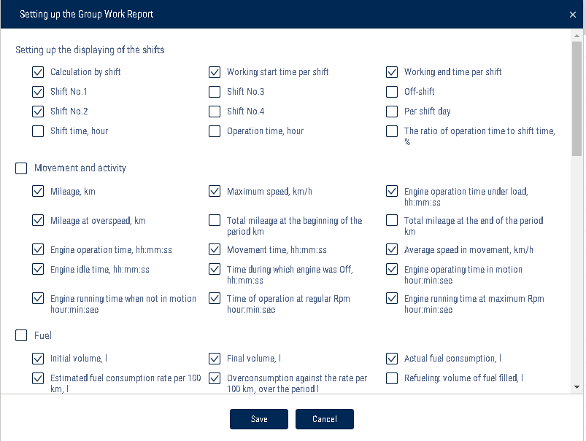

In the "Shift display settings" section:

Payment by shifts

Start of work during a shift

End of work during a shift

Shift no. 1, 2, 3, 4

Off-shift

Per shift day

In the “Movement and Operation” section:

Mileage, km

Mileage with speeding, km

Engine operation time, hh:mm:ss

Time of idle engine operation, hh:mm:ss

Time of engine operation without movement, hh:mm:ss

Maximum speed, km/h

Mileage at the beginning of the period, km

Mileage at the end of the period

Time of movement, hh:mm:ss

Time with engine turned off, hh:mm:ss

Time of engine operation at regular rpm, hh:mm:ss

Time of engine operation under load, hh:mm:ss

Average speed in movement, km/h

Time of engine operation at maximum rpm, hh:mm:ss

In the “Fuel” section (main tank):

Initial volume, l

Final volume, l

Actual consumption, l

Estimated consumption rate per 100 km, l

Overconsumption against the rate per 100 km, l

Refueling volume, l

Draining volume, l

Filling volume, l

Dispensed fuel volume, l

Actual consumption per 100 km, l

Actual consumption per engine hour, l

Actual consumption per hour of engine operation, l

Overconsumption against the rate per 1 hour of engine operation, l

Actual consumption per hour of engine operation in movement, l

Actual consumption per hour of engine operation without movement, l

Possible draining / Excess, l

Minimum volume, l

Maximum volume, l

Actual consumption per 100 km in movement, l

Actual consumption in movement, l

Actual consumption without movement, l

Consumption norm per 100 km, l

Deviation from the norm per 100 km, l

Actual consumption during the time of engine operation, l

Consumption norm per hour of engine operation

Estimated consumption as per norm per hour of engine operation, l

Deviation from the norm per hour of engine operation, %

In the “Fuel” section (auxiliary tank):

Initial volume, l

Final volume, l

Actual consumption, l

Refueling volume, l

Draining volume, l

Minimum volume, l

Максимальный объем, л

Фактический расход на 100 км, л

Maximum volume, l

Actual consumption per 100 km, l

- In the “Auxiliary Equipment work” section:

Maximum value during the period

Minimum value during the period

Total value during the period

Mileage with auxiliary equipment in operation, km

Time of operation, hour:min:sec

Idle time, hour:min:sec

Time of operation above the allowable value

Time of operation below the allowable value

Consumption with auxiliary equipment turned on, l

Consumption with auxiliary equipment turned on per motor hour, l Consumption with auxiliary equipment turned on per 100 km, l
In the “Meter readings (CAN bus data)” section:

Engine hour meter reading, hour:min

Fuel consumption meter reading, l

CAN odometer reading at the beginning of the period/shift, km CAN odometer reading at the end of the period/shift, km
In the “Meter readings before maintenance (from CAN bus)” section:

Mileage before Maintenance service, km

Engine hours before Maintenance service, hour

In the “CAN data during the report period” section:

Mileage, km

Engine hours, hour:min

Fuel consumption, l

“Report Object Groups” - enable to display the names of groups that the vehicles belong to.

TRIP EXECUTION

- Select a vehicle or a route

- Select the time period for report generation

- Press the “Add report” button and select “Trip Execution”
To select the information displayed in the report, right-click and select "Report settings":
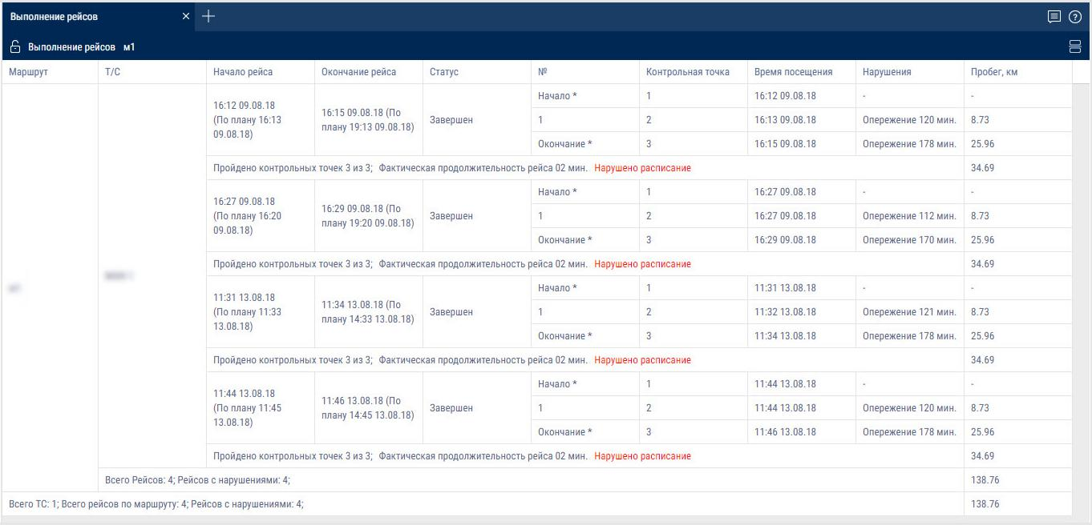

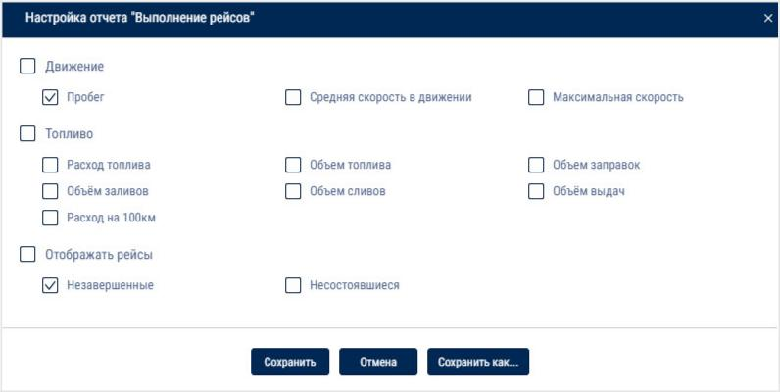

"Vehicle name or Route" - one or more vehicles, or one or more routes, for which the report has been generated.

“Trip start (hh:mm DD.MM.YY)” - the date and time when the vehicle leaves the geofence of the start of the route and the planned departure time specified in the trip schedule settings. If the actual time has not been determined and the scheduled time of departure

has not been specified in the trip schedule settings, “-” is displayed.

“End of the trip (hh:mm DD.MM.YY)” - the date and time of the actual completion of the trip and/or the scheduled time of the end of the trip if the time of departure and the time between control points is specified in the settings. If the actual time has not been determined and the scheduled time of the end of the trip has not been specified, “-” is displayed.

"Status" - the current trip status. Possible values:

"In progress" - the vehicle left the geofence of the start of the route and the trip has not been completed

"Completed" - the vehicle entered the geofence of the route end

“Terminated because the maximum duration of route control has expired” - the trip was terminated automatically after the maximum duration of route control specified in the route settings has run out

“Force stopped” - terminated by pressing the button in the “Active trips” report

"Not carried out" - the vehicle did not leave the geofence of the start of the route at the schedule departure time, taking into account the allowed deviation

"Control point no." - sequence number of the control point specified in the route settings. The control points are listed in the order they were visited. The missed control points are displayed at the bottom of the list.

"Control point name" - name of the geofence defining the control point.

"Visiting time (DD.MM.YYYY hh:mm)" - the time of entering the geofence, which defines the control point.

“Violations” - violations which took place while visiting control points if the control of visits or of the order of control points is enabled in the route settings or if the vehicle has gone beyond the geofence delimiting the route.

- If a violation occurred while visiting the control point, the corresponding row is highlighted in red. If no violations occurred while visiting control points, "-" is displayed. Possible violation values:

"Late/Early"

"Missed control points"

"Wrong order of control points"

"Mileage" - mileage over the period of time between adjacent control points.

For the starting point of the trip "-" is displayed.

Total value for all vehicles (if the report is generated for selected vehicles) - the value of the fuel volume at the time of the last control point visit.

Total value for all routes (if the report is generated for selected routes) "-" is displayed.

“Volume of fuel refilled, l (for vehicles)” - the total volume of fuel refilled for the period of time between adjacent control points.

Total value for the trip - the total of all values of the volume of refilled fuel at all control points of the trip.

Total value for all trips - the total of all values of the volume of refilled fuel for all trips.

Total value for all vehicles or routes - the total of all values of the volume of refilled fuel for all vehicle's or route's trips.

"Volume of fuel fillings, l (for fuel tankers)" - the total volume of fillings for the period of time between adjacent control points.

Total value for the trip - the total of all values of the volume of filled fuel for all control points of the trip.

Total value for all trips - the total of all values of the volume of filled fuel for all trips.

Total value for all vehicles or routes - the total of all values of the volume of filled fuel for all vehicle's or route's trips.

"Volume of fuel drained, l" - the total volume of drained fuel for the period of time between adjacent control points.

Total value for the trip - the total of all values of the volume of drained fuel at all control points of the trip.

Total value for all trips - the total of all values of the volume of drained fuel for all trips.

Total value for all vehicles or routes - the total of all values of the volume of drained fuel for all vehicle's or route's trips.

"Volume of dispensed fuel, l (for fuel tankers)" - the total volume of dispensed fuel for the period of time between adjacent control points.

Total value for the trip - the total volume of dispensed fuel at all control points of the trip.

Total value for all trips - the total volume of dispensed fuel for all trips.

Total value for all vehicles or routes - the total volume of dispensed fuel for all vehicle's or route's trips.

“Consumption per 100 km, l (for vehicles)” - consumption per 100 km for the period between adjacent control points.

Total value for the trip - the total of all values of fuel consumption per 100 km at all control points of the trip.

Total value for all trips - the total of all values of fuel consumption per 100 km for all trips.

Total value for all vehicles or routes - the total of all fuel consumption per 100 km for all vehicle's or route's trips.

Active trips

This report displays the current status of the trips. Active trips are those that have not been completed at the time when the report was generated or completed no later than the time specified in the report settings.

- Select one or more vehicles or drivers

- Select the time period for report generation

- Press the “Add report” button and select “Active trips”

To select the information displayed in the report, right-click and select "Report settings":

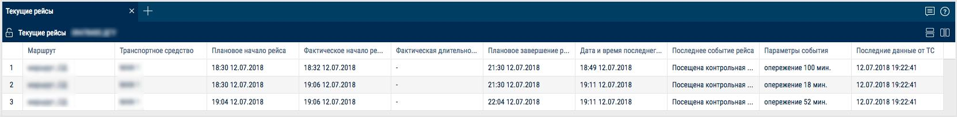

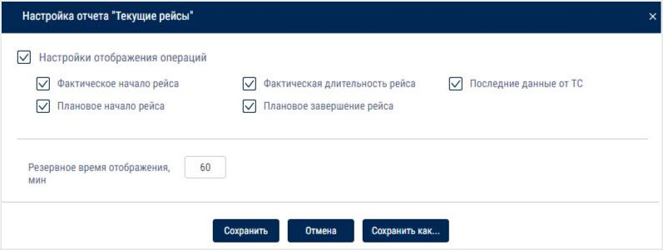

"Additional display time, min" - the time after the trip is completed, during which the trip is still displayed in the report.

The report contains the following information:

"Route" - name of the route

“Vehicle” - name or registration number of the vehicle

"Scheduled trip start" - the date and time when the vehicle leaves the geofence of the start of the route, specified in the trip schedule settings.

"Actual trip start" - the date and time when the vehicle actually left the geofence of the start of the route

"Actual trip duration" - the actual duration of the trip calculated in one of the following ways:

If the trip has not been completed, the actual duration is equal to the current time minus the actual trip start time

If the trip was completed, the actual duration is equal to the time when the trip was completed minus the actual trip start time:

"Scheduled end of the trip" - date and time when the vehicle enters the geofence of the end of the route. It is calculated in one of the following ways:

If in the route settings for the geofence of the end of the route, the "time from the beginning of the route" is set and the "scheduled time of departure" is set in the trip schedule:

"Scheduled end of the trip" = "Scheduled time of departure" + "Time from the start of the route in the geofence of the end of the route".

If in the route settings for the geofence of the end of the route, the "time from the beginning of the route" is set and the "scheduled time of departure" is not set in the trip schedule:

"Scheduled end of the trip" = "Actual start of the trip" + "Time from the start of the route".

If in the route settings for the geofence of the end of the route, the "time from the beginning of the route" is not set and the "scheduled time of departure" and the "actual start of the trip" have not been set in the trip schedule: The "Scheduled end of the trip" is displayed as "-".

"Latest data from the vehicle" - date and time when the latest data was received from the vehicle completing the trip.

"Date and time of the last event" - date and time of the last events for the active trips.

"Last event" and "Event parameters" contain brief information on the status of the active trip. Possible events:

“Awaiting departure” is recorded under the following conditions:

"Scheduled time of departure" is set in the trip settings

the current time is more than the "Scheduled time of departure" - "Allowable deviation from the scheduled time of departure"

the "Trip started" event was not recorded and the maximum time of route control has not expired

"Trip started" is registered when the vehicle leaves the geofence of the start of the route. If “Scheduled time of departure” and “Allowable deviation from the scheduled time” are set in the trip settings, the “Delay” parameter is displayed with the number of minutes.

"Control point visited" is recorded when the vehicle visits a control point. Event parameters:

-

If "Scheduled departure time" and "Allowable deviation from the scheduled time" are specified in the settings of the route control point, the "Late/Early" parameter will be displayed with the number of minutes

- If the vehicle missed one or more control points, the "Previous missed control points" parameter is displayed

- If the vehicle visited all control points of the route but the order of control points set in the route settings was violated, the “Wrong order of control points” parameter is displayed

"Trip completed" is recorded only if the vehicle entered the geofence of the end of the route or the maximum allowable time for completing the trip set in the route settings has expired. Possible parameters:

If the control points order is enabled and the scheduled time of departure is specified in the route settings, the "Late/Early" parameter is displayed with the number of minutes

If the control points order is enabled in the route settings and violations in the order of control points have been recorded, the "Missed control points" parameter is displayed with the names of the control points

"Trip force stopped" is recorded when the trip was terminated using the "Force stop" button in the "Active trips" report

"Trip not carried out" is recorded if the vehicle did not leave the geofence of the start of the route at the scheduled departure time, taking into account the allowable deviation from the scheduled departure

Notifications

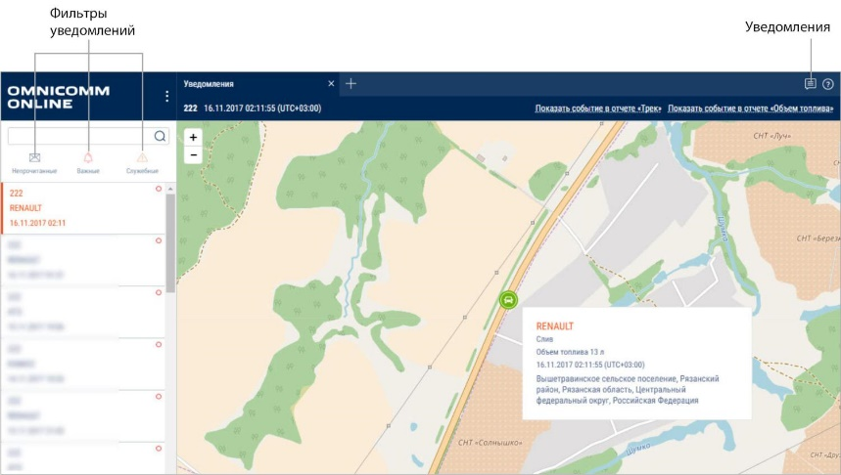
You can store up to 100 notifications in the notifications list. In case more than 100 notifications are created, the older ones will be removed.

Notification filter
Notifications

To switch notifications sound on/off press the right mouse button on the notification icon:
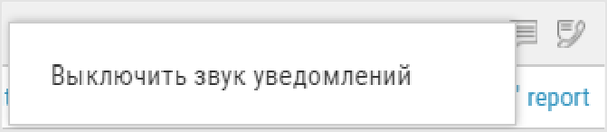
Popup message is displayed after authorization on Omnicomm Online, if there are unread or new service notifications. To move to the notifications list press on the service notification title in the popup message:
The popup message can be closed only after reading the service notifications. The table with the notifications list contains the following fields:
Notification is the notification title
Date and time are date and time of recording of the event end taking in accout time zone specified when setting up the notification
Vehicle is a vehicle for whose event the notification was created
To see detailed information and display an address at which the event was recorded select a notification from the list.

Detailed information contains:

Notification title

Date and time of the notification creation are displayed taking in account time zone specified when setting up the notification
VH name is a name of the vehicle for whose event the notification was created

Driver's name (if the driver is assigned to the VH, otherwise the line is excluded)

Event date is date and time of recording of the event end taking in account time zone specified when setting up the notification
Event is event for which the notification is created

Parameters of event are possible additional parameters of the events. If the event does not contain additional parameters, the line is not displayed.
Geofence name is displayed, if the notifications settings have “In geofence”.

Address is the address at which the event was recorded. The line is displayed, only if the address is identified.

If it is necessary, please use filters:
Unread, only unread notifications will be displayed in the notifications list
Important, in the notifications list only notifications in whose settings “important” label was ticked. Important notifications are highlighted pink.
Service, only notifications sent from the Dealer's profile will be displayed in the notifications list. A message to user is displayed in the service notifications.
Notification with “important” label opens automatically to be displayed above all windows.
To quickly move to the “Track” report press the link in “Display event in the Track report”. The “Track” report for VH will open, for whose event the notification was created.
Period for track generation shall be set as follows:
The time of the period start shall be one hour earlier than the time of the event recording, for which the notification is created. The time of the period end shall be the current moment.
For notifications created for the events related to the fuel parameters (drains, fuel fillings, refueling), if it is necessary to quickly move to “Fuel volume” report, press the link in “Move to Fuel volume report”. The “Fuel volume” report will open for the VH , for whose event the notification was created.

The period for “Fuel volume” report generation shall be set as follows:
The time for the period start shall be one hour earlier than the time of the event recording, for which the notification is created.
The time of the period end shall be one hour later than the time of the event recording, for which the notification is created.

Control over VH maintenance

Task creation
Select one or several VH for which it is required to control the maintenance, press the right mouse button and select “Maintenance control”:
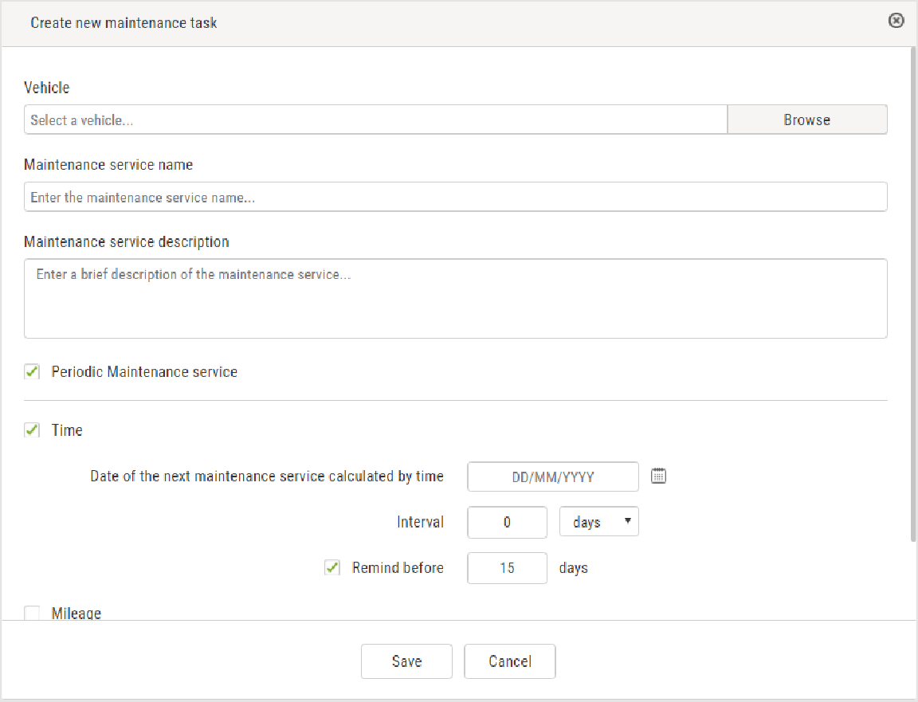
“VH” select a VH, for which it is necessary to add a task for maintenance.

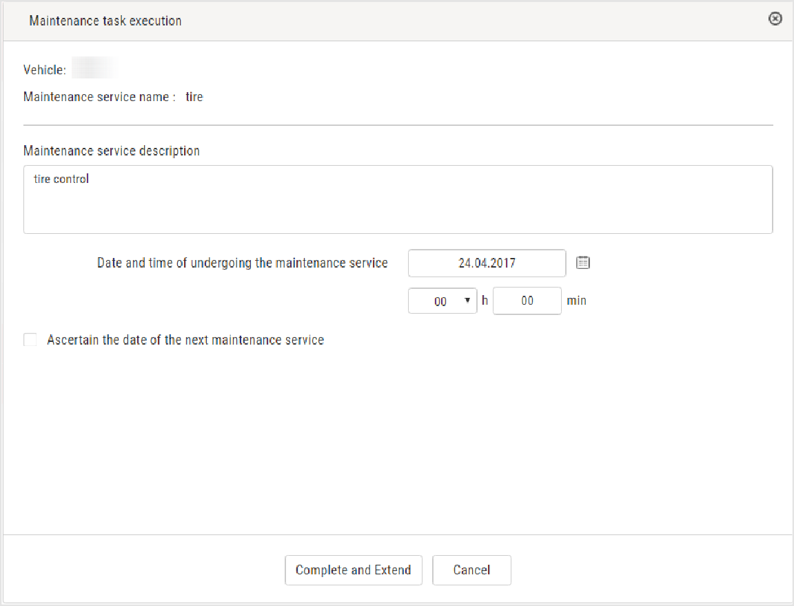

“VH name” enter a name of maintenance.
“Scheduled maintenance”, switch it on, if automatic generation of task for maintenance service with the set intervals after their performance.
“Maintenance description”, enter description of works to be performed during maintenance.
“Time” is time of switching on/off control over performance of maintenance by date. With switched on control over maintenance performance date:
“Maintenance service due date”, select a date for maintenance service performance. Allowed values: from 01/01/2000 to 31/12/2030
“Period”, set a number of days or months between maintenance services for automatic generation of a next maintenance task. It applies to periodic maintenance service only.
“Remind before”, specify in how many days before the maintenance service date, the notification shall be generated and the maintenance task shall be selected in the list.

For notifications generation it is required to add a notification on event “Maintenance

is expected”. “Mileage” is switching on/off control over performance of maintenance service by mileage. Switching on control over mileage is allowed only with the set initial parameters for control over maintenance service in the VH profile.
With switched on control over VH mileage before the maintenance service:

“Time before the next maintenance service by mileage, km”, select a value of VH mileage upon reaching of which it is required to get VH maintenance service performed. Allowed values: from 1 to 1 0000000.

“Period”, set a number of kilometers between maintenance services for automatic generation of a next maintenance task. It applies to periodic maintenance service only.

“Remind before”, specify in how many kilometers before the mileage value of maintenance service, the notification shall be generated and the maintenance task shall be selected in the list.

For notifications generation it is required to add a notification on event “Maintenance is expected”.
“Engine hours” is time of switching on/off control over performance of maintenance by number of engine hours. Switching on control over engine hours is allowed only with set initial parameters for control over maintenance service in the VH profile.
With switched on control over VH engine hours before the maintenance service:

“Due date of the next maintenance service, eoh”, set a number of the VH engine hours upon reaching of which it is required to get the VH maintenance service performed. Allowed values: from 1 to 10 000000.

“Period”, set a number of engine hours between maintenance services for automatic generation of a next maintenance task. It applies to periodic maintenance service only.

“Remind before”, specify in how many engine hours before the achievement of the value of the next maintenance service, the notification shall be generated and the maintenance task shall be selected in the list.

For notifications generation it is required to add a notification on event “Maintenance is expected”.

Performance recording

Select one or several VH, for which it is required to record the maintenance service recording, press the right mouse button and select “Perform maintenance task”:
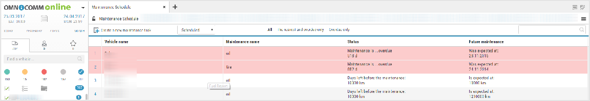
The window will open:
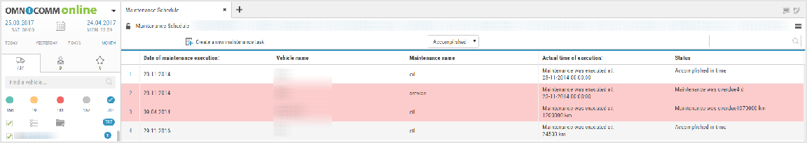
“VH” is a name of the VH on which the maintenance service was performed. “VH name” is a title of the maintenance service.
“Maintenance description”, enter description of works which were performed during the maintenance service.
“Date and time of actual maintenance service completion”, specify the date and time, when the maintenance was performed.
“Specify the due date of the next maintenance service”, switch on, if it is required to perform correction of performance of the next maintenance service. With correction of the due date of the next performance switched on:
“Due date of the next maintenance service by time”, set the date of performance of the next maintenance service.
Press the “Perform and extend” button.

Scheduled tasks
Select one or several VH, for which it is necessary to gather information on conducting of maintenance service, press the right of mouse button and select “Maintenance service control”. Select filter “Scheduled”:
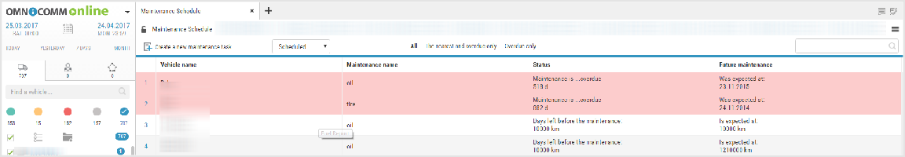

Color-coded indication of tasks for maintenance:
Pink means the tasks for maintenance are not performed, their due date has already passed
Green is for maintenance tasks, whose performance is expected in the period of time specified when creating the task in the field “Remind in”
Not highlighted with color are the maintenance tasks upon creating of which the reminder was not required
Upon view of the planned tasks for maintenance performance, there is an option to use the following filters:

“All”, the list displays the overdue tasks; the tasks which were created, when the reminder was ON and the tasks, whhich were created when the reminder was OFF.
“The nearest and overdue”, the list will display the overdue tasks and the tasks which were created with the parameter value “Remind in” specified and whose time for reminder has come.

“Only overdue”, the list will display only overdue maintenance tasks, as the term for performance of which has already passed and maintenance was not performed.

The following information for Maintenance control is given: “VH name” is a name of VH, whose maintenance was performed. “VH name” is a title of the maintenance service.
“State” is the state of maintenance (overdue or expected) specifying the number of days before the maintenance or how many days are overdue.
“Expected maintenance” are expected and overdue maintenance services specifying the scheduled date of the maintenance.

Performed tasks
Select VH, for which it is necessary to collect the information on performance of maintenance service, press the right mouse button and select “Maintenance service control”. Select the filter “Performed”:
The performed maintenance tasks are not selected with color the maintenance by color are not separated.
“Date of maintenance performance” is the date of maintenance performance, specified
in the maintenance task.
“VH name” is a name of VH, whose maintenance was performed. “VH name” is a title of the maintenance service.
“Actual period of performance” is the date of the actual performance of maintenance.
“State” is the information about the timeliness of performance of maintenance specifying the number of days, if the maintenance was overdue.

Routes

Creating a route

- In the "Routes" section, create a group of routes or choose an existing group to which you want to add the route and click the "Create a route" button.
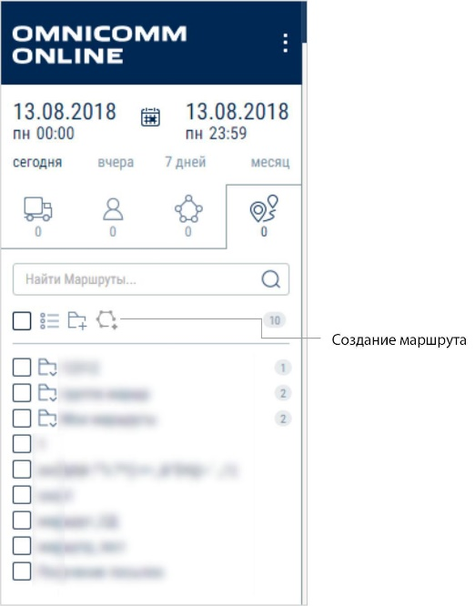

The route editing window will open:

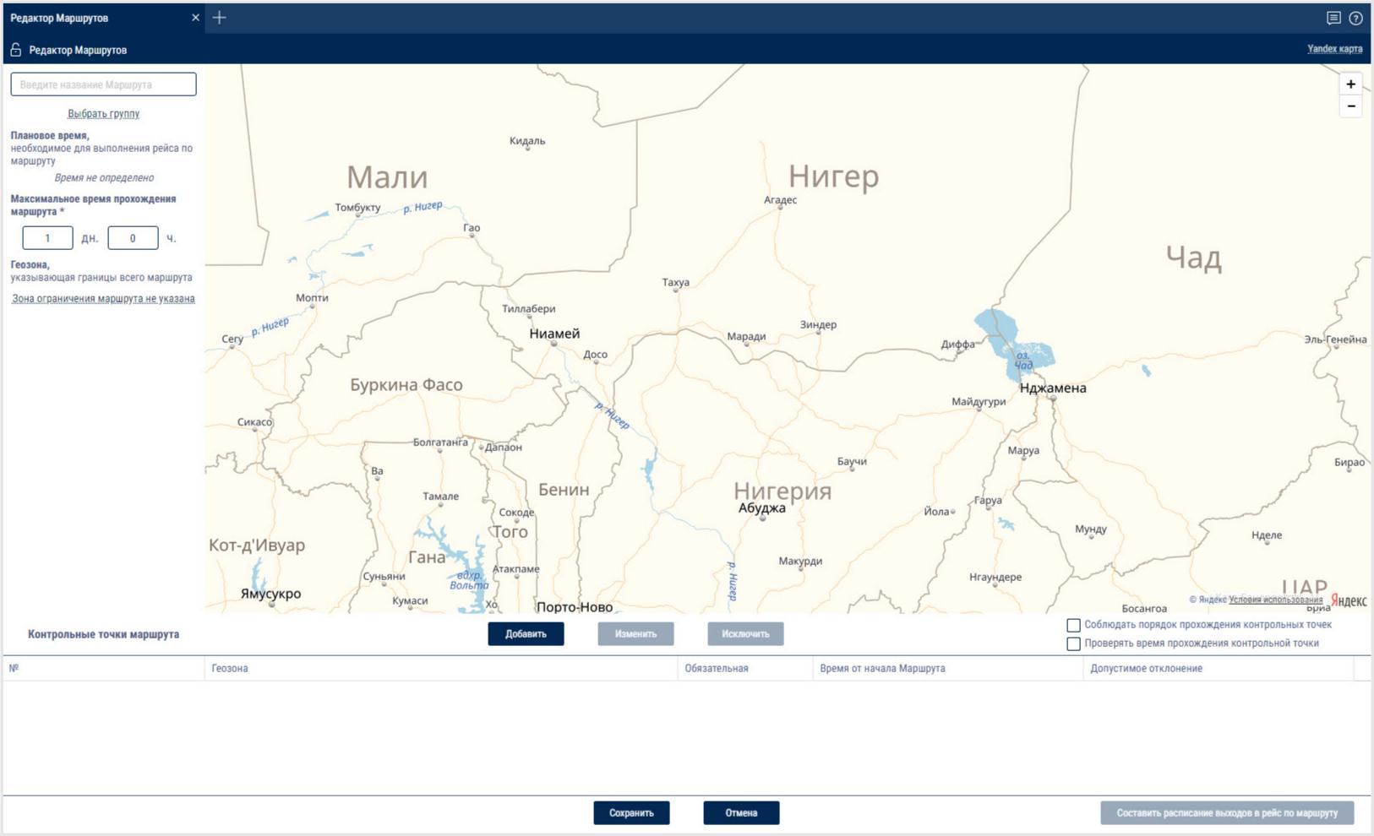

"Name" - enter the name of the route.

Choose the group of routes that will include the created route by clicking "Select the group"

"Scheduled time" - the scheduled time required to complete a trip along the route. The scheduled time is calculated automatically when the time for passing control points and setting parameters for a scheduled visit are enabled in the settings of control points.

"Maximum time for completing the route" - the maximum time from the

start of the trip allotted to complete the trip. If during the course

of the maximum route control time, the trip was not completed,

Omnicomm Online force stops the trip and displays

"Terminated because the maximum duration of route control has expired” in the report. The maximum allowable

time may not have a value lower than the "Scheduled time".

If necessary, select the geofence that will limit the route or click the "Route delimiting area not set" link. If the vehicle leaves the selected geofence, Omnicomm Online will record a violation. In the window that opens, select the geofence and click "Save".

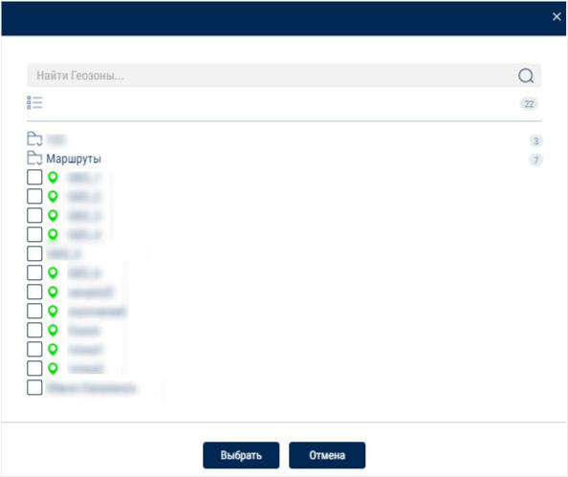

Route control points setup

“Follow the order of control points” - is indicated when it is necessary to check the sequence of control point visits according to the order specified in the route settings. If the sequence of control points is not observed, the reports will show a “Missed control point” or a “Wrong order of control points” violation.

"Check the time of visit to control points" - indicates if it is necessary to check the time of control point visits according to the scheduled visit time from the beginning of the trip along the route, taking into account the allowable deviation from the scheduled visit time specified in the settings for each control point.

To add control points, click "Add" in the route editor window.

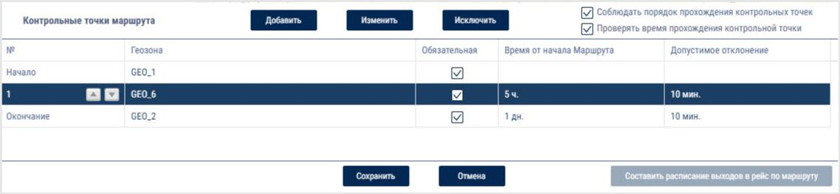

“Compulsory visit” - check the box if visiting this checkpoint is mandatory. If the vehicle does not visit this control point, a violation will be displayed in the reports.

"Scheduled time of visit from the start of the trip on the route" - the time from the start of the route, after which the vehicle must visit the control point. The setting is displayed only when "Check the time of visit to control points" is enabled and not displayed for the geofence of the start of the route.

"Allowable deviation from the scheduled time" - if the vehicle visits the checkpoint within the time of allowable deviation from the schedule, the violation will not be recorded. The setting is displayed only when "Check the time of visit to control points" is enabled and not displayed for the geofence of the start of the route.

Press the “Save” button. The first control point will be the geofence of the start of the route, the following will be added below. Each following control point will be automatically registered as the geofence of the end of the route. The start and the end of the route are compulsory control points of the route.

If it is necessary to add intermediate control points, click the "Add" button and select the geofences of the intermediate control points. The added control point will automatically become the geofence of the end of the route. To change the order of control points in the list, use the Up and Down button.

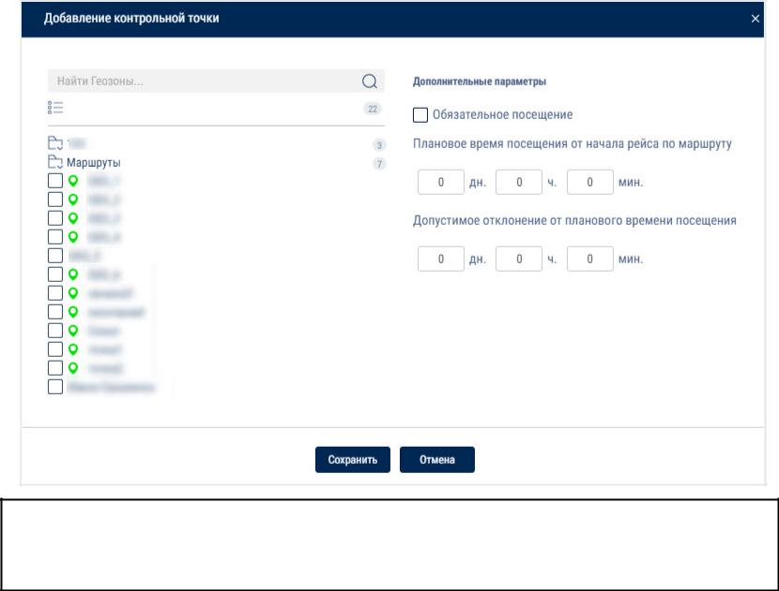

Changes to the route will not affect an active trip. Changes to the route become effective only for the new trips.

After the route is saved, the "Create a trip schedule" button will become active. Press it to open the trip schedule editor window. Create a trip schedule to monitor the movement of vehicles along the route.

Creating a trip schedule

The trip schedule establishes the correspondence between the vehicle and the routes, i.e. it establishes which vehicle should follow the route and, if necessary, indicates the time of departure. Trips for several vehicles can be created on the same route. In the "Route" section, select one or more routes for which you wish to create a trip schedule. Right-click and select "Open trip schedule". A window will open:

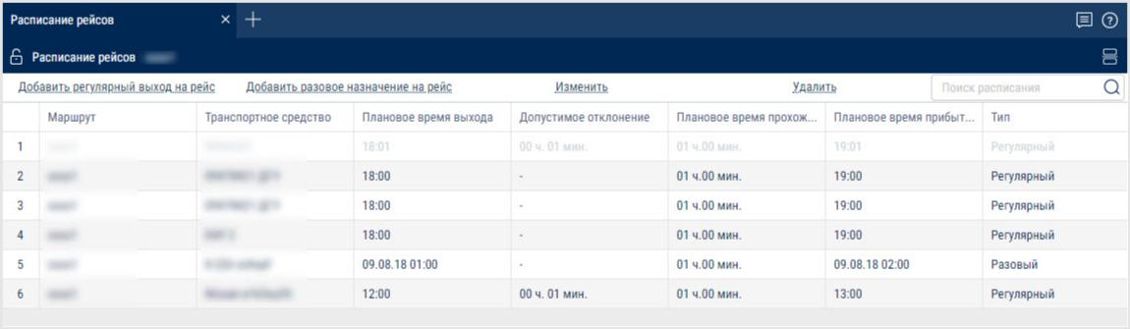

Click "Add a scheduled departure time". A window will open:
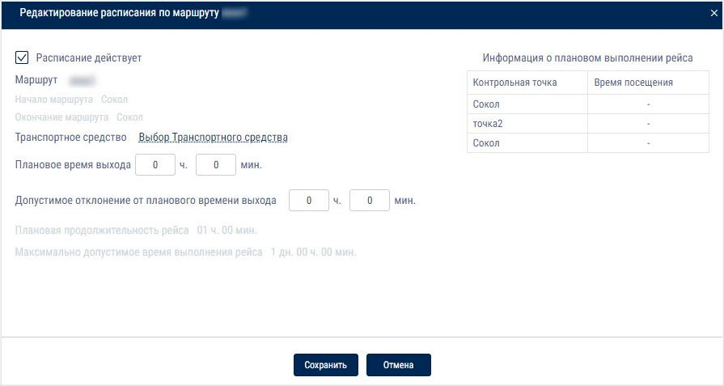

"Schedule active" - enables/disables trip monitoring based on the given schedule.

"Route" - displays the route for which the schedule is created. If you require to change the route for which a trip is being created, click on the link and select the route.

Select the vehicle which must start the trip at the scheduled time by pressing "Select the vehicle". Press the “Save” button.

"Scheduled departure time" - specify the time when the vehicle must start the trip every day. It is not necessary to set a scheduled departure time.

Omnicomm Online will automatically establish the start of the trip when the vehicle leaves the control point at the start of the route.

"Allowable deviation from the scheduled departure time" - the deviation from the scheduled departure time during which a trip start will be recorded. If the trip did not start at the scheduled time, accounting for the allowable deviation, the trip will register as not carried out.

Press the “Save” button. A window with trip schedules will open.

For a trip without a scheduled departure time, the geofence of the start of the route should not coincide with any control point (except for the geofence of the end of the route) of any other trip.

Creating a once-off trip

For a once-off trip, it is possible to set a date for the vehicle to complete the route. The once-off trip will be removed from the schedule after the vehicle completes the route In the "Routes" section, select the route for which you wish to create a once-off trip, right-click and select "Add a once-off trip assignment"
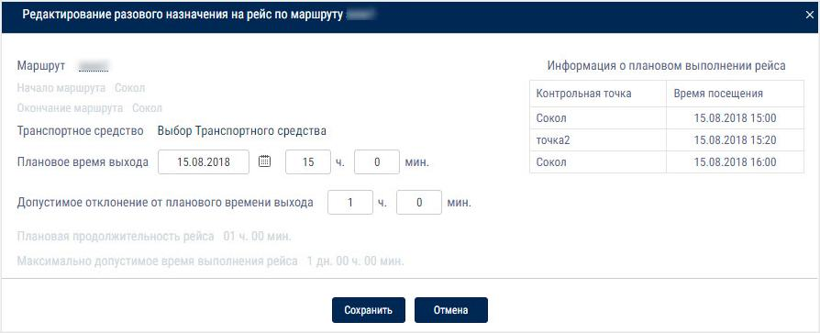

Select one or more vehicles that have to complete the trip by clicking "Select vehicles". Press the “Save” button.

"Scheduled departure time" - date and time when the vehicle must leave

- for the once-off trip. If only a date is provided, the trip will be monitored starting at 00:00 of the specified date. If no date or time is indicated, the start of the trip will be recorded when the vehicle leaves the geofence of the start of the trip.

"Allowable deviation from the scheduled departure" - the deviation from the scheduled departure of the vehicle during which the start of the trip will be recorded (Figure 196). If the trip did not start at the scheduled time, accounting for the allowable deviation, the trip will register as not carried out. Press the “Save” button.
Creating a route duplicate

It is recommended to use a route duplicate when you wish to create

a route that has only minor differences from the selected one.

- In the "Routes" section, select a route that you wish to duplicate, right-click and select "Create a route duplicate". The route editor will open with all the settings of the selected route:
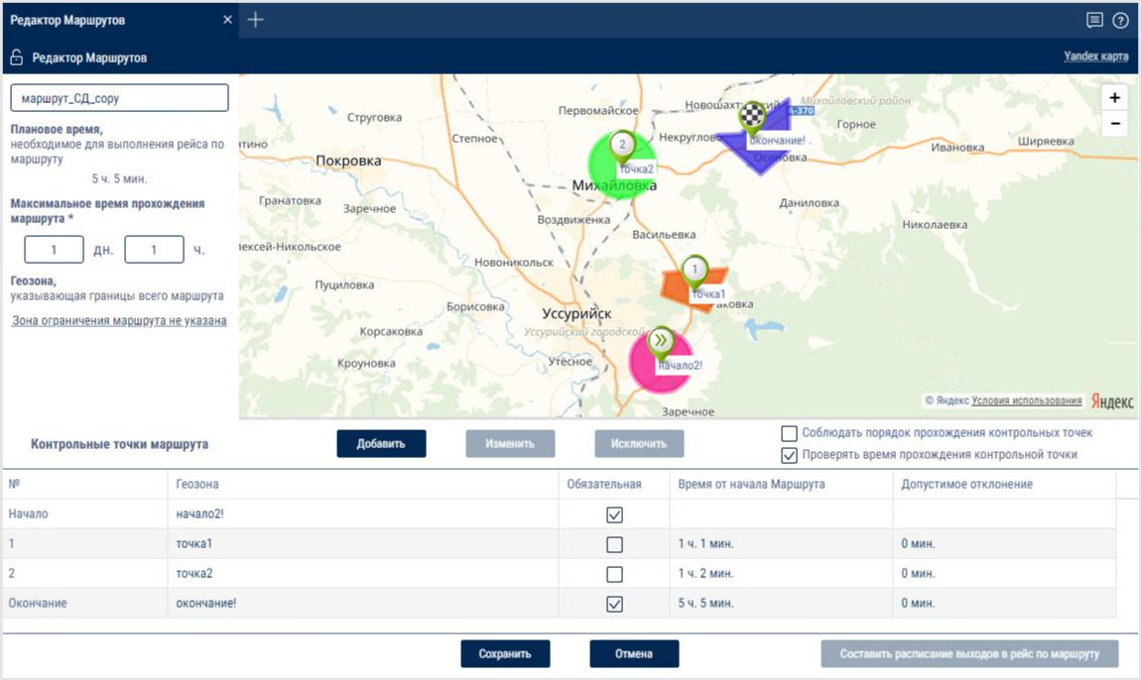

The "Name" field will show the name of the route with the word "copy" at the end.

Make the necessary changes and click the "Save" button.

Drivers

Drivers assignment to VH
This function is available to a user with full access for drivers and VH.
Select a VH to which it is required to assign a driver, press the right mouse button and select “Driver registration”.
or
Select a driver to be assigned to the VH, press the right mouse button and select “Driver registration”.
Select the today's date, any day in the past or the period of time in the past to be used for driver assignment to the VH.
Today's date The driver will be assigned to the VH from the today's date for an indefinite term, till the moment of deassignment or automatic assignment of another driver with IButton.
From the given date. The driver will be assigned to the VH from the selected date for an indefinite term, till the moment of deassignment or automatic assignment of another driver with IButton.
The past period. After data recalculation generation of the reports for VH for the given period will be performed taking in account the registered driver.

If the driver has already been assigned to the selected VH, the date selection window will display the message with the information on the date and assigned driver.
If the registration periods overlap, the registration period should be processed as follows:
- Registration period overlapping and repetition of the same Driver-Vehicle combination. It occurs if there is an attempt to assign the Driver to the Vehicle, who has already been assigned to this Vehicle. – If the date of the assignment added is within the period of the existing assignment and the end date of the added assignment is within the effective period of the same registration, the registration is not added.
- If the effective date of the added assignment is within the existing assignment, the end date of the existing assignment is set equal to the end date of the added assignment and the assignment is not not added.
- Registration period overlapping and a wrong Driver-Vehicle combination. It occurs if there is an attempt to assign the Driver to the Vehicle, who has already been assigned to another Vehicle. – If the effective period of the added registration completely overlaps the existing registration, the existing registration shall be removed.
- If the effective start date of the added registration is within the existing assignment and the effective date of the added registration is within the effective period of the same existing registration, this registration shall be divided into two parts. In this case the first part of the existing assignment of the start date does not change, but the end date is set equal to the start date of the added registration minus 1 second. The second part of the existing registration of the start date is set equal to the end date of the added registration plus 1 second.
- If the effective date of the added period is within the existing assignment, the end date of the existing assignment is set equal to the start date of the added assignment minus 1 second.
- If the end date of the added period is within the existing assignment, the start date of the existing assignment is set equal to the end date of the added assignment plus 1 second. Press “Register”. The window will open, press “Ok”.

Deassignment from the VH
Driver deassignment from the VH can performed automatically using one of two methods upon application of the I-Button of another driver or on Omnicomm Online.
Select a VH from which it is required to deassign a driver, press the right mouse button and select “Driver deassignment”.

or select a driver to be deassigned from the VH, press the right mouse button and select “Driver deassignment”.
The window will open:
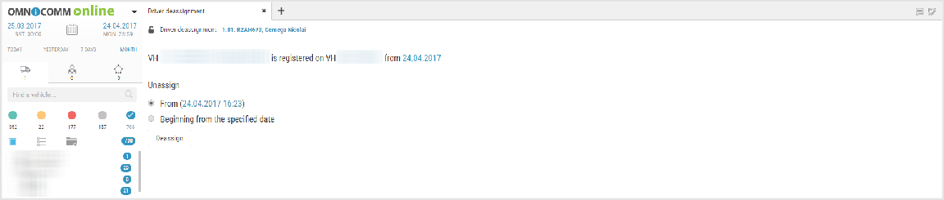
Select the today's date or select any past date and time from which it is required to finish the driver assignment to the VH.
Press “Finish registration”.

Geofences
Geofences data processing is performed with reference to user. Therefore, Omnicomm Online is going to process only entries and exits of VH from geofences owned by the client. The user with a dealer account can only view “Geofences” report against the geofences and client's VH.
Creation of the Geofences can be performed from the “Geofences” section and “Track” and “Location” reports.

In the “Geofences” section in the root catalogue press to create geofences.

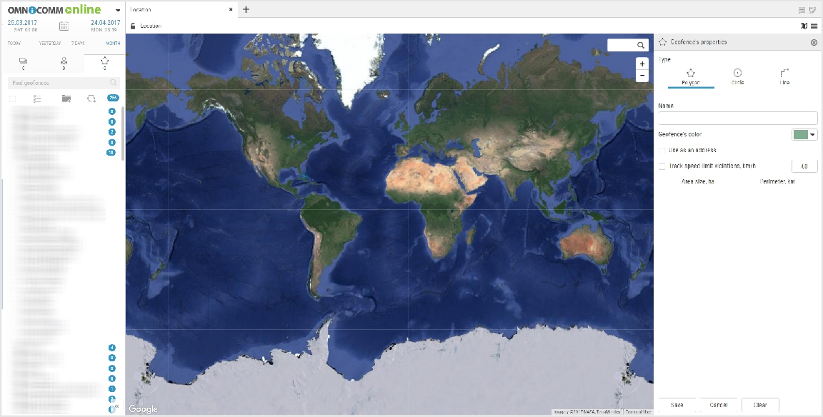
In the “Geofences properties” section:
“Type” — select a shape to be used to highlight the geofence. Allowed options: “Polygon”, “Circle”, “Line”.
“Name”, enter the geofence name.
“Geofence color”, select the color to highlight the geofence on the map.
For the geofence of “Circle” type specify “Radius, km” of the created geofence circle.
If necessary, specify the coordinates of the circle center in the fields “Latitude” and “Longitude”.
For the “Line” type geofence in the “Width, m” field select the width of the created geofence. Allowed values: from 10 to 100 m.
“Use instead the address”, display the geofence name in the reports instead of the address.
“Track speeding”, switching on recording of the event of speeding when the VH is in the geofence.
“Allowed speed, km/h” enter the value of maximum allowed speed for the VH located in the geofence upon exceeding of which the event “Speeding in the geofence” will be recorded. The field is active only with switched on tracking of speeding. Press “Save” button.
If it is required to view the reports on the created geofence for the passed period of time select the VH, specify the period of time and perform recalculation.

Appendix. Calculation of the VH operation parameters

Motion and work
Parameter name | For one VH | For several VH | For one or several drivers

Mileage, (km)/Total mileage, (km) | Mileage for the selected period | Total mileage, (km) for several VH during the selected period | Total mileage, (km)
Average mileage, (km) | - | Average mileage, (km) for several VH during the selected period | Average mileage, (km)
Mileage with speeding (km)/Total mileage with speeding (km) | Speeding mileage, (km) Mileage with speed exceeding the allowed speed, set in the VH profile | Total mileage with speed exceeding the allowed speed, set for each VH in its profile Total mileage with speed exceeding the allowed speed, set for each VH in its profile | Total speeding mileage, (km)
Average speed in motion, km/h | Average speed= mileage/motion time | - | Average speed in motion, (km/h) for one driver
Average speed in motion, km/h | Average speed= mileage/motion time | - | Average speed in motion, (km/h) for one driver

Time of motion | Average time of motion of the | Average time of | Average
/Average time of | several VH for the period, | motion of the several | motion time
motion | which is calculated based on | VH for the period,
(hh: mm: sec) (% from | the conditions: speed is over 2 | which is calculated
the report period) | km/h and ignition is ON | based on the
 | Average percentage of time | conditions: speed is
 | from the total time of the | over 2 km/h and
 | report. | ignition is ON
 |  | Average percentage
 |  | of time from the total
 |  | time of the report
 |  | generation.
Total time of motion, | - | Total time of motion | Total time of
(hh:mm:sec) |  | of several VH during | motion
 |  | the period of the | according to
 |  | report generation | the selected
 |  |  | drivers
 |  |  | during the
 |  |  | period of the
 |  |  | report

Time of engine | Time of engine operation | Total time of engine | Total time of
operation/Total time | Time, during which the level | operation. Time, | engine
of engine operation | of engine revolutions was | during which the level | operation
(hh:mm:sec) (% from | greater than 10 rev/min and | of the VH engines
the report period) | not less than level of idle | revolutions was
 | revolutions set in the VH | greater than 10
 | profile | rev/min and not less
 | Percentage of engine | than level of idle
 | operation time from the total | revolutions set in the
 | period of the report. | VH profiles
 |  | Average percentage
 |  | of engine operation
 |  | time from the total
 |  | period of the report.
Time of engine | Time of engine operation in | Total time of engine | Total time of
operation/Total time | motion. The sum of all | operation in motion. | engine
of engine operation | intervals of time with the level | The sum of all intervals | operation
(hh:mm:sec) (% from | of revolutions greater than 10 | of time with the level
the report period) | rev/min and the speed over 2 | of revolutions greater
 | km/h | than 10 rev/min and
 | Percentage of engine | the speed over 2 km/h
 | operation time in motion from | Average percentage
 | the total period of the report | of engine operation
 |  | time for several VH in
 |  | motion from the total
 |  | period of the report.

Time of engine | Engine operation time when | Total engine | Total engine
operation without | VH is motionless. The sum of all | operation time when | operation
motion/Total time of | intervals of time for the period | the VH is motionless. | time when
engine operation | of report without required | The sum of all intervals | the VH is
without motion | conditions of motion (ignition | of time for the period | motionless
(hh:mm:sec), (% from | is ON and speed is over 2 | of report without
the report period) | km/h) | required conditions of
 | Percentage of engine | motion (ignition is ON
 | operation time without | and speed is over 2
 | motion from the total period | km/h)
 | of the report. | Average percentage
 |  | of engine operation
 |  | time without motion
 |  | from the total period
 |  | of the report
Time of idle engine | Engine idle time | Total engine idle time | Total engine
operation/Total time | The sum of all intervals of time | The sum of all intervals | idle time
of idle engine | during the period of the | of time on several VH
operation | report where the revolutions | during the period of
(hh:mm:sec) (% from | level is less than the level of | the report with the
the time of engine | idle revolutions specified in | level of revolutions
operation) | the VH profile | lower than the levels
 | Percentage of engine idle | of the idle revolutions
 | operation time from the total | set in the VH profiles.
 | period of the report.

Time of engine | The sum of all intervals of time | The sum of all intervals | Total time of
operation on normal | during the period of report | of time during the | engine
revolutions/ Total | with the level of engine | period of report with | operation
time of engine | revolutions greater than the | the level of engine | with the
operation on normal | level of idling and less than | revolutions greater | normal
revolutions | the level of maximum | than the parameters | revolutions
(hh:mm:sec) (% from | revolutions, which is set in the | of levels of idling and
the time of engine | VH profile | less than the level of
operation) | Percentage of engine | maximum revolutions,
 | operation time on normal | set in the VH profile
 | revolutions from the total | Average percentage
 | time of the report | of engine operation
 |  | time on normal
 |  | revolutions from the
 |  | total time of the
 |  | report
Time of engine | Time of engine operation with | Total time of engine | Total time of
operation with | the maximum revolutions | operation with the | engine
maximum | The sum of all intervals of time, | maximum revolutions. | operation
revolutions/ Total | during which the level of | The sum of all intervals | with the
time of engine | engine revolutions was | of time, during which | maximum
operation with | greater than the level of | the level of engines | revolutions
maximum revolutions | maximum revolutions, set in | revolutions was
(hh:mm:sec),(% from | the VH. Percentage of engine | greater than the
the time of engine | operation time with the | levels of maximum
operation) | maximum revolutions from | revolutions, set in the
 | the total time of the report | VH profiles.
 |  | Average percentage
 |  | of engine operation
 |  | time with the
 |  | maximum revolutions
 |  | from the total time of
 |  | the report

Total engine OFF time/Total engine OFF time for several VH  (hh:mm:sec), (% from the time of engine operation) | Engine OFF time, which is calculated by the formula: Engine OFF time = (Date of the period end - the date of the beginning of period) - the time of engine work with the normal revolutions during the period - idle time during the period - time of operation with the overultimate load time | Total engine OFF time for several VH | Total engine OFF time
Fuel (vehicle)
Parameter name | For one VH | For several VH | For one or several drivers
Initial volume, (l) | Volume of fuel at the start of the selected report period | - | -
Final volume, (l) | Volume of fuel at the end of the selected report period | - | -
Actual consumption, (l) | “Actual consumption during the period” = “Fuel level at the period start” – “fuel level at the period end” – “the sum of fuel levels at the refueling start” + “the sum of fuel levels at the refueling end” – “the sum of fuel levels at the drains start” + “the sum of fuel levels at the drains end” | Actual total fuel consumption for several vehicles during the period of report | Actual total fuel consumption for one or several drivers of the report period

Average actual consumption, (l) | - | Average actual consumption of fuel for several VH | Average actual consumption,  (l) for one or several drivers
Refueling volume, (l) | The total refueling volume, start of which is not included in the selected report period | The total refueling volume, start of which is not included in the selected report period | The total volume of the refueling, the date of whose start is not included in the driver registration period
Fuel volume drained, (l) | The total fuel volume drained, start of which is not included in the selected report period | The total volume drained, start of which is not included in the selected report period | The total fuel volume drained, the date of whose strart is not included in the driver registration period
Minimum volume, (l) | Minimum volume of fuel during the period of the report | - | -

Maximum volume, (l) | Maximum volume of fuel during the period of the report | - | -
Actual consumption per 100 km, (l) | Actual consumption per 100 km = (Actual consumption during the period/Mileage during the period) *100%  *under the condition that the mileage is over 10 km | Average actual consumption of fuel for several VH per 100 km | -
Actual mileage per 1 l, km | Actual consumption per 1 l = (Actual consumption during the period/Actual mileage during the period) | Average actual consumption per 1 liter for several VH | -
Actual consumption per 100 km in motion, (l) | Actual consumption per 100 km in motion = (Actual consumption in motion/Mileage during the period) *100%  *under the condition that the mileage is over 10 km | The sum of total consumptions per 100 km in motion of all VH divided by number of VH | -
Actual consumption per 1 l in motion, (km) | Actual consumption per 1 l in motion = Mileage during period/Actual consumption in motion | - | -
Actual consumption in motion, (l) | Actual consumption in motion is calculated in accordance with the following: ignition is on, speed is over 2 km/h | Total actual consumption in motion for several VH during the selected period of the report | Total actual consumption in motion

Actual consumption motionless, (l) | Difference between actual consumption and consumption in motion: Consumption motionless = Actual consumption - Consumption in motion | Total actual consumption motionless for several VH during the selected period of the report | Total actual consumption motionless
Actual consumption per hour of engine operation, l | Actual consumption per hour of engine operation, l = Actual consumption during the time of engine operation/Quantity of engine operation hours  **under the condition that a quantity of engine operation hours exceeds 0.5 | Average actual consumption per hour of engine operation, l for several vehicles, the average actual consumption of fuel per hour of engine operation | -
Actual consumption per motor hour, l | Actual consumption per motor hour, l = Actual consumption during the period/Quantity of engine operation hours | - | -
Actual consumption per hour of engine operation motionless, l

Actual consumption during the time of engine operation motionless is the actual consumption, calculated for the intervals of time of the period, during which the engine worked and the vehicle was motionless. | *under the condition that a quantity of engine operation hours exceeds 0.5  for several vehicles — average actual consumption per hour of engine operation motionless | - | -
Actual consumption per hour of engine operation in motion, l | The actual consumption per hour of work of engine operation in motion = (Fuel consumption during the time of engine operation - Fuel consumption during time of engine operation motionless/Time of engine operation in motion  *under the condition that a quantity of engine operation hours exceeds 0.5 | - | -

Actual consumption during the time of | Actual | -
engine operation, l | consumption
 | during the time of
 | engine operation
 | is the actual
 | consumption,
 | calculated for the
 | intervals of time of
 | the period, during
 | which the engine
 | worked

Сonsumption rate per 100 km, (l) | Normal consumtion per 100 km shall be set in the VH profile “Ready” standards of the fuel consumption can be found::  - in the technical documentation on vehicle;  - 2) consumption rates of fuel and lubricants for road transport (R3112194-0366- 03), affirmed by the Ministry of Transport of Russia on April 29, 2003 They also can be calculated independently in the process of VH operation, based on the actual consumption of fuel per 100 km. | -
Mileage rate per 1 liter, km | Mileage rate per 1 liter, km | -

Rated consumption according to the rate for | Rated | -
100km, (l) | consumption per
 | rate for 100 km
 | shows how much
 | the vehicle should
 | consume during
 | the selected
 | period in
 | accordance with
 | consumption rate
 | per 100 km
 | Rated
 | consumption per
 | rate for rate 100km
 | = (rated
 | consumption per
 | 100 km * mileage)/
 | 100
Calculated mileage according to the rate | Rated | -
per 1 liter for the period, km | consumption per
 | rate per 1 loiter
 | shows how much
 | the vehicle should
 | travel during the
 | selected period of
 | report in
 | accordance with
 | consumption rate
 | per 1 liter

Deviation from rate per 100 km, (%) | Difference between the Actual consumption per 100 km and the fuel consumption rate per 100km, given in percent. Deviation from rate per 100 km, (%) Deviation from the rate per 100 km, (%) = 100*  (actual consumption per 100 km - consumption rate per 100 km)/Consumption rate per 100 km Negative value corresponds to consumption, less than the set rate | -

Deviation from the mileage rate per 1 liter, | Deviation is the | -
(%) | difference
 | between the
 | actual mileage per
 | 1 liter and the
 | rated mileage per1
 | liter, given in
 | percent value:
 | Deviation from the
 | mileage rate per 1
 | liter, (%) = 100*
 | (Actual mileage
 | per 1 l - Mileage
 | rate per 1
 | l)/Mileage rate per
 | 1 l

Overconsumption against the rate per 100 | Difference | -
km for the period, (l) | between the
 | Actual
 | consumption and
 | the Rated
 | consumption per
 | 100 km:
 | Overconsumption
 | against the rate
 | per 100 km for the
 | period, (l) = Actual
 | consumption -
 | Rated
 | consumption per
 | 100 km
 | Positive value
 | corresponds to the
 | excessive fuel
 | consumption (over
 | the rate).
 | Negative value
 | corresponds to
 | consumption, less
 | than the set rate.
Under consumption against the rate per 1 l | Difference | -
during the period, km | between the
 | actual mileage and
 | the rated mileage
 | per 1 liter:
 | Mileage against
 | the rate per 1 l =
 | Actual mileage -
 | Rated mileage per
 | 1 l

Rate of consumption per hour of engine operation | Rate of consumption per hour of engine operation | -
Rated consumption per hour of engine operation, (l) | Consumption according to the rate of engine operation = rate of consumption per hour of engine operation * a quantity of engine operation | -
Deviation from rate per hour of engine | Positive value | -
operation, (%) | corresponds to the
 | excessive fuel
 | consumption (over
 | the rate).
 | Negative value
 | corresponds to the
 | consumption less
 | than the set rate
 | per hour of engine
 | operation.

Overconsumption against the rate per hour | Difference | -
of engine operation for the period, (l) | between the
 | actual
 | consumption and
 | consumption
 | according to the
 | engine operation
 | rate per hour
 | Overconsumption
 | against the rate
 | per hour of engine
 | operation = Actual
 | consumption -
 | Consumption per
 | engine operation
 | rate per hour
 | Positive value
 | corresponds to the
 | excessive fuel
 | consumption (over
 | the rate).
 | Negative value
 | corresponds to the
 | consumption less
 | than the set rate
 | per hour of engine
 | operation.
Fuel (fuel tanker)

Parameter name | For one VH | For several VH
Volume of fillings, (l) | The total fillings volume, start of which is not included in the selected report period | Total fillings volume
Volume of fuel dispensed, (l) | The total dispenses volume, start of which is not included in the selected report period | Total dispenses volume
Volume of fuel drained, (l) | The total dispenses volume, start of which is not included in the selected report period | Total fuel volume drained
Minimum volume, (l) | Minimum volume of fuel during the report period | -

Maximum volume, (l) | Maximum volume of fuel during the report period | -
Probable fuel draining/Excessive volume | The difference between the readings of Fuel level sensor LLS and counter is calculated by the formula::  Initial volume - End volume + Volume of fillings - Dispenses volume If the value “Difference between readings”  <0, the parameter “Excess of dispenses value over fillings value, l” is displayed.  If value “Difference between readings” is less than one of the maximum values: “Fuel draining threshold”, “Refueling threshold”, “1% of fuel tank volume” or “20 liters”, Omnicomm Online  assumes “Excess of | -

n
dispense volume over fillings volume, (l)” value to be equal to zero If difference between values is
≥0, “Potential drain, l” is displayed.
Additional equipment (one vehicle)
Parameter name | Analogue type | Pulse type  Potential type
Minimum value within the period | Minimum value at the universal input during the selected period | Minimum value at the universal input  during the period

Total value during the period | - | Total number of switchings on of additional equipment  Total number of switchings
Operating time is less than the allowed value | Time in the period, during which the value at the universal input was less than the “Maximum allowed value” | -
Mileage with additional equipment ON, km | Mileage during the time when the additional equipment was on | -

Consumption with additional equipment ON, l | Fuel consumption during the time of additional equipment operation
Consumption with additional equipment ON per hour of engine operation, l | Fuel consumption against engine operation and additional equipment operation time | Consumption with additional equipment  ON
Mileage with additional equipment ON per 1 l, km | Average mileage per 1 liter during the time of additional equipment operation | Areas treatment
Parameter name  For one or several VH | Treated area, ha | Treated area, ha = Mileage*Width of area of treated area

Reading of engine hours counter, hour:min

Accuracy: 0.1 min |||

Reading of fuel flow meter, l | Total fuel volume consumed by VH as of the end of the selected period from the date of VH production. Accuracy: 1 l
Readings of counters from CAN-bus before maintenance
Parameter name  For one VH | Mileage before maintenance, km | Mileage remained before maintenance. If the maintenance was missed, the “Mileage before maintenance” parameter takes a negative value Accuracy: 1 km
Engine hours before maintenance, h | Time of engine operation, remaining before the next maintenance. . If the maintenance was missed, the “Engine hours before maintenance” parameter takes a negative value.  Accuracy: 1 h

The data from CAN during the report period
For one VH
Mileage, km | Total mileage of the VH during the report period. Accuracy: 0.1 km

The data from CAN during the report period
For one VH
Engine hours, hour:min | Total number of the VH engine hours during the report period. Accuracy: 1 min
Fuel consumption, l | Total volume of the fuel consumed by the VH during the report period. Accuracy: 1 l

info@omnicomm-world.com www.omnicomm-world.com

